Section 6 - The Outbreak of World War I
By the time the first ship sailed through the Panama Canal, the world’s attention was not on Panama, but on far-off Europe. In August 1914, German troops poured across Belgium, on their way to try to conquer France. Europe was at war.
Tensions in Europe European countries had long competed with each other for colonies, trade, and territory. By the early 1900s, nationalism was complicating these rivalries. Austria-Hungry had built an empire by taking over smaller countries in the part of eastern Europe known as the Balkans. Nationalism inspired in the Balkan people a burning desire to be independent of Austrian rule.
As tensions grew, European leaders looked for safety in militarism, a policy of glorifying military power and military ideas and values. When Germany built up its navy to challenge Great Britain’s fleet, Great Britain constructed more battleships. As Germany’s army grew, France built up its own army.
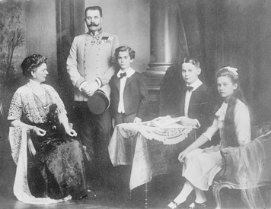
European countries also looked for safety in alliances. In secret treaties, Germany and Austria-Hungary agreed to help each other in case of attack. Great Britain, Russia, and France made similar agreements. Europe was dividing into what amounted to armed camps.
Assassination Leads to War An outburst of nationalism lit the fuse of war. On June 28, 1914, the heir to the Austro-Hungarian throne, Archduke Franz Ferdinand, was visiting the city of Sarajevo in the province of Bosnia. Many Bosnians were Serbs who wanted to be part of nearby Serbia instead of Austria-Hungary. A Serbian nationalist jumped out of a crowd and fatally shot the archduke and his wife.
Outraged, Austria-Hungary accused Serbia of having a hand in the assassinations and pressured Serbia to give up most of its independence. When the Serbs refused, Austria-Hungary declared war. The Russians stepped in to defend the Serbs. The Germans came to the aid of Austria-Hungary by declaring war on Russia. Russia’s ally, France, began to prepare for war.
Eventually, more than a dozen countries took sides in the “Great War.” Decades later, people called the conflict World War I. Austria-Hungary and Germany headed the Central Powers. France, Russia, and Great Britain led the Allied Powers.
Like most Americans, President Woodrow Wilson wanted to stay out of the war. Declaring that the United States would remain neutral, Wilson begged citizens to be “impartial in thought as well as deed.”

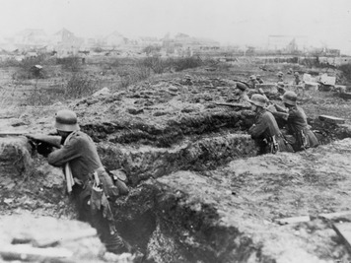
Section 7 - A New Kind of Warfare

By September 1914, approximately 6 million soldiers were on the march across Europe. On Germany’s Eastern Front, German troops fought Russians. On the Western Front, German forces advanced quickly before being stopped by French and British troops at the Marne River, about 40 miles outside the city of Paris. With neither army able to advance, both sides dug long, narrow ditches called trenches to protect their soldiers.
Trench Warfare For the next three years, the war in the west was fought from two parallel lines of trenches. Men ate, slept, fought, and died in these miserable ditches. Eventually, the lines of trenches stretched for 600 miles across France.
Each side protected its front trench with barbed wire and booby traps. The land between opposing trenches was a deadly “no-man's-land.” Attacking soldiers came under intense fire from the men in the trenches. Thousands upon thousands of soldiers died trying to advance their line of trenches a few yards.
The trenches were wretched places, infested with rats, lice, and disease. “We are not leading the life of men at all,” wrote an American who had volunteered to fight with the British forces, “but that of animals, living in holes in the ground, and only showing outside to fight and to feed.”
New Weapons New weapons added to the horror of trench warfare. “We never got anywhere near the Germans,” one English corporal remembered. “The machine-guns were just mowing the top of the trenches.” These new machine guns fired hundreds of bullets a minute. By the end of 1914, the French had lost 300,000 men. Germany lost more than 130,000 soldiers in a single battle.
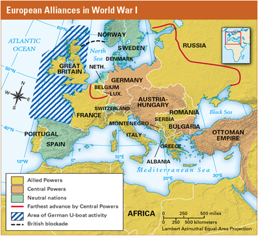
The next spring, a green cloud floated over the Allied lines. Soldiers gasped and died, their throats and noses burning. The Germans had invented poison gas. Soon both sides were using chemical weapons.
The armies’ new technology and strategies were effective for defense, but not for decisive attack. In the First Battle of the Somme, fought in France in 1916, the British tried for six months to advance their lines. They gained only five miles and lost about 420,000 men.
War at Sea To supply soldiers in the trenches with food, ammunition, and other supplies, the warring nations bought goods from neutral countries. Each side tried to cut off the flow of supplies to its enemy.
Most trade, especially with the United States, was by sea. Great Britain had the world’s greatest fleet and numerous ocean ports. Germany had a strong navy, but its only access to the ocean was through the North Sea. To close German ports, Great Britain laid mines in the North Sea. This blockade stopped most of the neutral shipping and kept the German fleet bottled up in harbors for most of the war.
Unable to use its surface ships, the German navy tried to blockade Great Britain using submarines, called U-boats (for “underwater boats”). Fearing that the British would try to disguise their ships as neutral, Germany announced that it might sink vessels flying the flags of neutral countries. Because submarines on the surface were easy targets for enemy fire, German submarines began sinking vessels on sight, instead of rising to the surface to give warning, as was expected even in wartime.
Germany Sinks the Lusitania The German embassy in the United States placed newspaper ads warning passengers not to sail to Great Britain and specifically not to take the Lusitania, a British luxury liner. On May 7, 1915, six days after leaving New York, the Lusitania neared the coast of Ireland. Suddenly a ship’s lookout shouted, “Torpedo coming on the starboard side!” Within moments, the ship exploded and quickly sank, killing 1,198 people, including 128 Americans.
Americans were outraged. One newspaper called the German attack “wholesale murder.” When President Wilson protested, Germany said that the Lusitania had been carrying arms. Still, Germany apologized and offered to pay for damages. Hoping to keep the United States out of the war, Germany also promised not to attack merchant and passenger ships without warning in the future.
Protected by this promise, U.S. manufacturers increased their trade with the Allies. Trade with Allied countries swelled to $3.2 billion in 1916, while trade with the Central Powers dropped to $1 million. Americans were not fighting in the war, but they had definitely taken sides.

Section 8 - To Make the World “Safe for Democracy”
After the sinking of the Lusitania, Wilson decided that the United States needed to prepare in case war became necessary. He worked with Congress to get money to improve the army and navy. Still, neither Wilson nor the country wanted war. In 1916, Wilson won reelection under the slogan, “He Kept Us Out of War.”
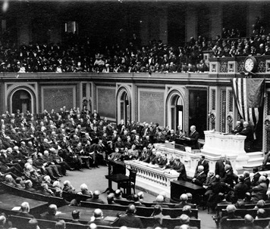
In a speech to the Senate in January 1917, Wilson declared that he wanted to find a way to end the stalemated war in Europe. He called on the warring powers to accept a “peace without victory.” He also spoke of forming a “league of honor” to help nations settle conflicts peacefully. Germany’s response to Wilson’s peace efforts was to launch an all-out effort to win the war, including a return to unrestricted submarine warfare.
The Zimmermann Note Wilson had hoped the Germans would back down, but his hopes were dashed in late February 1917. Britain had gotten hold of a note sent in code by the German foreign minister, Arthur Zimmermann, to the German minister in Mexico. Zimmermann suggested that if the United States entered the war, Mexico and Germany should become allies. Germany would then help Mexico regain “lost territory in New Mexico, Texas, and Arizona.” The Zimmermann note created a sensation in the United States and stirred anti-German feeling across the nation.
The United States Enters the War On April 2, 1917, Wilson spoke to a special session of Congress and called for a declaration of war. America would join the Allies in the fight to defeat Germany, he said, not just to protect shipping but because “the world must be made safe for democracy.” Congress greeted Wilson’s speech with applause.

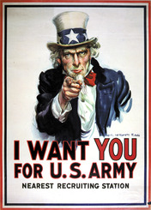
Americans Prepare to Fight On April 6, 1917, Congress declared war. The Allies rejoiced, hoping for U.S. supplies—and soldiers. To get U.S. supplies delivered safely, convoys of U.S. warships started escorting cargo vessels, protecting them from attack. U.S. destroyers also helped the British navy assault U-boats. These strategies dramatically reduced shipping losses.
When the United States entered the war, it had only 200,000 soldiers, and most of those had limited training. Congress quickly authorized a national draft. Soon, 3 million men had been drafted. Another 2 million volunteered.
Fighting and Winning U.S. troops who sailed overseas were called the American Expeditionary Force (AEF). As they began arriving in Europe in June 1917, AEF soldiers soon learned from the Allies about trench warfare. The U.S. commander, General John J. Pershing, hated these terrible conditions for soldiers. He also realized that trench warfare was not winning the war. He worked on a plan for driving the Germans out of the trenches and forcing them to retreat into open country.
Meanwhile, Russia had dropped out of the war. With millions of soldiers dead and starvation spreading across the country, Russians had revolted against their ruler, the czar. The Russian Revolution ended 400 years of monarchy and led to the creation of a communist government. Russia’s new government made peace with the Germans. This enabled Germany to bring soldiers back from the east, swelling their western forces to 3,500,000 men.
The German forces rushed to capture Paris before large numbers of Americans could arrive from overseas. Starting with the Second Battle of the Somme in the spring of 1918, German forces opened a series of offensive attacks. They pushed quickly through the village of Château-Thierry and a nearby forest called Belleau Wood. They were within 50 miles of Paris when Americans reinforced the exhausted French. Gradually, U.S. machine guns and artillery enabled the Allies to push the Germans back.
By the summer of 1918, more than a million Americans were in Europe. Pershing set his Allied offensive into motion. His plan took advantage of several new technologies that had been developed during the war. Tanks could advance through trenches. Airplanes could deliver machine-gun fire and drop bombs. Carefully coordinating huge numbers of forces in a final series of battles known as the Hundred Days Offensive, the Allies forced the weakened Germans back to their own border.
To avoid the invasion of their own country, German leaders agreed to an armistice, or cease-fire. On November 11, 1918, for the first time in four years, the guns were silenced. The costs of the war horrified the world. More than 9 million people died, including about 116,000 Americans.

Section 9 - World War I on the Home Front
The military draft approved by Congress in May 1917 made sure the country had enough soldiers to fight in Europe. But Wilson and other government leaders realized that all Americans, not only those who were sent overseas, would be needed to win the war. “It is not an army that we must shape and train for war; it is a nation,” President Wilson said. He considered the people at home to be just as much a part of the army as the soldiers in France “beneath the battle flags.” Once the United States entered the war, the federal government turned to the task of organizing Americans at home to support the war effort.
Propaganda and Patriotism When President Woodrow Wilson called the nation to war, he knew that not all citizens would respond with enthusiasm. As the war raged in Europe, pacifists had formed peace groups to keep the United States out of the conflict. Pacifists are people who oppose war for political, moral, or religious reasons. Other opponents took an isolationist view. They said that the United States should fight to defend itself, but not become involved in what they saw as a European conflict.
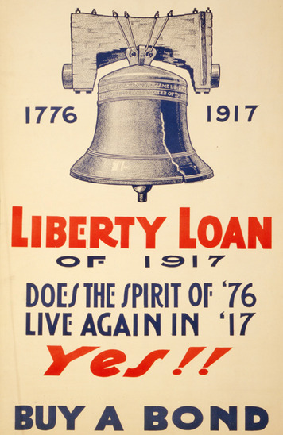
To win support for the war effort, the government used propaganda. Wilson created a government agency that carried out a campaign to “sell” the war to the public. The agency produced films, posters, and books that promoted the war. It sent thousands of men into towns and cities to make speeches on such topics as why the United States was fighting and the need to save food and fuel.
Americans responded by showing their support for the war effort. Families saved tin cans, paper, and old toothpaste tubes for recycling into war materials. Women met in homes or churches to knit blankets and socks for soldiers. Many people joined local Red Cross chapters, where they rolled bandages and packed supplies to send to Europe.
Propaganda and patriotism sometimes stirred up anti-German hysteria. Almost all German American communities supported the war effort once the United States entered the conflict. However, they often suffered as the result of the suspicions of others. Some employers in war industries fired German American workers, fearing they might wreck machinery or report plans to the enemy. Music groups stopped playing music written by German composers. Libraries removed books by German writers.
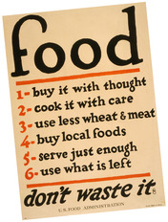
Raising Money for the War Once the United States entered the war, the government had to find ways to pay for it. World War I ended up costing the United States about $35.5 billion. About one third of that cost came from taxes. The government raised the rest of the money by selling bonds. A bond is a document issued by a government or a company that promises to pay back an amount of money, plus an additional amount. Thousands of citizens worked to sell Liberty Bonds in their hometowns.
Organizing Industry for the War As the nation geared up for war, industries began to produce fewer consumer goods and more war supplies. In the past, the government had left businesses alone to make this transition. World War I was different. For the first time, the federal government worked with industries to make sure they made what the military needed. This included the power to tell factories what goods to produce and how much to make.
Efforts to Conserve Food and Fuel The United States faced the huge job of feeding its armed forces, as well as the people at home. To meet the challenge, farmers produced more food. The government began a campaign that urged Americans to conserve food so that more could be sent to U.S. troops in Europe. Families took part in Meatless Mondays and Wheatless Wednesdays. They increased the food supply by planting “victory gardens” in their backyards and public parks.
The government encouraged Americans to conserve fuel to help make sure factories had the coal and oil they needed to increase production of war supplies. To save energy, Americans turned down their furnaces on “heatless Mondays.” On “gasless Sundays,” they walked instead of driving their cars. The government introduced daylight savings time during World War I. By having an extra hour of daylight at day’s end, households used less electricity for lighting.
Efforts to Enforce Loyalty Most Americans supported the war, including most of the people who had emigrated to the United States. Immigrants wanted a chance to show their loyalty to their country. They bought war bonds, took part in conservation efforts, and worked in wartime industries.
Nevertheless, recent immigrants became targets of patriot groups like the American Protective League. These groups tried to enforce what they called “100 percent Americanism.” Their members sometimes walked around immigrant neighborhoods looking for signs of disloyalty. They also sent the Federal Bureau of Investigation (FBI) names of people they suspected of disloyalty.
Fear of espionage, or spying, led Congress to pass the Espionage Act in 1917. This law made it a crime to try to interfere with the military draft. It also set severe penalties for spying.
In 1918, Congress further cracked down on opposition by enacting the Sedition Act. This law made it a crime to say anything that was disloyal about the government. Hundreds of people were arrested for offenses such as criticizing the military draft or wartime taxes.

Section 10 - The Struggle for Peace
Less than two months after the fighting ended in Europe, President Wilson traveled to Paris to take part in the Paris Peace Conference. He was cheered by huge crowds. The United States had saved the French from endless war. And many Europeans welcomed Wilson’s eagerness to prevent future wars.
Fourteen Points for World Peace Months earlier, Wilson had presented to Congress a 14-point proposal for a postwar agreement. The first five points aimed to prevent conflict. Nations were asked to avoid secret treaties, to practice free trade, and to reduce their weapon supplies. Wilson asked that new borders be drawn based on self-determination, or the will of the people in each area.
Points 6 through 13 described new boundaries for many European countries. Finally, the ambitious Point 14 called for nations to join a general association of countries to protect each other’s independence. Wilson called this organization the League of Nations. With the League of Nations, Wilson believed, the world could achieve a lasting peace.
Germany had surrendered, believing that Wilson’s “Fourteen Points” would be the basis for a fair and just peace. But after years of fighting and dreadful losses, some Allied leaders were not satisfied with a just peace.
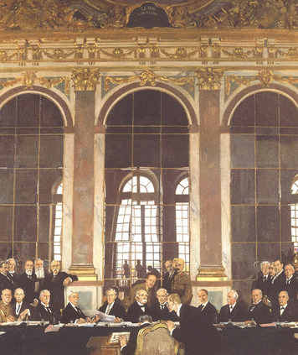
The Treaty of Versailles On January 18, 1919, delegates from dozens of countries assembled at a French palace outside Paris called Versailles (vehr- SIGH). In addition to Wilson, three Allied leaders dominated the treaty talks. They were David Lloyd George of England, Georges Clemenceau (kleh-mahn-SOH) of France, and Vittorio Orlando of Italy.
The German representatives were not allowed to speak. This reflected the Allies’ anger and their determination to punish Germany and remove it as a future threat. They created a treaty that forced Germany to disband almost all of its armed forces, give up its colonies, and surrender territory in Europe.In addition, they called on Germany to pay reparations, or money to make up for damages and war deaths. The amount of these reparations was later set at $33 billion.
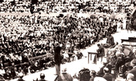
President Wilson opposed such harsh treatment of Germany. However, he eventually accepted the Allied leaders’ demands for punishment in order to win their support for his Fourteen Points.
The Allies rejected some of Wilson’s points, including freedom of the seas. But the peace conference did create new national boundaries in Europe based on self-determination. Most important to Wilson, the Treaty of Versailles established a League of Nations. Wilson thought that this agreement would make the peace treaty successful. The League of Nations, he believed, could fix any problems created by the treaty.
Struggling for Senate Ratification Wilson needed the approval of two-thirds of the U.S. Senate to ratify the peace treaty. He quickly ran into opposition, especially to the League of Nations. Some senators worried that other countries would force U.S. soldiers to fight in international conflicts. They argued that only Congress had the constitutional power to send Americans to war.
The struggle over the treaty became a fight between political parties. Republicans held a majority in the Senate. They felt that Wilson, a Democrat, had made his Fourteen Points a political issue by not appointing any Republicans to his negotiating team.
Anxious to increase public support for the League of Nations, Wilson undertook an intense speaking tour. In 22 days, he toured 29 cities. He spoke up to four times a day, with hardly any rest. Finally, he collapsed with severe headaches. He was rushed back to Washington, D.C., where he suffered a massive stroke.
Recovering slowly, Wilson was less willing or able to compromise with opposition senators. In March 1920, the Senate rejected the Treaty of Versailles.
A Return to Isolationism Once again, the United States was heading toward a policy of isolationism. When the League of Nations opened in Geneva, Switzerland, the United States did not participate. In later years, when crises developed in Europe, the League lacked the power that Wilson hoped it would have.
In Germany, the Treaty of Versailles left a bitter legacy. Germans—notably Adolf Hitler, a corporal who had been temporarily blinded by gas during the war—felt betrayed by the treaty. Hitler’s rise to power in the 1930s would pose a fresh challenge to U.S. isolationism. Only after a second world war would the United States take on the role of world power that it continues to fill today.

