World War II

Section 1 - Introduction
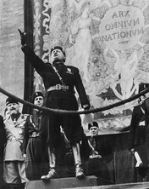
The peace settlement that ended World War I was unsatisfactory to many nations, even some nations on the winning side of the war. As a result, the peace of the 1920s was a troubled one, marked by instability within nations and between them. Unrest intensified in the 1930s, as the Great Depression that began in the United States spread around the world. The hard times that followed, when added to tensions that already existed, caused people in some countries to support dictators—rulers who have absolute power—who promised order, prosperity, and a better future. Dictatorships developed in Germany, Italy, and the Soviet Union.
In Italy, a leader named Benito Mussolini overthrew the government in 1922. Within a few years, he turned the Italian government into a dictatorship based on a political philosophy called fascism. Mussolini planned to expand Italy’s territory and to restore Italy to the glorious days of the ancient Roman Empire.

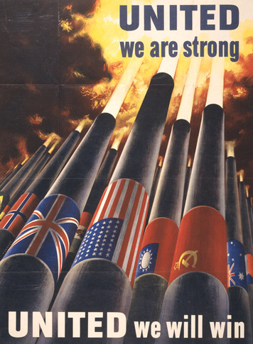
Russia also became a dictatorship. In 1922, the Communist Party in Russia formed the Union of Soviet Socialist Republics (USSR), commonly known as the Soviet Union. By the 1930s, Soviet leader Joseph Stalin had established a dictatorship and created a totalitarian state. The Communist Party totally controlled all aspects of the government, economy, and society.
Under the Nazi Party, Germany also fell to dictatorship. In Germany, the effects of the Great Depression were especially severe. By 1932, about a third of German workers were out of work. Industrial production was cut nearly in half, and German exports fell dramatically. Banks failed and could no longer make loans to businesses. Many German farmers lost their farms, which led to food shortages.
In the 1930s, a leader named Adolf Hitler took advantage of Germany’s troubles to stir up German nationalism. Hitler led the National Socialist German Workers’ Party, also known as the Nazi Party. The Nazis wanted to create a powerful Germany, and to greatly expand German territory. They also believed that ethnic Germans were racially superior to other peoples. They aimed to deny citizenship and political power to those who were not ethnically German—and especially to Jews.
The Nazis promised to impose order, promote their racial policies, and create a stronger, more prosperous Germany. Their message appealed to unemployed workers, farmers, and young people eager to support the ideals of German nationalism. The Nazi message also appealed to middle-class Germans who were being hurt by the depression. By the end of 1932, the Nazis were the largest political party in the German parliament.
In 1933, Germany’s president named Hitler as chancellor—the top position in the German cabinet. Once in power, Hitler moved quickly to create a government based on the principles of fascism in which he held all the power.
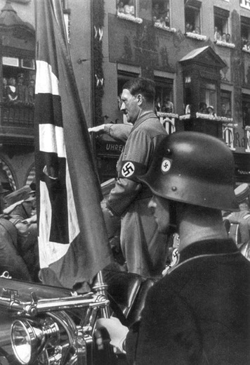
Hitler brought Germany under complete Nazi control and established a totalitarian state. All other political parties were banned. Nazis were appointed to head all state and local governments. In 1934, Hitler combined the offices of president and chancellor and ruled Germany as a dictator.
Like the Nazis, in Japan military leaders also sought to greatly expand their nation’s territory. In the 1930s, the military began to gain more power and play a greater role in government. They used aggressive military action to conquer new land and seize raw materials. In 1931, Japan invaded and took control of a region in China called Man-churia. More aggression followed in 1937. The Japanese army attacked Beijing, China’s capital, and went on to capture the city of Nanjing. In Nanjing, Japanese soldiers massacred about 300,000 Chinese civilians.

Meanwhile, European leaders Mussolini and Hitler began to use military force to gain territory. Mussolini invaded the East African nation of Ethiopia in 1935. In 1936, Hitler sent German troops to occupy the Rhineland, a German region on the border with France. The Treaty of Versailles prohibited military action in this region. But the League of Nations did nothing to stop Germany. In 1938, Hitler annexed Austria and part of Czechoslovakia as part of his plan to unite all German-speaking peoples.
At first, Great Britain and France chose to avoid war by allowing Hitler to expand German territory. But in 1939, when Germany took over the non-German speaking area of Czechoslovakia, Britain and France were prompted to take stronger action. They said that if Germany made further attacks on small states, they would declare war. Hitler had no interest in avoiding war. He had already made plans to invade Poland.
On Hitler’s order, German troops invaded Poland on September 1, 1939. Two days later, Great Britain and France declared war on Germany. World War II had begun. Great Britain and France were known as the Allied powers. In 1940, Germany, Italy, and Japan formed a military and political alliance called the Axis powers. When war broke out, the United States stayed neutral. Despite its tradition of isolationism, however, the United States would soon join the Allies in the fight against the Axis powers.

Section 2 - The United States Enters World War II
At first, the Axis powers seemed unstoppable. By the end of 1941, Japanese forces had conquered most of China and had moved into French Indochina. France had fallen to Germany, and the German army had begun an invasion of the Soviet Union. The Axis powers also controlled most of North Africa. Great Britain and the Soviet Union were the only powers left to fight against the dictators in Europe.
The United States Provides Aid President Franklin Roosevelt knew that Americans were not yet ready to abandon isolationism and join the war. But he was able to persuade Congress to sell, lend, or lease war supplies to “any country whose defense the President deems vital to the defense of the United States.” Passed in early 1941, this legislation was called the Lend-Lease Act. Over the course of the war, the United States gave about $50 billion in war supplies to more than 40 Allied nations. Most of the aid went to Britain, France, the Soviet Union, and China. At the same time, Roosevelt prepared for war. He got funding from Congress for ships and planes, and started the first peacetime draft.
Japan Attacks the United States While the war in Europe grabbed headlines, tensions were also rising between the United States and Japan. In 1942, Japan began to occupy bases in southern Indochina (now Vietnam and Cambodia). The United States protested by halting trade with Japan. This trade embargo cut Japan off from the one thing its leaders could not live without—oil for their armed forces. They could get oil by seizing the Dutch East Indies (now Indonesia). But the United States and its navy stood in their way.
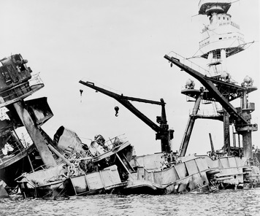
The morning of Sunday, December 7, 1941, dawned cloudy at Pearl Harbor, Hawaii, the home of the U.S. Navy’s Pacific fleet. Aboard the battleship Oklahoma, crew members were eating breakfast when loudspeakers blared out, “Real planes, real bombs; this is no drill!” Japanese planes roared out of the clouds, raining bombs on the naval base.
The Oklahoma sank almost immediately. Four hundred and twenty-nine crew members aboard were killed. Nearby, the battleship Arizona caught fire and disappeared beneath the waves, taking more than 1,000 men with it. In a little more than two hours, the Japanese had sunk or damaged all eight battleships in the U.S. Pacific Fleet. The attack destroyed or damaged 347 aircraft. More than 2,400 Americans were killed.
The next day, President Roosevelt spoke to a shocked nation. “Yesterday,” he began, “December 7, 1941—a date which will live in infamy [evil fame]—the United States of America was suddenly and deliberately attacked by naval and air forces of the Empire of Japan.” Within an hour, Congress declared war on Japan. In turn, Germany and Italy declared war on the United States. America was finished with isolationism. It was time to fight.

Section 3 - The War in Europe
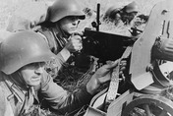
Great Britain and France had been fighting Germany since 1939. In 1940, Italy entered the war on the side of Germany and the Axis powers. France surrendered to Germany in 1940. Great Britain fought on alone, led by Prime Minister Winston Churchill. In the Battle of Britain, the Royal Air Force successfully defended Britain from bombing raids launched by German planes over a devastating three-month period in the summer and fall of 1940.
By the time the United States entered the war, the Axis powers controlled most of Europe. In late December 1941, President Roosevelt met with Churchill in Washington, D.C. Believing that Germany posed a bigger threat to the world than Japan, they agreed that the Allies should concentrate first on the war in Europe.
The Allies Invade North Africa and Italy When the United States entered the war, the Allied powers were not strong enough to attack Germany directly. Instead, they began their campaign in North Africa, where German defenses were weaker. In November 1942, more than 100,000 Allied troops landed in North Africa with a mission to destroy the Axis forces. The bulk of the Axis troops in North Africa were Italian, but Germany’s Afrika Korps formed the backbone of the force. The Afrika Korps was led by General Erwin Rommel, the legendary “Desert Fox.” After months of fierce desert fighting, the Afrika Korps surrendered in May 1943.
From North Africa, the Allies crossed the Mediterranean Sea to attack Italy. The Italian island of Sicily fell quickly. But conquering the mountainous Italian peninsula proved to be far more difficult. Even after the Italians surrendered, German troops stubbornly defended Italy. It took the Allies almost two years to drive the Germans off Italian soil.
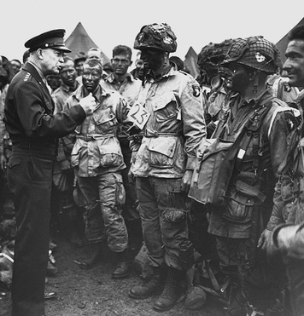
The Battle of Stalingrad Meanwhile, beginning in June 1941, Hitler launched an invasion of the Soviet Union. Under the leadership of Joseph Stalin, the Soviets joined the Allies and fought back against Germany. Advancing rapidly, German troops reached the industrial city of Stalingrad in the summer of 1942. At Stalingrad, German firebombs set most of the city ablaze, but Stalin ordered his soldiers not to retreat. As the brutal Russian winter set in, the German army attacking the city was surrounded by Soviet troops and forced to give up.
The bloody defense of Stalingrad cost the Soviets more than 1 million soldiers and civilians—more than all the American casualties in the entire war. However, the victory marked a turning point. After Stalingrad, the Russian army stopped retreating and began to advance on Germany. The Soviet struggle on the Eastern front played a huge role in defeating Germany. In the course of the war, Soviet troops destroyed more German divisions than the British, Americans, and other Allied countries combined.
The Allies Liberate France While the Soviet Union prepared to invade Germany from the east, the Allies readied an invasion of France from the west. They gave the mission the code name of Operation Overlord. D-Day, or invasion day, came on June 6, 1944. Early that morning, about 176,000 troops, 4,000 landing craft, 600 warships, and almost 14,000 planes left England for the beaches of Normandy, on the coast of German-occupied France.
The D-Day invasion was the largest combined land-sea-air operation in history. It began with a massive air and sea bombardment of German positions on the Normandy coast. Even with this support, troops landing on the beaches were met by murderous fire from the cliffs above. “It seemed we had entered hell itself,” an American recalled. “The whole beach was a great burning fury. All around were burning vehicles, puffed-up bodies. . . . The water was burning.”
Despite heavy losses, the troops captured the Normandy beaches. Within two weeks, the Allies landed a million soldiers in France and began to move inland.
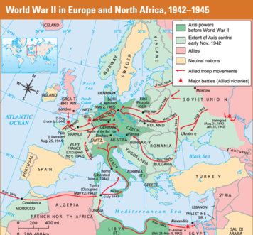
German Concentration Camps By 1945, the Allies were closing in on Germany. While marching across Poland toward the German capital of Berlin, Soviet troops came upon Majdanek, a German concentration camp. There they found a thousand people so weak and sick that they seemed like living corpses. They also found a huge crematorium—a furnace for burning dead bodies. “This is not a concentration camp,” reported a horrified Soviet war correspondent. “It is a gigantic murder plant.”
He was right. Long before invading Poland, Hitler and his followers had persecuted Jews and other groups, including Gypsies and Poles. They viewed these groups as inferior to the German “master race.” When German troops invaded the Soviet Union, they formed mobile killing squads, and executed over 1 million Jews as the army advanced into Soviet territory. Germany then turned to more industrial methods of killing. Wherever German troops went, they rounded up Jews and other groups they considered inferior and sent them to prison camps. Some were forced to work as slaves. The rest were murdered soon after their arrival. This massive program of systematic murder came to be called the Holocaust. Across Europe, the Nazis murdered 11 million people in the Holocaust. Six million of them were Jews.
As the Allies pushed toward Berlin from the west, they found more death camps, each more horrifying than the last. After seeing the horrors at the Gunskirchen concentration camp, one American said, “I finally knew what I was fighting for, what the war was all about,” and why Hitler had to be defeated.
The War Ends in Europe By April 30, 1945, Hitler knew the war was lost. Rather than surrender, the German dictator committed suicide in his Berlin headquarters. A week later, Germany surrendered to the Allies.
Throughout the Allied countries, people celebrated V-E Day (Victory in Europe Day). But the struggle was only half over. On the other side of the world, the Pacific war still raged.

Section 4 - The War in the Pacific
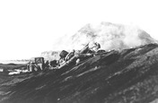
The United States did not wait until V-E Day to move against Japan. While the Americans rebuilt their Pacific Fleet after the attack on Pearl Harbor, Japan quickly expanded its Asian empire. By the spring of 1942, Japanese forces controlled an area covering almost a seventh of the earth.
The Battle of Midway In May 1942, a huge Japanese fleet headed for Midway Island in the Pacific. From that point, Japanese forces could easily invade Hawaii. Although outnumbered, U.S. bombers attacked the Japanese fleet again and again. By the end of the Battle of Midway, Japan had lost four aircraft carriers and 322 planes. Never again would Japan directly threaten the United States. The tide of battle in the Pacific had turned.
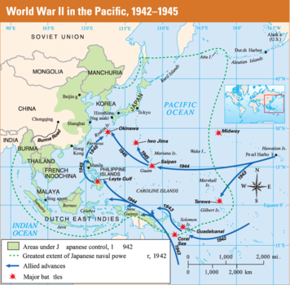
Island Hopping After Midway, the Allies began the task of driving the Japanese off hundreds of islands scattered over thousands of miles of ocean. Rather than attack every Japanese stronghold, the Allies adopted a strategy known as “island hopping.”
Using this strategy, Allied troops seized islands that were less well defended. Then they used these islands as bases from which to attack Japanese ships supplying nearby islands. As a result, reported a Japanese officer, “Our strong points were gradually starved out.”
While island-hopping worked, few islands fell easily. Japanese soldiers viewed surrender as deeply shameful, and they offered fierce resistance. One U.S. marine observed, “You don’t really comprehend it until you get out there and fight people who are faced with an absolutely hopeless situation and will not give up.”
The Allies Push Toward Japan The Allies’ push through the Pacific steadily shrank the defensive forces the Japanese had established around Japan. Those forces disappeared after the Allies captured the key islands of Iwo Jima and Okinawa in early 1945. The month-long Battle of Iwo Jima was among the bloodiest of the war. Nearly all of the 22,000 Japanese troops fought to their deaths. More than 6,800 American troops also died.
To capture the much larger island of Okinawa, the Allies mounted a huge invasion in April 1945. More than 1,300 American ships, including 40 aircraft carriers, supported a force of 182,000 American troops. As on Iwo Jima, the 120,000 Japanese troops defending Okinawa fiercely resisted the invaders. The Battle of Okinawa continued for three months. It claimed the lives of some 12,000 American and more than 100,000 Japanese soldiers.
Earlier in the Pacific war, the Japanese had introduced a new method of attack. Japanese pilots flew planes filled with explosives into American warships to blow them up. The men flying these suicide missions were called kamikaze pilots. Kamikaze, which means “divine wind,” was the name given to a legendary storm that saved Japan from an invasion by sea in 1281. In the Battle of Okinawa alone, kamikaze attacks killed 5,000 American seamen.
The United States Develops the Atomic Bomb President Roosevelt did not live to see the hard-won victory in Okinawa. On April 12, 1945, he died from a stroke. Vice President Harry S Truman became the nation’s new president.
A few days later, Truman was handed a memo that began, “Within four months we shall in all probability have completed the most terrible weapon ever known in human history.” This was the first Truman had heard of the Manhattan Project and the atomic bomb.
The Manhattan Project was a top-secret U.S. government program established to build an atomic weapon. The program had been set up under Roosevelt in 1942 and was kept so secret that even his vice president did not know about it. A team of scientists, many of whom had fled from fascist nations in Europe, carried on the research and development. When the first bomb was successfully tested at a site in New Mexico in July 1945, Truman faced a terrible choice. He could order an invasion of Japan, which might cost half a million American lives. Or he could use this frightening new weapon.
The United States Uses the Atomic Bomb Truman did not hesitate. “I regarded the bomb as a military weapon and never had any doubt that it should be used,” he wrote of his decision. Japan was warned that it faced “prompt and utter destruction” unless it surrendered at once. No surrender came.
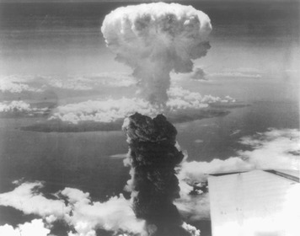
On August 6, 1945, an American plane named the Enola Gay dropped an atomic bomb on the Japanese city of Hiroshima. A blinding flash filled the sky. The explosion that followed killed about 70,000 people, most in mere moments. “I felt I had lost all the bones in my body,” recalled a survivor. “I saw a beautiful blue sky and a dead city.”
A stunned Japan did not surrender. Three days later, a second atomic bomb exploded over the city of Nagasaki, killing an estimated 40,000 people. “I cannot bear to see my innocent people suffer any longer,” said Japanese emperor Hirohito. He announced Japan’s surrender. As many as 250,000 Japanese may have died from the two atomic bombs, either directly or as the result of burns, radiation poisoning, or cancer.
On August 15, 1945, Americans celebrated V-J Day (Victory in Japan Day). After signing the surrender treaty, American general Douglas MacArthur announced, “A great victory has been won. The skies no longer rain death—the seas bear only commerce—men everywhere walk upright in the sunlight. The entire world is quietly at peace.”

Section 5 - The Aftermath of World War II
Millions of people around the world celebrated the end of World War II. But they also mourned the terrible loss of life. As many as 60 million people died in World War II. About half of them were civilians, or people not serving in the military. The Soviet Union suffered the highest losses. Perhaps 20 million or more Soviet soldiers and civilians were killed, although an accurate count was never made. Poland was also hit hard, suffering about 6 million deaths, nearly all of them civilians. Nearly 2 million Japanese were killed and more than 7 million Germans. Britain, France, and the United States each lost several hundred thousand people.
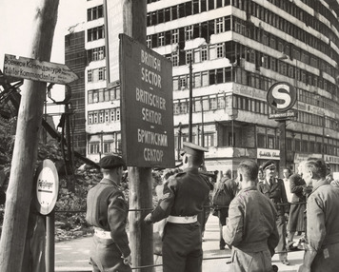
More than 20 million Europeans were made homeless by the fighting. The huge number of dead and homeless in China and the rest of Asia will probably never be known. Nor can the cost of all the property destroyed, resources depleted, and economic activity disrupted by the war. Just the money governments paid to fight the war totaled more than a trillion dollars.
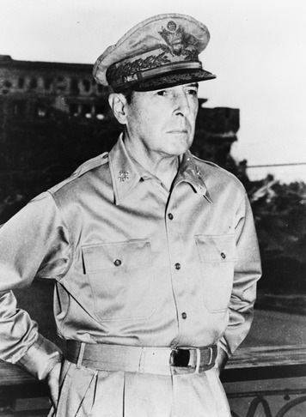
The Allies Reshape Europe The Allies set out to restructure Germany after the war. In February 1945, President Franklin Roosevelt, British Prime Minister Winston Churchill, and Soviet leader Joseph Stalin met in the Soviet city of Yalta for the Yalta Conference. The Allied leaders agreed that after the war they would divide Germany into four military zones occupied by American, British, French, and Soviet forces.
The German capital of Berlin lay entirely within the Soviet zone. In July 1945, Allied leaders met at another conference in Potsdam, near Berlin. This time, the United States was represented by President Truman, who had taken office after FDR died. At the Potsdam Conference, the Allies divided Berlin into four sectors—one for each occupying power.
The Allies Occupy Japan The Americans took a different approach to postwar Japan. They put American general Douglas MacArthur in charge of the country. Allied soldiers occupied Japan, but they did not control it directly as they did in Germany. Instead, the Japanese government carried out a series of political and economic reforms that MacArthur and his staff prescribed. However, MacArthur had ultimate power in Japan, and could overrule Japanese decisions as he saw fit. The Allies also disbanded, or broke up, Japan’s military.
The Allies worked to bring democracy to Japan. U.S. officials working under MacArthur’s command prepared a new constitution. It set up a parliamentary government, based on the British model, with a strong legislature and an independent judicial branch. The emperor would only have ceremonial powers. Women as well as men could elect members of parliament. A bill of rights listed civil and political liberties. MacArthur also made sure that the Japanese constitution banned the use of force as an instrument of power. Japan’s new constitution took effect in 1947. The Allied occupation of Japan ended in 1952.
War Crimes Trials The Allies made a number of demands of the Axis powers at the end of World War II. Germany and Japan had to disarm and give up all territory they had taken. The Allies did not want to inflict more suffering on the people of these defeated nations. However, they did want to punish those who had committed war crimes.
The most famous of the war crimes trials occurred in November 1945, when the Allies put 22 Nazi leaders on trial in the German city of Nuremberg. They were charged not only with war crimes but also with crimes against humanity, such as enslavement and extermination. Judges from the United States, the Soviet Union, Great Britain, and France heard their cases. Twelve defendants were condemned to death by hanging, seven received prison terms, and three were acquitted in the Nuremberg Trials.
In May 1946, a separate court in Tokyo put 28 Japanese war criminals on trial. All were found guilty. Sixteen received life sentences. Seven were sentenced to death by hanging, including Japanese Prime Minister Tojo.

Section 6 - Life on the War Front
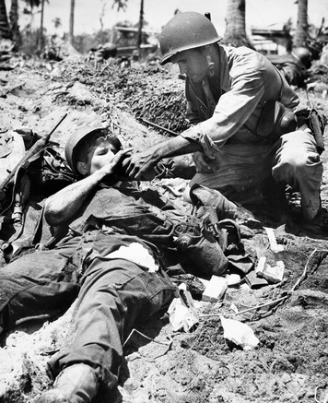

World War II changed life for all Americans, most especially the people who served in the military. The day after the attack on Pearl Harbor, thousands of Americans signed up to fight. More than 5 million people volunteered for the military during World War II. Another 10 million were drafted.
Becoming a GI The military mixed Americans together as never before. Northerners and southerners, city dwellers and farmers, Protestants, Catholics, and Jews all trained together. After three months of basic training, they were battle-ready GIs. The term GI—meaning “Government Issue”— was stamped on government-issued uniforms and supplies. Soon the troops were applying it to themselves.
Military life for GIs began at training camps, where new recruits were turned into fighting teams. Officers expected obedience to every order. Recruits exercised, drilled, and crawled through the mud with heavy equipment as machine guns fired overhead. After basic training, more than half the troops were sent overseas. The rest worked on military bases in the United States in a wide variety of jobs.
Life in Combat American GIs frequently complained about the military. But combat soldiers had the most to complain about. They griped about their rations of dried and canned food. They complained about having no beds, toilet paper, or showers. They grumbled about endless marching, about digging trenches, about cold nights and hot days.
Combat was deafening and terrifying. “The ground all around us shook with gigantic explosions,” said one soldier. “Each man is isolated from everyone else. Death is immediately in front of him. He only knows that his legs and arms are still there and that he has not been hit yet. In the next instant he might.”
Yet even when overwhelmed by fear, most GIs did the job they were trained to do. Where did ordinary men find such courage? When asked, they answered that they were motivated by patriotism and by the desire to help their buddies.
More than 292,000 Americans died in World War II battles. Those who survived were proud of their military service. “You felt you were doing something worthwhile,” said a GI who was part of the D-Day invasion. “I always felt lucky to have been part of it.”

Section 7 - Wartime Government
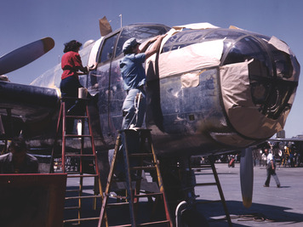
When World War II began, the American economy was focused on producing consumer goods. The head of the German air force joked that “Americans can’t build planes—only electric iceboxes and razor blades.” It probably shocked Germany to see how quickly the American government transformed the United States into what President Roosevelt called the “arsenal of democracy.”
Increasing Production In January 1942 , just a month after the attack on Pearl Harbor, President Roosevelt set up the War Production Board. This agency’s job was to transform American factories into machines for making war supplies and equipment. The board banned the production of nonessential civilian goods, from cars to coat hangers. Automakers began making tanks, jeeps, and trucks. Shirtmakers went to work making mosquito nets to protect soldiers from disease-carrying mosquitoes in tropical regions.
The War Production Board organized nationwide drives to collect scrap iron, tin cans, paper, rags, and cooking fat for recycling into war goods. Children took part by searching through their homes, vacant lots, and back alleys for useful scrap. During one paper drive in Chicago, schoolchildren collected 36 million pounds of paper in just a few months.
To prevent worker strikes that might shut down essential wartime production, the government also established the War Labor Board. This agency worked with unions and workers to settle labor issues without halting production.
Americans took pride in aiding the war effort. In 1939, U.S. aircraft companies turned out only 6,000 planes. By 1944, however, they were producing 96,000 planes a year. Shipbuilders cut the time needed to make military cargo vessels, known as Liberty ships, from eight months to as little as two weeks. Within two years of Pearl Harbor, U.S. factories were producing more military equipment than all of the Axis countries combined.
Supporting the War Effort Huge amounts of money were needed to fight the war. To raise these funds, the government borrowed from banks, businesses, and individuals. Millions of Americans bought war bonds as a way of lending the government money for the war.
To keep spirits high, the government established an Office of War Information. This office provided upbeat stories and photographs to newspapers, magazines, and radio stations. Government officials read news stories before they were published. Often they cut out reports of setbacks and tragedies to keep them from reaching the public.

Section 8 - Wartime Consumers
As factories and farms focused on military needs, consumers were hit by shortages of almost everything. While some complained, most Americans encouraged each other to “use it up, wear it out, make it do, or do without.”
Price Controls and Rationing Expanding war production created millions of new jobs, ending the Great Depression. With more money flowing into workers’ pockets, the government feared that inflation would cause a rapid rise in the price of scarce consumer goods. So the government established the Office of Price Administration (OPA) to control the prices of most goods.
The OPA also set up a rationing system. Rationing means limiting the amount of scarce items that any one individual can buy. Each person received ration coupons labeled for specific items. Anybody who wanted to buy a rationed item, such as shoes or gas, had to provide the proper coupons along with the money.
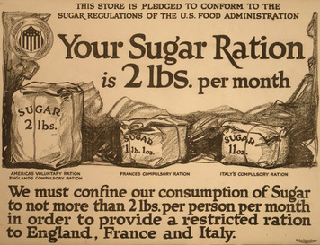
Every meal reminded Americans of the war. Meat, sugar, and coffee were strictly rationed. Most people understood why. Meat was needed to feed soldiers. Sugarcane was better used for making gunpowder than sugar cubes. Importing coffee from Latin America required ships that were better used to support troops overseas.
Victory Gardens and Pocketless Pants To supplement their food rations, Americans planted “victory gardens” in backyards and playgrounds. By 1943, 20 million gardens were producing over a third of all the vegetables eaten in the United States.
Wartime shortages changed what was available to Americans to buy. With steel needed for weapons, stores no longer stocked lawn mowers, bicycles, or even hairpins. With cloth needed for uniforms, the War Production Board ordered that women’s skirts be made without pleats and men’s trousers be made without pockets or cuffs.
In 1943, the government hired a Harvard professor to find out how Americans were reacting to rationing. “The good temper and common sense of most people under restrictions and vexations [annoyances] was really impressive,” he reported. “My own observation is that most people are behaving like patriotic, loyal citizens.”

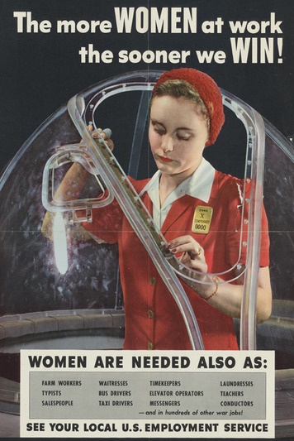
Section 9 - Women in World War II
As men went into the armed forces, business owners worried that the nation would not have enough workers to meet its military and industrial needs. They were wrong. By 1944, nearly 18 million workers were laboring in war industries, three times as many as in 1941. More than 6 million of these workers were women.
Women on the Job At first, war industries were reluctant to hire women. Employers feared that women were not strong enough for factory work. But once women showed they could use a riveting gun as well as a man, employers couldn’t hire enough of them. Women worked as welders, electricians, and machinists. They became police officers, doctors, taxi drivers, and railroad workers. No matter how well they worked, however, women were paid only about 60 percent as much as men doing the same jobs.
New work also posed new difficulties. Women in industry were often criticized as being “unfeminine,” especially those whose jobs required them to wear pants.
Despite the challenges and lower pay, women valued their new opportunities. “Those years changed our lives,” recalled one woman. “All of a sudden I was making money. I was head of a household and it made a different person of me.”
Most women wanted to keep their jobs after the war was over. “I like my work so much that they’ll have to fire me before I leave,” said one electrical worker. As it turned out, many women were fired at war’s end to make way for returning men.
Women in the Military Women also took on new jobs in the military. Until World War II, the military had accepted women only as nurses. Under the slogan “Free a Man to Fight,” women were now recruited into the armed forces to take on a variety of noncombat assignments.
More than 200,000 women played vital roles in the armed services as radio operators, armed guards, translators, codebreakers, and mechanics. Women served as test pilots and flight instructors. More than 200 women, mostly nurses, died in the line of duty during the war.

Section 10 - Japanese Americans and the War
On December 7, 1941, an angry white neighbor came to the home of a Japanese American family. “You . . . started the war,” the neighbor yelled. “You bombed Pearl Harbor!” Of course, Japanese Americans had nothing to do with starting the war. But after the Japanese attack on Pearl Harbor, a cloud of suspicion settled on these loyal citizens.
Internment Camps Japanese immigrants to the United States had already endured decades of racial prejudice. After Pearl Harbor, politicians, military leaders, and opinion makers warned that Japanese Americans might be secretly working to help Japan attack the West Coast. The Los Angeles Times warned, “. . . a Japanese American born of Japanese parents . . . grows up to be a Japanese, not an American.”
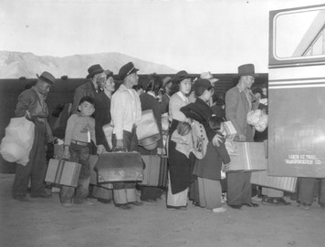
In response to these fears, President Roosevelt ordered the removal of people of Japanese ancestry from the West Coast in 1942. About 120,000 Japanese Americans were forced to leave their homes and businesses and move to distant internment camps . There they would remain for three long years, even though not one Japanese American was ever accused of spying or treason.
Most of the hastily constructed camps were located in bleak deserts. Families were crowded together in flimsy housing with no running water. Barbed wire and armed guards surrounded each camp. One resident recalled, “We struggled with the heat, the sandstorms, the scorpions, the rattlesnakes, the confusion, the overcrowded barracks, and the lack of privacy.”
Overcoming Injustice Despite the injustice suffered by their families, many young men in the camps volunteered for military service. In the Pacific, Japanese Americans worked as interpreters. In Europe, the Japanese American 442nd Regiment earned more medals than any other army brigade in U.S. history. President Truman welcomed the brigade when they returned home. “You fought not only the enemy,” the president said. “You fought prejudice—and you won.”
In 1988, Congress passed legislation that gave $20,000 to every Japanese American who had been interned, or confined, in the camps. With each check came a written apology from President George H.W. Bush for “the serious injustices that were done to Japanese Americans during World War II.”

Section 11 - African Americans in the War
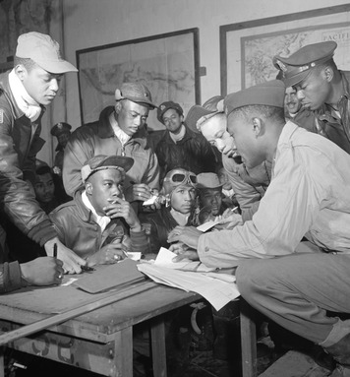

When Japanese bombs hit the battleship West Virginia at Pearl Harbor in 1941, an African American cook named Dorie Miller grabbed an antiaircraft machine gun and started shooting. Miller, who had never been trained to fire a weapon, showed immense bravery as he shot at attacking Japanese planes. In 1942, the U.S. Navy awarded him with the Navy Cross. He was the first African American to earn such an honor.
Miller had no weapons training because the military limited black soldiers and sailors to unskilled support jobs. As a result, African Americans in the armed forces faced what some called the “Double Victory” campaign. They were fighting dictatorship overseas as well as discrimination at home.
African American Servicemen Almost 900,000 African Americans served in the military during the war. Trained in segregated camps, they were assigned to noncombat jobs such as driving trucks and cooking.
Under great pressure from civil rights organizations, the military changed its policy. African Americans began to serve in every kind of combat position, from fighter pilots to tank operators to sailors. Although still in segregated units, by the end of the war blacks served alongside whites on Navy ships.
Many black units distinguished themselves in combat. The 92nd Infantry Division, nicknamed the “Buffaloes,” won more than 200 medals for courage under fire. The 99th Pursuit Squadron, better known as the Tuskegee Airmen, won awards for its daring aerial combat against the German air force.
Progress at Home As factories geared up for war production, many would not hire African Americans. An aviation company expressed the attitude of many in the defense industry when it announced that African Americans would be hired only as janitors. It was not company policy to hire them as mechanics or aircraft technicians.
To protest such discrimination, the nation’s leading black labor leader, A. Phillip Randolph, called for a march on Washington, D.C. President Roosevelt responded by issuing an order calling on employers and labor unions to end “discrimination because of race, creed, color, or national origin” in defense industries.
By 1944, some 2 million African Americans were working in defense plants across the nation. “The war made me live better, it really did,” said one black woman. “My sister always said that Hitler was the one that got us out of the white folks’ kitchen.”

Section 12 - Mexican Americans in the War
Sergeant José López was called a “one-man army.” In one battle, he singlehandedly held off dozens of attacking Germans so that his company could retreat to safety. For his courage, he received the nation’s highest military decoration, the Congressional Medal of Honor.
Mexican American Servicemen More than 500,000 Latinos, most of them Mexican Americans, served in the military during World War II. Unlike African Americans, they did not fight in segregated units. But they did face prejudice. “I’ll never forget the first time I heard [a racial insult],” one Mexican American soldier recalled. “It really hurt me.” Still, military service had its rewards. A California soldier remembered:
I view the service and World War II, for me and many others, as the event that opened new doors. I, like so many of the Hispanic people, was from a farm family. When I went into the Air Corps and I found that I could compete with Anglo people effectively, even those with a couple years of college, at some point along the way I realized I didn’t have to go back to the farm.
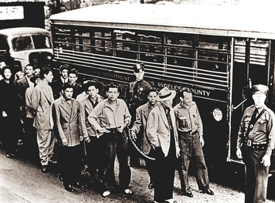
Braceros and Zoot Suits To help American farmers grow more food, the United States began the Bracero Program (after brazo, the Spanish word for arm). Under this program, large numbers of Mexican farmworkers were brought into the United States to harvest crops. Farmers liked hiring braceros because they were cheap labor. Braceros were sometimes treated unfairly. One farmworker reported working for twelve hours a day, but only getting paid for eight.
Many Mexican Americans moved to cities to take jobs in defense industries. They found housing in poor, mostly Mexican neighborhoods called barrios. In the barrios, young Mexican Americans developed a style of dress called the “zoot suit” that featured a long jacket and baggy trousers.
Influenced by generations of prejudice, whites associated youths in zoot suits with gang violence and crime. In June 1943, hundreds of white soldiers and sailors roamed through Los Angeles attacking zoot suiters. The violence quickly escalated to race riots that spread from Los Angeles to other cities.

Section 13 - Jewish Americans in the War
When Hitler took power in Germany in 1933, the United States was home to 4.5 million Jews. Some were recent immigrants. Others were members of families who had come to America in colonial times. But all lived under the shadow of anti-Semitism, or prejudice against Jews. While this prejudice worried American Jews, they were far more concerned about the fate of Jews in Europe.
Jewish Refugees Hitler and his Nazi Party blamed Germany’s problems on Germany’s Jews. After taking power, Hitler ordered Jews to be removed from government jobs. They were stripped of their civil rights and forced to wear a yellow star on their clothing to mark them as Jews.
Every year, tens of thousands of Jews fled Germany. But few countries would accept them. Between 1933 and 1941, the United States admitted about 150,000 Jewish refugees. Despite the persecution of Jews in Europe, the U.S. government refused to relax its strict immigration limits. Widespread anti-Semitism played a part in this decision. In addition, many Americans worried that accepting more refugees would mean added competition for jobs that were already scarce due to the Great Depression.
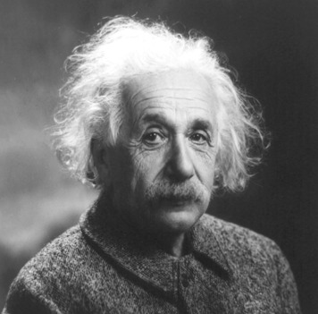
Many Jewish Americans protested the government’s reluctance to help Jewish refugees. In 1943, when Americans began to hear stories about German death camps, more than 400 Jewish rabbis marched in Washington, D.C., to urge the Allies to rescue Europe’s Jews from Nazi extermination.
In 1944, President Roosevelt finally created the War Refugee Board. In just a few months, the board rescued 200,000 Jews from the Nazis. But this effort came too late to help the vast majority of Europe’s Jews.
Jewish American Servicemen More than 550,000 Jews served in the military during World War II, a greater proportion than among Americans overall. By the end of the war, Jewish war heroes had received 52,000 decorations.
Jewish soldiers had even more reason than others to be horrified at what they found in Hitler’s death camps. “Some cried,” wrote an officer, “while others raged.” A rabbi who served with the army said grimly, “If my own father had not caught the boat [out of Europe] on time, I would have been there.”

