W.E.B. DuBois: A Biographical Briefing
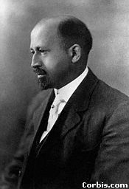
William (W.E.B.) DuBois was born on February 23 1868, in Great Barrington Massachusetts. DuBois grew up in a close tight knit black community. At a young age, Du Bois was aware of the “vast evil” of prejudice that separated him from white people. Very talented and well spoken, Du Bois wrote for the New York Globe at age 15. His success impressed some of the town’s wealthy people who arranged to pay for his education at Fisk University. Fisk’s students were black, but its faculty white. As a result, Du Bois experienced there both extreme racism and a growing awareness of African American identity. He recalled: “One ever feels his two-ness- An American, a Negro; two souls, two thoughts… two warring ideals in one dark body.” While at Fisk, he taught at black schools where he witnessed firsthand the devastating poverty and insufficient education of the local black community. He went on to receive a master’s degree from Harvard University and because the first African American to receive a Ph.D.
W.E.B. DuBois
DuBois spent his life speaking and writing about racial injustice in America. He fiercely criticized the conditions in American society that kept African Americans poor, uneducated, and oppressed. At the root of black misery, he argued was the deep and continuing racism of white American society. He believed racism was institutional in America, meaning racial prejudice was a fundamental part of the social system and ran through its every structure, institutions and policy. DuBois criticized another famous African-American educator, Booker T. Washington, for placing African Americans’ economic independence before the issue of civil rights. While DuBois agreed that economic stability was an important part of improving black peoples’ lives, he felt that African Americans needed to fight first and foremost against racial prejudice and for their civil rights.
DuBois believed that African Americans should not accept the limits of white society, but rather protest long and vigorously for equal rights, opportunities, and treatment under the law. DuBois believed in both blacks’ full and equal integration into American society, and the importance on their own unique culture and accomplishments. DuBois also promoted education as a key element of black advancement. He stated, “We demand for the Negros as for all others a fee and complete education.” He further asserted that the “Talented Tenth”- top 10 percent of African American society in terms of education and talent- were best qualified to lead the black community in the fight for social equality.
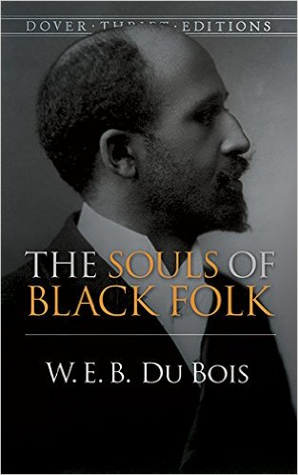
During the Progressive Era, DuBois focused primarily on racially based problems, rather than social issues caused by capitalism. He was basically supportive of labor unions but he strongly criticized the labor movement for its history of racial discrimination and its corresponding unwillingness to fully defend the rights of black workers. In his famous 1903 book, The Souls of Black Folk, DuBois noted “To be a poor man is hard, but to be a poor race in a land of dollars is the very bottom of hardships.” Therefore, DuBois promoted “the formation of a black economic cooperative enterprise based on equality and self-help.

Focus Questions:
- What events in DuBois’s life contributed to his commitment to racial issues?
- According to DuBois, what was the foundation of black oppression?
- In what ways did DuBois’ ideas differ from Booker T Washington’s?
- What actions did DuBois encourage African Americans to take in the face of racial injustice?
- Whom did he believed were the best qualified to lead the black community?
- What were DuBois’ views on the labor movement?
- What did DuBois believe to be the best way to improve American society?

