Federal Food Assistance
The Federal Food Assistance- or Food Stamp- program began in 1939 during the Great Depression. It was started to enable the poorest Americans to get enough to eat at a time when many American farmers were producing a surplus of food. The program was discontinued in 1943, when The American economy had recovered from the Depression. The program resumed in 1961 under President John F Kennedy, after studies during the 1950’s demonstrated that millions of Americans were living in poverty and were not eating nutritionally balanced diets. As part of his “War on Poverty,” President Lyndon Johnson requested that Congress make the Food Assistance Program permanent, which it did by passed the Food Stamp Act of 1964. Since that time the goal of the program has been to ensure that disadvantaged Americans of all ages obtain at least the minimum diet of healthy balanced foods, whether or not they can afford it. The federal government-under the Department of Agriculture- distributes food coupons to individuals or families who can demonstrate an income insufficient to purchase an adequate amount of food.
In its first year as a permanent program, the Federal Food Assistance programs reached more than 500,000 needy Americans. By 1970, the number of participants had grown to 4 million, and by the mid 1970’s, that number had grown to 15 million nationwide. Despite budget cutbacks during the 1980’s, the program has continued uninterrupted since its inception. By the late 1990’s, the program was helping to feed more than 20 million disadvantaged Americans annually, from the youngest children to the oldest senior citizens.
Legal Services
The Legal Services program was designed to help poor, disadvantaged people with civil legal problems. The Office of Economic Opportunity (OEO), a federal government agency that Congress created in 1964, administered the program. The goal of this program was not only to assist poor people with various legal problems, but to act in a “representative fashion” to change laws that were harmful to the disadvantaged. Lawyers for the program sought to make laws simpler and more accessible to the poor, and fought laws that punished or harmed people living in poor communities. The program recruited lawyers in cities and towns throughout the country to work as advocates for the poor.
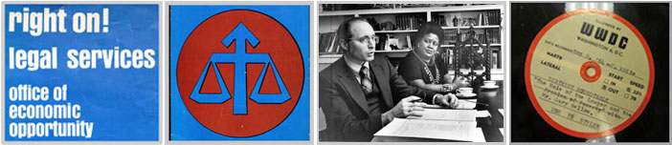
Initially, the Legal Services program had one of the lowest budgets of any of the “War on Poverty” programs administered by the OEO. In 1966, Congress allocated only $25 million in funds, enough to established local legal services agencies in about 125 communities around the country. In 1974, Congress created the Legal Services Corporation (LSC), a nonprofit corporation, to administer the program. Under the LSC, the program concentrated its efforts on providing legal assistance to those who could not afford it, rather than attempting to change the legal system itself. In the late 1990’s, the LSC’s annual budget was about $283 million. This money funded more than 260 local legal services programs, which provided legal assistance to more than 4 million people annually.

The Job Corps
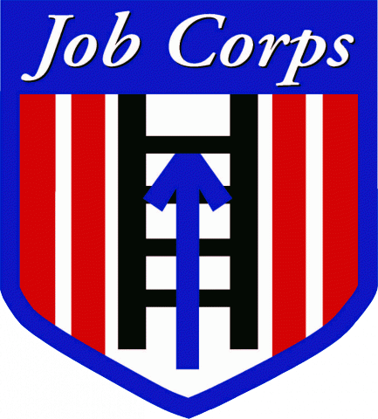
The Jobs Corps was a national job-training program administered by the Office of Economic Opportunity (OEO), the federal government agency created by Congress in 1964. The Goal of the program was to train disadvantaged youth’s aged 16 to 24 in technical, social, and educational skills so they could find work in a variety of fields. The Job Corps established both rural and urban centers throughout the country. Enrollees underwent six to nine months of technical training, learned social skills, and, if necessary, learned basic educational skills such as reading and writing. They also received room and board, clothing for work, books, supplies, and cash allowance. Trainees in rural centers learned to repair roads, build firebreaks, and help manage conservation and natural resource efforts. Urban centers- for those youths with basic sixth grade education- taught skilled crafts such as carpentry, plumbing, welding, and electrical wiring. They could stay in a Job Corps center as long as two years, and at the end of which time they were given assistance in finding a job.
In 1967- the peak year of the program during the 1960’s- the Job Corps operated 123 centers with 42,000 enrollees. Since then, more than 1.8 million economically disadvantaged youths have gone through the program. In the late 1990’s, the Job Corps operated some 114 centers, with an enrollment of about 68,000 students.
Head Start
Head Start was an educational program for disadvantaged children administered by the Office of Economic Opportunity (OEO), the federal government agency Congress created in 1964. The main goal of Head Start was to improve the overall school performance of poor children by entering them in a two-month prekindergarten program. During this time, the preschoolers were introduced to a variety of experiences designed to increase their intellectual awareness. They were taken to local supermarkets, fire stations, zoos, and working farms. They were introduced to a variety of culture, such as art, music, dance, and theater. They were also intellectually spurred by a variety of toys, games, and puzzles. In addition, the program provided hot meals and immunizations against man childhood diseases to support children’s health. Funded by the federal government, Head Start was run by local school districts, activists, and civic groups in cities and towns throughout the country. Local Head Start projects were held in schools, churches, stores, apartments and civic centers.
The first Head State project began in the summer of 1965, with more than 500,000 four and five year old preschool children in 2,500 communities around the country. The cost of the program was $82 million. It was such a success that President Johnson soon announced that Head Start would become a full-one year permanent program to benefit about 350,000 poor children, ages three and up. By the late 1990’s Head State was enrolling more than 800,000 children a year and its annual budget was more than 4$ billion. Since Head Start’s inception in 1965, more than 17 million preschool children have benefited from the program.

