Name:_____________________ Date:_____________
President Johnson’s Great Society and “War on Poverty” Programs
“War on Poverty Program” | Description of the Program | Goals of the Program | How Program has Influenced Contemporary Society
Federal Food Assistance
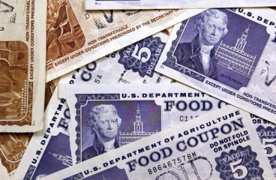
Legal Services
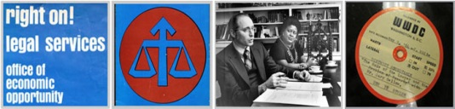
The Job Corps
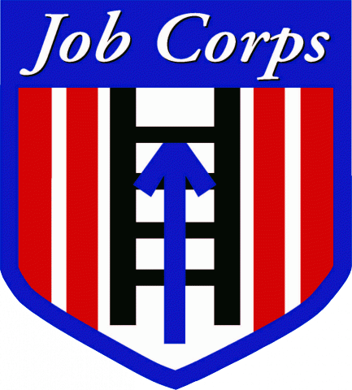

“War on Poverty Program” | Description of the Program | Goals of the Program | How Program has Influenced Contemporary Society
Head Start
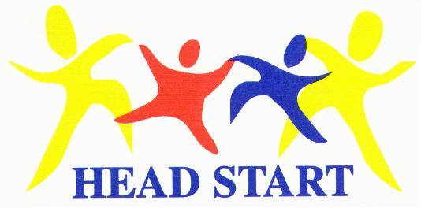

Notes from Johnson’s Great Society Review
The Economic Opportunity Act of 1964

Development Act of 1964_____________________________________________________________________________
BUT all Johnson’s _____________________________________________________ were undermined by the _____________________________________________________________________.

