Cover Page on “The War in the Pacific”
After reading “The War in the Pacific” Creatively display the following information on a Cover page on the back of this paper. I would encourage you to create pictures, graphics and many other interesting representations of the information.
This is designed so that you are creating something with the information that you are processing. It is important to make sure to clarify that you understand the meaning of the material.
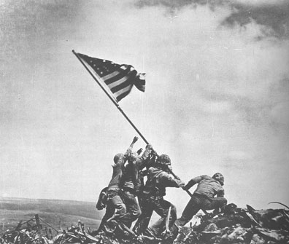
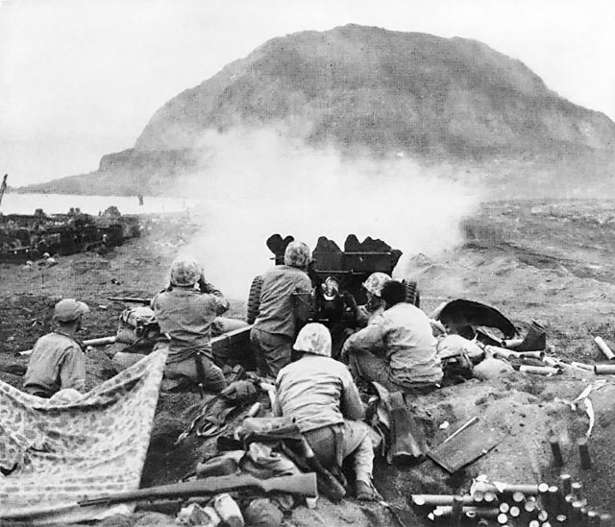
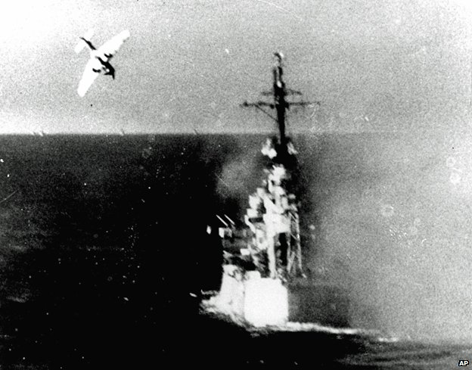
Please provide ATLEAST 3 pictures/ Graphics to go along with the information that you are presenting.

Be sure to include information on the following
- The Battle of Midway & its impact
- The meaning of the American Strategy Island Hopping
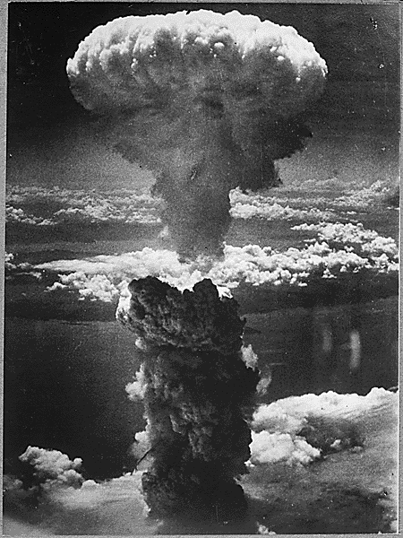
- What was the fighting like on the islands?
- The capture Iwo Jima and Okinawa
- Details about the Battles of Iwo Jima and Okinawa
- Kamikaze pilots
- Death of Roosevelt
- The Manhattan Project and the Atomic bomb
- Effects of the Atomic bomb on Hiroshima
- Effects of the Atomic bomb on Nagasaki
- V-J Day and the surrender of Japan

