Section 1 - Introduction

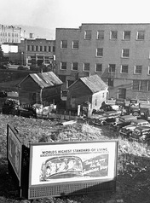

In April 1933, classrooms in Chicago, Illinois, were about to shut down. Teachers had received little or no pay for months because schools had run out of money. So had just about everybody, it seemed. Many children came to school hungry, so teachers found bread to give them. Some pupils could not afford shoes to protect their feet in the freezing weather, so teachers somehow came up with shoes.

Thousands of outraged teachers charged into city hall, demanding to be paid. Outside, students and parents marched with signs supporting the teachers. Protesters poured into banks, demanding that the banks lend the city enough money to pay teachers. In a few minutes, police arrived. Soon, one newspaper reported, “unpaid policemen were cracking their clubs against the heads of unpaid schoolteachers.”
The scene in Chicago reflected the hard times that had overtaken the entire country. Governments could not pay their employees, and many companies could not pay their workers. Everywhere, people were losing their farms and homes. The country was in the grip of a deep depression—a severe and long-term economic downturn.
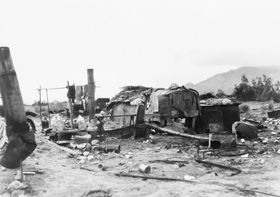
The depression was even more shocking because the 1920s had been a prosperous time for many Americans. World War I had brought a lot of new business to American industries. After the war, the good times continued as factories shifted from wartime production to consumer goods.
Yet by 1932, many businesses had failed. One in four workers did not have a job. One teacher recalled of the depression, “I thought it was going to be forever and ever. That people would always live in fear of losing their jobs.” The nation’s fortunes had changed drastically, and for many families in the early 1930s, the future looked bleak.

Section 2 - The Roaring Twenties
During the 1920s, a glance down Main Street in most American towns revealed a sight that was new in the United States: cars. For the first time, many Americans could afford to buy an automobile. Cars moved faster than the horse-drawn buggies they replaced. In fact, just about everything was moving faster, from assembly lines to music and dancing. Values were changing rapidly, too. Many people were eager for a little fun, and “modern women” stepped out of their traditional roles. This exciting decade became known as the Roaring Twenties.
Modern Life Begins When World War I ended, Americans looked forward to better times ahead. Factories, no longer turning out supplies for war, responded by producing consumer goods that made life easier and more comfortable. Electricity was now supplied to many towns, making electric appliances both practical and desirable. Americans quickly shifted from iceboxes to refrigerators and from carpet sweepers to electric vacuum cleaners.
Americans bought these laborsaving devices, and much more, at stores where they could shop in person or order items through the mail. Department stores like Sears, Roebuck and Company sold a wide variety of goods to eager buyers.
Department stores were not a new invention of the 1920s. They got their start in the late 1800s. Sears, for example, started in 1886 in Minnesota. It sold one item by mail—watches. Richard Sears moved the business to Chicago in 1887. By 1893, the company was known as Sears, Roebuck and Company. Sears sold goods through catalogs that were mailed to farmers and people living in rural areas. Because of its low prices and wide variety, Sears’s mail-order business thrived.
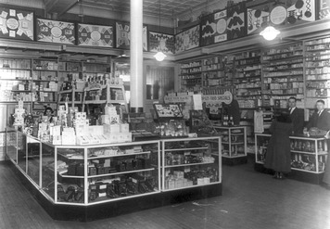

By the 1920s, things had changed. Many people were moving to urban areas. In 1925, Sears opened its first department store where people could come to shop. By 1928, Sears had 192 stores and contin¬ued to open more.
Automobiles also changed American life. People who owned cars could travel farther to work. Cars ended the isolation of farmers and made travel to far-away places enjoyable.
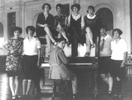
Many members of the rapidly-growing middle class bought automobiles in the 1920s. The middle class especially benefited from the increased availability of consumer goods. Middle class men often worked as doctors, lawyers, small business owners, and mid-level company managers.
Modern Women With housework becoming easier and families on the average becoming smaller, more women than ever went to work outside of the home. By the end of the decade, women made up almost a quarter of the workforce. Women also gained political power. In 1920, the passage of the Nineteenth Amendment guaranteed women’s right to vote in national and state elections.
Women’s new sense of freedom was reflected in changes in fashion. Young women who called themselves flappers cut their hair short and wore makeup. They traded their mothers’ long, heavy skirts for short, thin dresses that barely reached their knees. These “modern women” wanted to have as much fun as men—smoking, drinking, and riding in automobiles.
Despite these changes, however, women still lacked the same opportunities as men. Women who did work outside the home were usually limited to low-paying jobs that were considered “women’s work,” such as teaching school or working as domestic servants. Although a few women won political positions in the 1920s, women were only rarely elected to public office.
Prosperous Times For many Americans, these changes took place at a time of growing prosperity. By the middle of the decade, the country had the highest standard of living the world had ever known.
Living standards were rising because manufacturing was becom¬ing more efficient. In 1914, for example, Henry Ford introduced a moving assembly line into his car factories. This revolutionary new method drastically cut the time needed to assemble cars. Such changes increased workers’ productivity, or the amount of goods they could produce at a given cost. As a result, companies could sell their products at lower prices while raising workers’ wages—and still make more money.
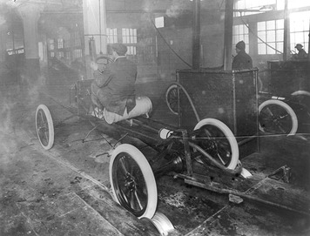
Each new industry sparked others. The rise of the automobile industry, for instance, increased the demand for steel for car bodies, rubber for tires, and oil refineries to make gasoline. People worked to build new roads and highways. As highways spread across the country, new businesses developed beside them. Gas stations, diners, motels, and campgrounds sprang up to serve the needs of travelers.
To encourage consumers to buy goods, stores started offering credit. Credit made it possible for consumers to buy what they wanted, even when they lacked enough cash. Credit is an arrangement for buying something now with borrowed money and then paying off the loan over time. In the past, most Americans had thought it shameful to borrow money to buy consumer goods. Thrifty people saved the money they needed and paid cash. By the 1920s, however, such thrift began to seem old-fashioned.
The growth of installment buying made it possible for Americans to buy goods on credit. In installment buying, a buyer makes a down payment on the product. The seller loans the remainder of the purchase price to the buyer. The buyer then pays back the loan in monthly installments. If the buyer stops making payments before the loan is repaid, the seller can reclaim the product.
By 1929, three of every four cars were bought on credit. So were half of all major appliances such as washing machines and radios. Buying on credit was so easy that many Americans begin to think the prosperous times would go on forever.
The Stock Market Booms Companies raise money by selling stock, or shares in the ownership of the company. When many people want to invest in a company, the price of its shares goes up. When few people want to buy, the price goes down. Such price shifts make investing risky because people can’t be sure what the value of their stocks will be in the future.
During the 1920s, Americans were very optimistic about business, and those with money to spare invested heavily in the stock market. One millionaire remarked, “Taxi drivers told you what to buy. The shoeshine boy could give you a summary of the day’s financial news.” As President Calvin Coolidge said, “The chief business of America is business.”
As stock prices soared, eager investors began using “margin buying” to purchase stocks. This meant that buyers paid just part of the price of the stock and borrowed the rest through their stockbrokers. The stockbrokers, in turn, often borrowed money from banks. Everybody involved was betting that stock prices would go up. Later, investors hoped to sell their stock at a higher price, which would give them the cash to repay the borrowed money and still make a profit. But if stock prices fell, investors could be stuck with huge debts.
As the stock market boomed, few worried about prices going down. In just three weeks in 1928, shares of Radio Corporation of America (RCA) rose from $95 to $178. Shares of General Electric tripled in value in 18 months. Happy investors imagined that stock prices would continue going up indefinitely.
The Great Migration Economic opportunities were improving life for many African Americans in the 1920s. World War I had a major impact on African Americans. When the United States entered the war in 1917, American industries met the demand for military supplies. Factories made weapons and equipment that U.S. soldiers carried into war. As production of war materials rose, new jobs opened up in the North. Steel and auto industries needed more workers. Mining and meatpacking industries needed workers, as well. At the same time, immigration from Europe had slowed, contributing to a growing labor shortage. Many southern blacks headed north to take advantage of job opportunities.
Between 1910 and 1930, about 2 million African Americans left the South to settle in industrial cities in the Northeast, Midwest, and West. This movement of African Americans is known as the Great Migration. New York, Chicago, Detroit, and other northern cities gained a high number of black residents.
Southern whites also took advantage of new opportunities in the North. During the time of the Great Migration, around 2 million white southerners moved north in search of better paying jobs.
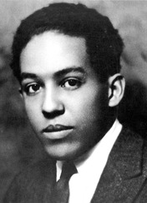
The Harlem Renaissance During the 1920s, many black Americans who migrated to New York City settled in the neighborhood of Harlem. This neighborhood became the center of the Harlem Renaissance. The word renaissance means “rebirth.” It usually is used to describe a literary or artistic movement. The Harlem Renaissance was the outpouring of creativity among African American writers, artists, and musi¬cians who gathered in Harlem during the 1920s.
Many African American writers who were part of this movement explored what it meant to be black in the United States. Langston Hughes wrote poetry, plays, and stories. His work captured African Americans’ hope and longing for equality. James Weldon Johnson was another important writer. His best-known book is The Autobiography of an Ex-Colored Man. It told the story of an African American who tried to escape racial discrimination. Johnson also wrote the lyrics to “Lift Every Voice and Sing.” It became the anthem for the National Association of the Advancement of Colored People (NAACP).
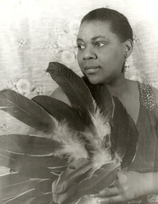
The Jazz Age With their pockets full of money, many Americans enjoyed life as never before. They went to clubs to dance and to listen to jazz, a new musical style. Young people loved this fresh style of music. Jazz became so popular in the 1920s that this decade is often called the Jazz Age.
Jazz is a uniquely American form of music. It grew from a combination of musical styles from Africa, Europe, and the United States. At the beginning of the 20th century, musicians mixed these styles into blues and ragtime music. Jazz musicians combined the beat of ragtime with the deep feelings of the blues. They also added improvisation. They made up and performed their own music rather than just playing the notes on printed music sheets.
Jazz developed in New Orleans, Louisiana, and moved north during the Great Migration. Harlem became a magnet for jazz. Famous musicians such as trumpet player and singer Louis Armstrong, jazz and blues singer Bessie Smith, and pianist and bandleader Duke Ellington per-formed there.
A Ban Against Alcohol For many Americans, part of the attraction of going to nightclubs was the opportunity to drink illegal alcohol. In 1919, anti-alcohol reformers had succeeded in passing the Eighteenth Amendment, which prohibited, or outlawed, the making, selling, and transporting of alcoholic beverages. This attempt to eliminate alcohol consumption was called prohibition.
Widespread support for prohibition was rooted in the temperance movement of the late 1890s. Some temperance reformers supported moderation in drinking alcohol. Around the turn of the 20th century, a growing number wanted to ban alcohol altogether. Their efforts resulted in the amendment that made prohibition the law of the land.
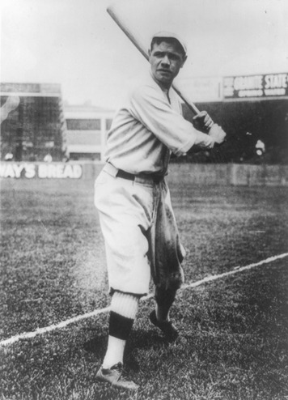
In response to prohibition, bars and liquor stores closed. At the same time, thousands of illegal clubs called speakeasies sprang up to sell illegal alcohol. In many large cities, police often looked the other way as people went on buying and drinking alcohol. Making and selling alcohol became big business for people operating outside the law.
Popular Culture in the 1920s Jazz, radio, and even prohibition were all part of America’s popular culture. Popular culture is the culture of ordinary people. It includes music, art, literature, sports, and entertainment. Mass media helps shape popular culture. In the 1920s, mass media included newspapers, magazines, radio, and motion pictures.
Newspapers and magazines had long been sources of information for Americans. During the 1920s, the amount and type of printed material grew dramatically. By 1929, Americans were buying more than 200 million copies a year of national magazines. The popularity of print media meant that more and more people read the same news and learned about the same events. A popular culture common to all regions of the country began to take shape.
Novelists also contributed to the print culture of the 1920s. In this period, American writers developed themes and styles that helped define modern literature. F. Scott Fitzgerald was the leading writer of the age. His novel The Great Gatsby criticized upper-class American life. Ernest Hemingway, another important American author, used a simple, direct style in his novels that influenced many later writers. The writers William Faulkner and Sinclair Lewis also made important contributions to American literature in the 1920s.
In addition to the popularity of print media, radio became very influential in the 1920s. Radio could reach very large audiences. Radio stations broadcast national news, such as elections. Many stations reported on sports events as they happened. Stations began to produce weekly programs of music, comedies, and dramas.
Movies became a big business in the 1920s and shaped popular culture on the “big screen.” At the beginning of the 1920s, movies were silent. The discovery of how to add sound to movies transformed the industry. In 1927, The Jazz Singer became the first feature-length motion picture with sound. It was an immediate success. The growth of the motion-picture industry turned actors into national celebrities. Americans all over the country recognized the faces made famous by movies.
By the 1920s, working eight hours a day and five days a week had become the rule in many industries. Many working Americans had more free time to spend on leisure activities. Going to the movies was a popular pastime. So was watching sports. In the 1920s, thou¬sands of people crowded into stadiums to watch professional baseball teams and college football teams. Boxing and wrestling matches also attracted crowds. Athletes, like movie stars, became national celebrities. The most famous sports celebrity of the 1920s was baseball player Babe Ruth. In 1927, Ruth became famous for hitting 60 home runs, a record that remained unbroken for 34 years.

Section 3 - The Dark Side of the 1920s

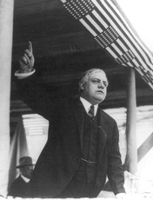
The Roaring Twenties wasn’t a period of good times for everyone. The decade also had a dark side. Many Americans were left out of the new prosperity, including many farmers, immigrants, and African Americans. In addition, some Americans became victims of intolerance.
The 1920s was also a time when cultural issues divided American society. Many people, especially those in rural areas, were traditionalists. They had deep respect for long-held cultural and religious values. Many other people, particularly those in urban areas, were modernists. They favored new ideas, styles, and social trends.
The Sacco and Vanzetti Case The Sacco and Vanzetti case was one example of the dark side of the 1920s. In 1921, Nicola Sacco and Bartolomeo Vanzetti had been found guilty of committing a double murder and robbery and were condemned to die. Sacco and Vanzetti were Italian immigrants in a time of great prejudice against foreigners. The case became very controversial. Many argued that there was no clear evidence tying Sacco and Vanzetti to the murders, and suspected they were being tried because they were immigrants who had radical political beliefs. In 1927, the two men were executed.
Decades after their executions, doubts remained about their guilt. Modern analysis of the evidence has confirmed that the gun found on Sacco at the time of his arrest was one of the murder weapons. This suggests that Sacco was guilty of the crime. But no one has found proof to link Vanzetti to the murders.
The Red Scare Sacco and Vanzetti supported radicalism—a point of view favoring extreme change in social or economic structures, sometimes through violent revolution. At the end of World War I, American radical groups were not very large or effective. Still, many Americans viewed them with suspicion and alarm, particularly after the success of the Communist revolution in Russia. This postwar fear of radicals became known as the Red Scare. Red was slang for communist. In 1919 and 1920, federal officials launched a campaign against people they suspected of plotting to overthrow the government. With little or no cause, they arrested 6,000 suspected radicals.
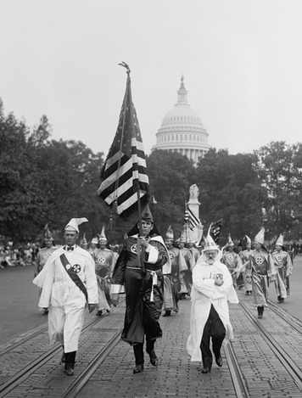
Most of the people arrested during the Red Scare were released without being accused of a crime. Nevertheless, the Red Scare trampled civil liberties, or basic rights guaranteed to individual citizens by law. Some alleged radicals were deported without a trial. Yet for some Americans, the fear of radicalism overshadowed concerns about abuses of civil liberties. Some 30 states passed laws that made stirring up opposition to the government a crime.

Revival of the Ku Klux Klan Anti-immigrant feelings played a role in the revival of the Ku Klux Klan in 1915. The revived Klan used both political power and mob violence to lash out against African Americans, immigrants, Catholics, Jews, and anyone else it regarded as “un-American.”
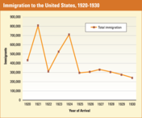
In the early 1920s, the Klan swelled to between 3 and 4 million members. Lawmakers supported by the Klan won control of state legislatures in Oregon, Oklahoma, Texas, and Indiana. To demonstrate their power, Klan members held massive marches in Washington, D.C., and other major cities. Yet the Klan’s violence remained secretive. They often struck at night, wearing hoods that concealed their faces and using whippings, kidnappings, cross burnings, arson, and murder to terrorize entire communities. Although its power had faded by 1930, during the 1920s the Klan spread terror through many communities, especially in the South.
Limits on Immigration Other Americans supported less violent forms of intolerance. During the 1920s, Congress limited immigration to the United States. The Immigration Act of 1924 reduced the number of immigrants allowed into the country. The law also reduced immigration from southern and eastern Europe. Another provision of the new law banned all immigration from Asia.
By the end of the 1920s, immigration had shrunk to a little over one quarter of what it had been in 1921. But even that was not enough of a reduction for many immigration opponents. In 1929, they persuaded Congress to further lower the number of immigrants allowed each year. In 1931, only 97,000 immigrants arrived in the United States—fewer than one eighth as many as in 1921.
Discrimination Against Asians and African Americans Asians and African Americans endured legal, social, and economic forms of discrimination in the 1920s. Asians were barred from becoming citizens and, in several states, from owning land. Many states also banned marriages between whites and Asians. African Americans faced continuing discrimination as well. At the end of World War I, returning black soldiers had problems finding jobs. In the South, some black soldiers were attacked and even killed by white mobs.
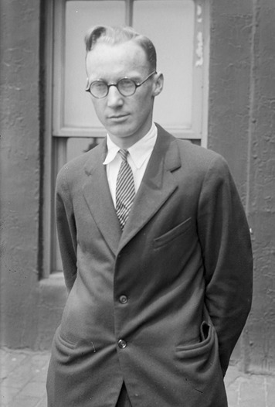
The Scopes Trial While the 1920s was a decade of change, not everyone had the same views or felt the same way about the changes taking place. American society in the 1920s was deeply divided between traditionalists and modernists. Defenders of traditional morality complained about the behavior of the “flaming youth” and the flapper. Old-time religion faced off against modern science. The result was a kind of “culture war.”
Traditionalists and modernists clashed over the issue of evolution in a famous court case that fascinated the nation in 1925. It is known as the Scopes Trial. The case began when a teacher named John Scopes was arrested for teaching his class a lesson on evolution. A Tennessee state law passed in 1925 made it illegal to for a public school to teach any theory other than “the story of the Divine Creation of man as taught in the Bible.”
The Scopes Trial turned into a dramatic contest between traditionalists and modernists. On one side were Christian fundamentalists who believed the Bible was the literal word of God and that God created the universe as described in the Bible. On the other side were modernists who believed in the concept of evolution as developed by British naturalist Charles Darwin. The entire country followed the trial. The jury found Scopes guilty, and he paid a fine of $100. The trial was about much more, however, than Scopes breaking the law. It started a debate over teaching evolution in public schools that continues today.

Section 4 - The Great Depression
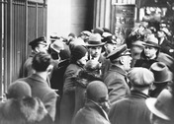
In September 1929, investors celebrated as stock prices hit an all-time high. But suddenly, the bubble burst. Stock prices began to tumble. The stage was set for disaster.
The Stock Market Crash On Thursday, October 24, the opening bell sounded at the New York Stock Exchange in New York City. Almost at once, stockbrokers were trying to sell tens of thousands of shares. No one was buying. Prices began falling faster and faster.
Investors panicked. Their money was locked up in stocks that were suddenly worth less and less. When brokers demanded cash from investors who had bought stocks “on margin,” many investors sold still more stocks to raise the money. With more sellers than buyers in the market, prices went even lower. People’s “paper wealth” was disappearing.
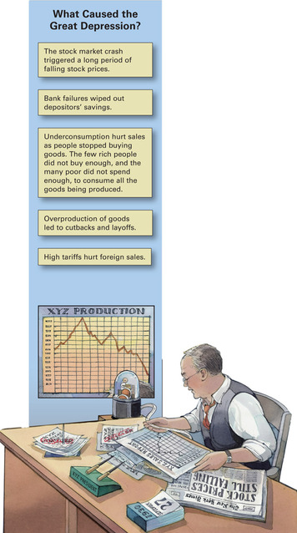
Brokers screamed out their orders to sell shares. They pushed each other out of the way, losing glasses and shoes in the chaos. One newspaper journalist wrote, “I heard it—and I can still hear it . . . the sound of running feet, the sound of fear.”
Over the next few days, sellers continued to outnumber buyers. The following Tuesday, investors filled the streets around the Stock Exchange. Grim, curious, and noisy, they waited. The opening bell sounded. Within minutes, as people tried to dump their stocks, stock prices fell more and more steeply. Before the day was over, people had stopped buying stocks, making them worthless. The market had collapsed. The terrifying day became known as Black Tuesday. It was, said the New York Times, “the most disastrous day in the stock market’s history.”
The Depression Begins The crash of the stock market was a dramatic sign that America’s good times had come to a sudden end. By the time the stock market stabilized a bit in November, businesses and investors had lost more than $30 billion, an amount that surpassed the total cost of the United States’ participation in World War I. Newspapers told of ruined investors leaping to their deaths off skyscraper ledges. In Kansas City, a man with big stock losses called out, “Tell the boys I can’t pay them what I owe them,” and shot himself.
The stock market crash affected millions of Americans, some right away, some over the years to come. Many banks had invested heavily in the stock market, or loaned money on margin. After the crash, they didn’t have enough money to pay depositors—people who kept their money in the bank. They went bankrupt, or closed down without paying off debts. Depositors lost their life savings.
Even healthy banks suffered as panicky depositors withdrew their money. When banks ran out of cash, they closed their doors. In 1930, more than 1,000 banks went out of business.
Businesses lost their deposits when banks closed. Others found banks no longer willing or able to make loans. Without funds to help them through rough times, thousands of businesses failed.
Banks that served farmers had special problems. These banks had been in trouble beginning in the 1920s. As prices for farm products like cotton and wheat fell, farmers with debts could not repay their loans.
The stock market crash and the problems of farmers were two of the many reasons the economy sank into a depression. Another problem was that millions of families had been left out of the prosperity of the 1920s. They didn’t have the money to buy the products that factories were turning out. Still another problem was that banks had loaned huge sums of money to foreign nations that could not afford to repay those debts. These and other factors combined to plunge the economy into depression. The economic downturn was so deep and lasted so long that people called it the “Great Depression.”
Losing Jobs and Homes By 1933, about 85,000 businesses had failed. Many more were barely surviving. Businesses that did stay open needed fewer employees. At Ford Motor Company, employment dropped from 128,000 to 37,000, while “hundreds of half-finished automobile bodies gathered dust.”
Even people with jobs were earning less. Secretaries who once received $40 per week settled for $10. Many cities couldn’t afford to pay their employees. As fewer people were able to afford consumer goods, factories fired their workers. By 1933, more than 12 million Americans had lost their jobs.
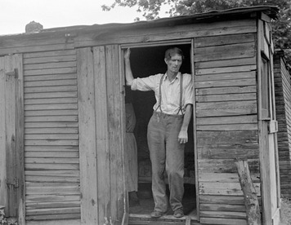
When workers couldn’t find jobs, they spent their savings and then sold what they owned. Finally, they had no way to pay their bills. By the beginning of 1933, almost 1,000 families per day were losing their homes. For the first time, homelessness became a major problem in America.
“All of a sudden we had to move,” remembered one child. “My father lost his job and we moved into a double garage.” Homeless families often built shacks out of scraps of wood, tin, and tar paper. Little “towns” of such shelters grew up around cities and were called “Hoovervilles,” after President Hoover. As the economy collapsed further, some people simply slept under newspapers on the streets.
Unable even to buy groceries, families scrounged for food in garbage cans and alleys. One boy said, “Every now and then my brother or Dad would find some sort of odd little something. Then . . . we’d go wild over food. We’d eat until we were sick.”
Under such stresses, families started breaking up. Jobless young people sometimes hopped onto freight trains to other cities and begged for food. Some families placed their children in orphanages—homes for children without parents—to keep them from starving.
President Hoover Tries to Respond Americans had suffered through depressions before. But the downturns of the past had usually been shorter and had never been as severe as the Great Depression. By the end of 1930, it was clear to President Hoover that this depression was not going to cure itself.
To deal with failing banks, Hoover first tried to encourage banks to cooperate with each other. He prodded the owners of healthy banks to loan money to banks that were suffering. When this cooperative venture did not work, Hoover changed his policy. In 1932, he supported the creation of a government agency to save failing banks and businesses. That agency, called the Reconstruction Finance Corporation (RFC), issued government loans to banks, railroads, and other big businesses.
Hoover hoped RFC loans would stimulate economic growth. Once companies began hiring again, he believed, prosperity would trickle down through the economy to those most in need. To his credit, the number of bank failures declined greatly that year. Still, conservatives criticized Hoover for putting the government in the business of saving banks. At the same time, liberals criticized Hoover’s approach to helping the needy. Poor people, they argued, could not wait for money to seep down to them from expanding businesses. They needed direct relief right away.
With a presidential election coming in the fall, Hoover knew he had to do more. In July 1932, he supported a bill authorizing the RFC to loan money to states that no longer had enough resources to help the needy. The bill also allowed the RFC to finance a variety of public works projects.
When Hoover’s efforts to end the depression failed, Americans began looking for a new leader. They wanted a president who was willing to do whatever it took to turn the country around.

Section 5 - The New Deal

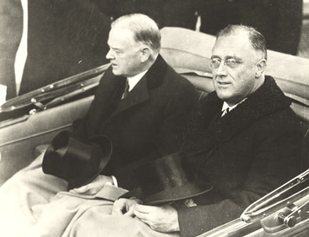
As the 1932 election drew near, the Republicans nominated Herbert Hoover to run for a second term. The Democrats chose the governor of New York, Franklin Delano Roosevelt, as their candidate.
To many, Hoover seemed cold and helpless in the face of the country’s misery. Even though Roosevelt came from a wealthy family, he seemed to care about ordinary citizens. His beaming smile radiated confidence and optimism.
In accepting his party’s nomination, Roosevelt pledged “a new deal for the American people.” Just what he meant wasn’t clear, but people liked his warmth and energy. Roosevelt related the country’s hardships to his own experiences when he became paralyzed by polio at the age of 39. “Once I spent two years lying in bed,” he said, “trying to move my big toe. That was the hardest job I ever had to do. After that, anything else was easy.” Roosevelt won the election by a landslide.
The First Hundred Days “This nation asks for action, and action now,” Roosevelt boldly proclaimed at his inauguration. “The only thing we have to fear is fear itself.”
Roosevelt began his energetic presidency by targeting the bank crisis. More than 9,000 banks had already failed, and panicked depositors were withdrawing their money from those that still survived. Roosevelt quickly closed all banks for four days. He promised that government officials would inspect bank records, allowing only banks with sufficient funds to open again.
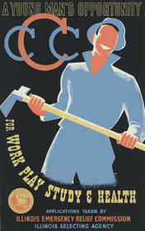
To help Americans understand this drastic step, Roosevelt addressed the nation by radio. More than 60 million Americans listened as their president spoke to them in ordinary words, as if sitting with them around a living room fireplace. “I can assure you that it is safer to keep your money in a reopened bank than under a mattress,” he said.
When banks reopened, more people put money in than took money out. Pleased, Roosevelt continued to use “fireside chats” to explain his programs to the public.
During Roosevelt’s first hundred days in office, he pushed Congress to deal quickly with the nation’s problems. In that short time, Congress passed 15 major bills, a record for that number of days. This legislation, along with laws passed later on, established programs with three goals: immediate relief for the needy, economic recovery, and reform intended to keep such problems from developing in the future. Together these programs became known as the New Deal.
Relief for the Needy Several New Deal measures were designed to help the 13 million Americans who were unemployed. The Federal Emergency Relief Act (FERA), for example, gave money to states to help them provide food and assistance to people in need. Some business leaders objected to this use of government money, saying that in the long run it would be better to help businesses provide more jobs. A member of Roosevelt’s staff responded, “People don’t eat in the long run. They have to eat every day.”
Other New Deal relief programs paid for useful public works, such as building bridges, lighthouses, schools, and sewer systems, providing jobs for thousands. One observer said of the workers in such programs, “For many, many of them it was the first money they’d seen in months. They took it with wide grins and made beelines for the grocery stores.”
The Civilian Conservation Corps (CCC) paid young men of all backgrounds to work on environmental improvement projects like replanting forests, draining swamps, and fighting fires. “I really enjoyed it,” said one man. “I had three wonderful square meals a day . . . You learned that everybody here was equal.”
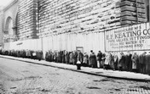
One of the bigger relief programs, the Works Progress Administration (WPA), created more than 8 million jobs. WPA employees built 120,000 public buildings and half a million miles of roads. WPA artists painted murals on public buildings that can still be seen today. As FDR remarked, such jobs preserved “not only the bodies of the unemployed . . . but also their self-respect, their self-reliance, and courage and determination.”
To feed the hungry, soup kitchens sprang up across the country. Soup kitchens were started around 1929 by private charities and churches. The federal and state governments joined the effort in the mid-1930s. Soup was easy to prepare and could be increased in order to feed more people by adding water. Breadlines—long lines of people waiting for their bowl of soup and piece of bread—became a common sight in most cities. For many, that soup kitchen meal was the only food they would eat all day. At one point, New York City had 82 soup kitchens, which provided the needy with 85,000 meals a day.
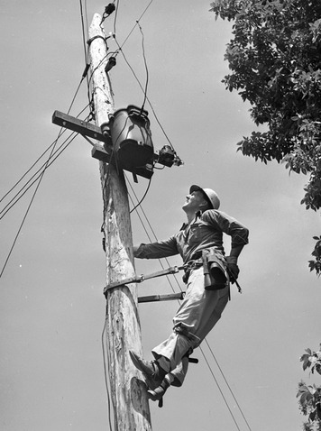
One of the most lasting parts of the New Deal was the Social Security Act, which was passed by Congress in 1935. To help older people in need, this law provided a small amount of money each month to elderly people who were extremely poor. To help the elderly of the future, the law established a national pension for most retired workers, to be paid for by taxes on workers and employers. Dependent children and handicapped persons could also get aid. In addition, states received funds to aid people who were temporarily unemployed.
Economic Recovery Roosevelt and his supporters believed that ending the Great Depression required more than just government spending. The New Deal had to make America’s economy strong again, so that businesses and farms could succeed on their own.
Early in the New Deal, Congress established the National Recovery Administration (NRA). To spur increased production, the agency let competing companies work together to set prices, maximum working hours, and minimum wages. The NRA also guaranteed workers the right to join unions and to bargain for contracts. One major project, the Tennessee Valley Authority (TVA), was headed by the government rather than by private business. This ambitious program was created to supply electric power at reasonable rates and, at the same time, to show that even the poorest regions of America could recover from the depression. All along the Tennessee River, the federal government built dams and waterways, eliminating disastrous flooding and harnessing waterpower to produce electricity. As electricity was brought to the valley for the first time, industry was encouraged to move in. The TVA also encouraged farmers to adopt better farming techniques. While much of the region remained poor, the TVA did improve the lives of thousands of people.
Agricultural Recovery Other recovery efforts focused on agriculture, which still employed one in five Americans. In the early years of the depression, farmers produced more food than people could buy. As a result, farm prices fell to the point that farmers could not turn a profit when they harvested their crops and brought their livestock to market. With no money coming in, many farmers couldn’t earn enough to pay their debts and feed their families. One third of them lost their farms.
In response to this problem, Congress created the Agricultural Adjustment Administration (AAA) in 1933. This agency paid farmers to plant less land and raise fewer animals. Many Americans resented paying farmers to grow less food while people were hungry. But within a year, farm prices did start to rise. Later, the government bought excess food instead, storing it to sell when prices got higher.
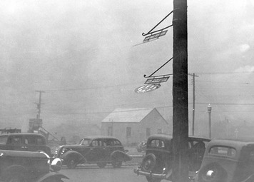
New Dealers also sought solutions to the serious problem of soil erosion. During the 1930s, a combination of poor farming practices and years of low rainfall on the Great Plains created a new terror—howling dust storms. During these “black blizzards,” sand and dust covered everything and even made breathing difficult. One observer wrote, “There were no fields, only sand drifting into mounds. . . . In the farmyard, fences, machinery, and trees were gone, buried.”

By 1938, some 100 million acres in the “Dust Bowl” had lost five or more inches of topsoil. With their farms destroyed, nearly 3.5 million people left the Great Plains. Some moved to nearby states. Others pushed west, seeking better futures in California and the Pacific Northwest. A large number of the migrating farm population was from Oklahoma. The term “Okie” soon became a common name for anyone migrating from Oklahoma, Arkansas, Missouri, or Texas.
To save the country’s farms, Roosevelt established the Soil Conservation Service (SCS). This agency planted belts of trees to break up the winds and hold down soil. One such belt, 100 miles wide, stretched from Texas to North Dakota. SCS also taught farmers how to avoid erosion and keep the soil in place for future generations.
Banking Reform Relief and recovery were intended to help the nation escape from the depths of the depression. But New Dealers also wanted reforms that would prevent such a depression from happening again.
A major target of reform was the banking industry. Congress quickly passed the Banking Act of 1933, Roosevelt’s plan to protect America from banking problems. This law created the Federal Deposit Insurance Corporation (FDIC), which guaranteed individual bank deposits up to $2,500. This guarantee helped restore public confidence in banks and stabilize the banking system. The law also limited the freedom of banks to trade in stocks and bonds, which made bankers avoid investments that were too risky. Before the stock market crash, some banks had used depositors’ savings for risky, speculative investments. Together with Roosevelt’s bank inspections, these actions helped calm people’s fears about the banking industry.
Speculation in stocks had helped cause the 1929 crash. Part of the problem was ignorance. Many investors lacked reliable information about investments. Together, President Roosevelt and Congress set out to reform the stock market. A key step was the creation of the Securities and Exchange Commission (SEC) in 1934. The SEC required companies to publish the important facts about their business. It also regulated the activities of stockbrokers and others in the investment business.

Section 6 - The Impact of the New Deal
In 1936, Roosevelt ran for a second term as president. Despite the fact that the Great Depression still continued, the economy had improved and he was reelected by an even larger majority than in 1932.
By this time, most of Roosevelt’s recovery and relief programs were in place. In addition, the New Deal was being attacked both by people who thought the government should do even more, and by those who wanted the government to do—and spend—less.
The Supreme Court also attacked the New Deal by declaring some of its programs unconstitutional. In response, Roosevelt introduced a “court-packing” bill into Congress in 1937. If it had passed, Roosevelt would have been allowed to appoint more justices to the court—justices that supported the New Deal. However, the court-packing plan backfired, and was opposed by both Democrats and Republicans. This failure decreased Roosevelt’s political prestige, and led to the breakup of the political coalition that had supported New Deal legislation.
Still, the New Deal had a significant impact on the United States. In the short run, Roosevelt’s programs helped many Americans survive the darkest days of the Great Depression. In the long run, the New Deal left a lasting mark on American society and government.
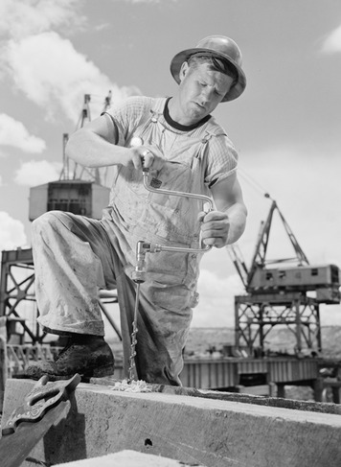
Impact on the Poor and Unemployed All over the country, New Deal construction projects put the unemployed to work. As a result, America had better roads, bridges, dams, schools, and other public buildings. These projects not only put money in people’s pockets, but also raised their spirits. As one Tennessee worker said, “I’m proud that I worked on that Crossville dam. I wasn’t afraid to tackle anything after that.”
The New Deal also introduced “safety nets” for many of the nation’s needy people. Social Security and unemployment insurance still exist today, providing a major source of income for retired and unemployed workers. In later years, other welfare, training, and assistance programs were established as Americans began to accept the idea that government had a responsibility to aid those in need.
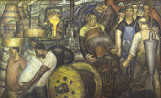
Although the New Deal did help reduce poverty in America, poverty was not eliminated, and remained a problem. In addition, the New Deal made little effort to solve problems of discrimination against African Americans and other minorities.
Impact on Workers and Businesses Legal problems slowed some efforts to assist workers and businesses. The Supreme Court declared the National Recovery Administration (NRA) unconstitutional, saying that the NRA had been given powers that were reserved only for Congress.
In response, Congress passed the National Labor Relations Act in 1935. This act gave workers the right to join unions and to bargain with employers for improved wages and working conditions. It also created the National Labor Relations Board (NLRB) to settle disputes between employers and workers. Supported by this legislation, union membership grew rapidly. The NLRB still exists today.
Another lasting effect of the New Deal was that the government became more involved in regulating the stock market and the banking industry. The Federal Deposit Insurance Corporation (FDIC) still protects bank depositors by insuring bank accounts. Laws limit margin buying, and other rules forbid banks from taking risks in the stock market with depositors’ funds.
Impact on Farmers and Rural Americans By raising crop prices and providing farmers with low-interest loans, New Deal programs helped farmers keep their farms. But not every New Deal farm program was a complete success. When the government paid farmers to plant less, they didn’t need as much hired help. As a result, many farmworkers lost their jobs. Some farmers also cut production by turning sharecroppers off their rented land.
Another New Deal agency, the Rural Electrification Administration (REA), helped improve life on the farm. The REA made loans to help bring electricity to rural areas. When this program was begun in 1935, only one farm in ten had electricity. Within 20 years, nine out of ten farms were electrified.
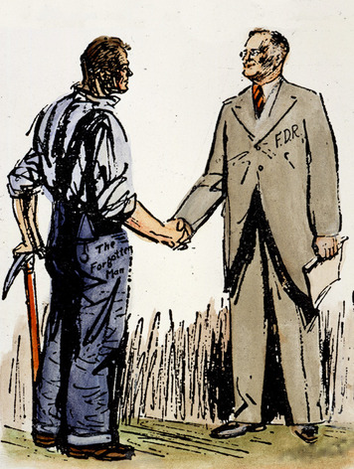
Impact on Government By 1939, most New Deal programs had come to an end. But Roosevelt’s ambitious response to the Great Depression had permanently changed both the size and the role of the national government. In 1931, the federal government had 580,000 employees. By 1941, 1.3 million people were government employees.
Before the Great Depression, most Americans probably agreed with Thomas Jefferson that the best government was that which governs least. Roosevelt disagreed. He strongly believed that one of government’s most important duties was to care for citizens who could not provide for themselves. “That responsibility,” he declared, “is recognized by every civilized nation.”
In the coming years, Americans would continue to debate how far the government should go in meeting this responsibility, and how it should go about it. But by the end of the 1930s, most Americans were prepared to accept that government did have a responsibility to lend a helping hand to those in need.
As the 1940s began, the depression still lingered. It would finally be brought to an end by a new and even greater crisis. America was about to go to war.

