Hitler’s Early Years- Hitler was born in Austria 1889. When World War One broke out Hitler enlisted in the German army, and he emerged from the war an extreme nationalist. He believed that Germany had been sold out by the Weimar Republic when it signed the Treaty of Versailles. Hitler settled in Munich, where his skill in public speaking made him popular among extreme nationalists.
Summary of Hitler’s Early Years___________________________________________________________________________________________________________________________________________________________
Hitler and the Nazi Party -Hitler became involved with the National Social German Workers’ Party (The Nazi Party) in 1921, at which time it was only a small force in German politics. In wildly emotional speeches, Hitler attacked the Weimar Republic and denounced the Treaty of Versailles. In 1923 he led an uprising in Munich that was quickly crushed by the army. For that action, Hitler was put in prison for a year. While in prison, he wrote Mein Kampf (“My Struggle”), a book in which he detailed his political ideas for Germany. Hitler claimed the German people belonged to a superior “Aryan” race that was destined to control inferior races and rule the world. Hitler considered Jews an inferior race and blamed them for Germany’s economic troubles and Germany’s defeat in World War I. He also attacked the Soviet Union, which he considered as an obstacle to German Expansion.
Summary of Hitler and the Nazi Party__________________________________________________________________________________________________________________________________________________________________________________________________________________________________________________________________________________________________________________________________________________________________________
Hitler Becomes Dictator-After his release from prison, Hitler worked hard to rebuild the Nazi Party. He promised benefits to peasants, workers, and the middle class and the membership of the party grew dramatically. Between 1928 and 1932 the Nazis were voted into more and more seating in the German legislature. The German president, Paul von Hindenburg, asked Hitler to become chancellor. Swiftly, Hitler formed a coalition government and increased his power. Hitler called for elections, hoping to increase Nazi strength in the Reichstag. The S.S. or storm troopers, staged the burning of part of the Reichstag building, and Hitler used the event as a pretest for suspending all constitutional rights. On August 2, 1934, President Hindenburg died and Hitler combined the offices of chancellor and president and declared himself Fuhrer (Leader). The Next day he had all members of the army take an oath to obey him. He took control of all aspects of the government, outlawed his organized political opposition and controlled the German Media. Within just one year of gaining control of Germany, Hitler had established a fascist state.
Summary of Hitler Becomes Dictator_________________________________________________________________________________________________________________________________________________________________________________________________________________________________________________________________________________________________________________________________________________________________________________________________________________________________________________________________________________________________________________
US Response to Hitler’s Early Actions-Franklin Roosevelt, a Democrat, was elected the same year Hitler Became dictator. Like Hitler he was faced with trying to fix a failing economy. He considered dealing with foreign issues as a secondary concern. Roosevelt’s goal was to fix the domestic issues, not stop the Growth of German power. At the time very little Money was put into the American military, in fact it was the 15th largest in the world, approximately the size of Sweden’s.
Summary of US Response to Hitler’s Early Actions________________________________________________________________________________________________________________________________________________________________________________________
Anti-Semitic Policies- Hitler also moved ruthlessly against German Jews. Jews were expelled from all government jobs and from teaching positions. Soon afterward, Jews were forbidden to practice law and medicine. The Nuremberg Laws of 1935 deprived German Jews of their citizenship and banned marriages between Jews and Non-Jews. All Jews had to register with the government and wear yellow Stars of David on their clothing so they could be easily identified. Though the majority of German Jews did not want to leave the country, many left for other European countries.
Summary of Kristallnacht __________________________________________________________________________________________________________________________________________________________________________________________________________________________________________________________________________________________________________________________________________________________________________
Summary of Anti-Semitic Policies__________________________________________________________________________________________________________________________________________________________________________________________________________________________________________________________________________________________________________________________________________________________________________
Kristallnacht- One of the most savage and most carefully orchestrated acts against Jews was an event that became known as Kristallnacht- or the night of broken glass. Supposedly in retaliation for the assassination of a German embassy official in Paris by a Jewish Student, thousands of S.S. storm troopers and non-Jewish sympathizer’s armed with hammers, axes, crowbars and firebombs went on an anti- Jewish Rampage. In 15 hours, over 200 synagogues were destroyed by fire, 7,500 Jewish-owned stores were looted and over 100 Jews were killed. 30,000 more were arrested and interned in prison camps.
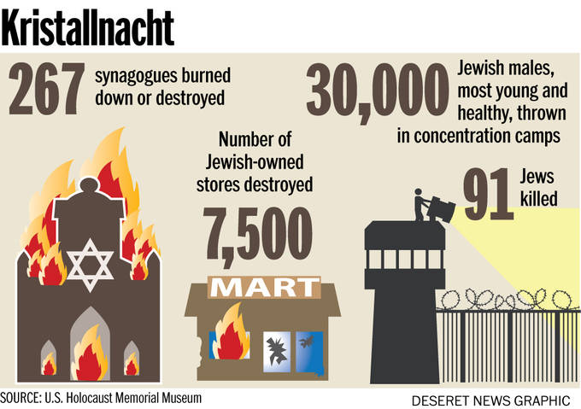
Hitler’s Policies- Hitler’s appeal grew among the German public despite the atrocities. He promised economic recovery and territorial expansion for Germany, and focused on building both foreign and domestic strength. Hitler saw a military buildup as the handmaiden to economic recovery, renewed national pride and the comings of the Third Reich (Nazi power that would last for 100 years). He used his belief in the “Aryan Master race” to convince the people that Germany had the right to expand eastward and win more territory. Claiming that Germany had to defend itself against the Soviet Union, he ignored the Treaty of Versailles (Ended WWI and called for Germany to demilitarize) and began rebuilding the Germany military, employing thousands of workers. He also built housing, highways and sports arenas. To pay for his programs, Hitler increased taxes and controlled wages and prices. By the mid 1930’s Hitler had made German Strength and determination clear to the world.
Summary of Hitler’s Policies __________________________________________________________________________________________________________________________________________________________________________________________________________________________________________________________________________________________________________________________________________________________________________

Turmoil in Italy- Like Germany, Italy faced severe political and economic problems in the years immediately following WWI. Though the Italian government had promised social change and land reform during the war, it did not live up to its promises. Peasants and workers joined Italian nationalists in denouncing the government for its weaknesses. The Socialist Party, which promised relief to the workers and peasants, was gaining power in the parliament at this time but seemed unable to prevent revolts. This turmoil was used by an ambitious politician, Benito Mussolini, to gain power.
Summary of Mussolini and Fascism __________________________________________________________________________________________________________________________________________________________________________________________________________________________________________________________________________________________________________________________________________________________________________
Summary of Turmoil in Italy __________________________________________________________________________________________________________________________________________________________________________________________________________________________________________________________________________________________________________________________________________________________________________
Mussolini and Fascism- As a young man, Mussolini had been a socialist. When World War I broke out, he became and enthusiastic nationalist, fighting for Italy. After the war, Mussolini organized many war veterans into the Fascist Party. Mussolini’s goal was to unite Italy using reminders of the glory of ancient Rome to inspire patriotism and obey his authority. Fascists hated democracy. They despised socialism and communism and defended a form of capitalism that was to be regulated by the government. Elements of fascism included aggressive nationalism and glorification of military sacrifice.
Mussolini’s Rise to Power- In 1922 Mussolini led a “March on Rome” to defend the capital from a supposed Communist revolution. As was hoped the march succeeded in frightening the government into surrender. King Victor Emmanuel II refused to use the army against the Fascist groups, and a few days later, he named Mussolini prime minister. In the next few years, Mussolini moved to increase his power. Outwardly, the government remained a monarchy with an elected parliament. Internally, however, Mussolini had the right to make laws on his own. Under his leadership, Fascists controlled elections and outlawed all opposition. Party members held all important jobs in the army and police. Mussolini imposed government censorship, and Fascists bought the Italian newspapers and wrote articles full of praise for him.
Summary of Improvement to the Economy __________________________________________________________________________________________________________________________________________________________________________________________________________________________________________________________________________________________________________________________________________________________________________
Summary of Mussolini’s Rise to Power ________________________________________________________________________________________________________________________________________________________________________________________________________________________________________________________________________________________________________________________________________________________________________________________________
Improvement to the Economy- to improve the Italian economy, Mussolini introduced a new type of economic organization, the corporative system. In the system, employers and employees in each industry joined a government sponsored corporation that controlled wages and prices. Unemployment dropped, which was much appreciated after the horrible worldwide depression.
The Rise of Militarism in Japan- In addition to those in Germany and Italy, a dictatorship arose in Japan in the years prior to WWII. While Japan’s economy had not been adversely affected after WWI, it was so dependent on world markets that the Great Depression of the 1930’s caused economic disaster. Also, the Japanese were dissatisfied with the instability of their country and resented their reputation as a second-rate power. This enabled a group of military leaders to rise to power. Those leaders built up Japan’s military and sought to expand its control in Asia. Within Japan, the military-controlled government imposed censorship, arrested government critics, and dismissed liberal professors from universities. A secret police was set up to punish enemies of the state. The press and the schools preached total obedience to the emperor. Nationalist groups glorified war and the empire.
Summary of Japanese Imperialism __________________________________________________________________________________________________________________________________________________________________________________________________________________________________________________________________________________________________________________________________________________________________________
Summary of Rise of Militarism in Japan ____________________________________________________________________________________________________________________________________________________________________________________________________________________________________________________________________________________________________________________________________________________________________________________________________________________________________
Japanese Imperialism- Seeking to expand Japanese territory, in 1931 the Japanese army attacked Manchuria, a region of northeastern China rich in coal and iron. Arguing that Japan’s 65 Million people could hardly be expected to remain within its tiny crowded Island, one Japanese politician stated, “We are only seeking room that will let us breathe.” Japan also south support from other fascists powers, and in 1936 signed a military agreement with Italy and Germany, forming the Rome-Berlin- Tokyo Axis. Hitler contemplated using Japan to attack Russian and British possession in Asia. Japan continued to prepare for continued aggression in Asia.
US Response-Words without Deeds- The United States responded with displeasure to the invasion of Manchuria in a moral lecture called the Stimson Doctrine, but took no serious action. Heartened by the weak response from the West, Japan’s aggression in China continued throughout the 1930’s as they attempted to build a Japanese empire in Asia. In 1937 Japan bombed innocent civilians in Shanghai, killing tens of thousands of people. In response the United States cancelled its trading treaty with the Japanese, but did not take military action. One historian wrote, “The democracies… uttered bold, brace words against the Japanese, but were afraid to act. They preferred to let Japan enslave millions of Asians rather than risk war themselves.”
Summary of US Response- Words without Deeds __________________________________________________________________________________________________________________________________________________________________________________________________________________________________________________________________________________________________________________________________________________________________________

