The Ford and Carter Years
1974-1980
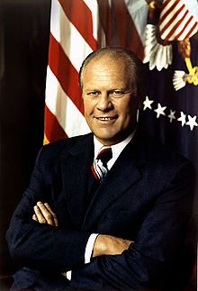
The Ford Administration 1974-1977

Ford becomes President when Nixon quits
Ford Pardons Nixon
August 8
President Nixon announced he would resign the next day, the first President to do so.
August 9
Vice President Gerald Ford of Michigan was sworn in as 38th President
September 8
Ford granted "full, free, and absolute pardon" to ex-President Nixon
“Our long national nightmare is over.” Ford after he pardoned Nixon.
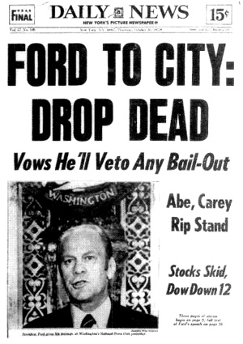
President Ford’s domestic and international problems
- A worldwide recession
- Highest unemployment
- Highest inflation rates in decades
As President….
Ford tried to cut government spending to curb inflation
Wielded the power of the Presidential veto 55 times.
Foreign Affairs
- Continued the policy of détente.
- Kept Kissinger as secretary of state.
==================================================================
Assassination Attempts : Twice Ford narrowly escaped death
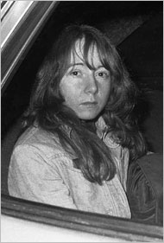
- September 5, 1975: At the California State Capitol, Lynette ‘Squeaky’ Fromme, a follower of Charles Manson, drew a Colt M1911 .45 caliber pistol on Ford when he reached to shake her hand in a crowd.

She had four cartridges in the pistol's magazine but none in the firing chamber. She was quickly restrained by Secret Service agent Larry Buendorf. Fromme was sentenced to life in prison, but was released from custody on August 14, 2009.
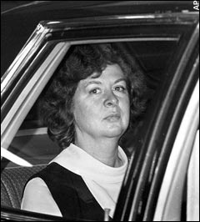
- September 22, 1975: In San Francisco, Sara Jane Moore fired a revolver at Ford from 40 feet away. A bystander, Oliver Sipple, grabbed Moore's arm and the shot missed Ford.

Moore was tried and convicted in federal court, and sentenced to prison for life. She was paroled from a federal prison on December 31, 2007 after serving more than 30 years. Both were released after Ford died.

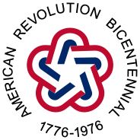

The U.S. Bicentennial
1776- 1976

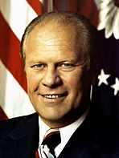
Election of 1976: Ford vs. Carter
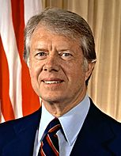
•Republicans:
Ford won the nomination over former California Governor Ronald Reagan
Running mate: Senator Robert J. Dole of Kansas
•Democrats:
Jimmy Carter, a former governor of Georgia
Running mate: Senator Walter F. Mondale of Minnesota

Carter won a narrow victory
Electoral vote 297 240

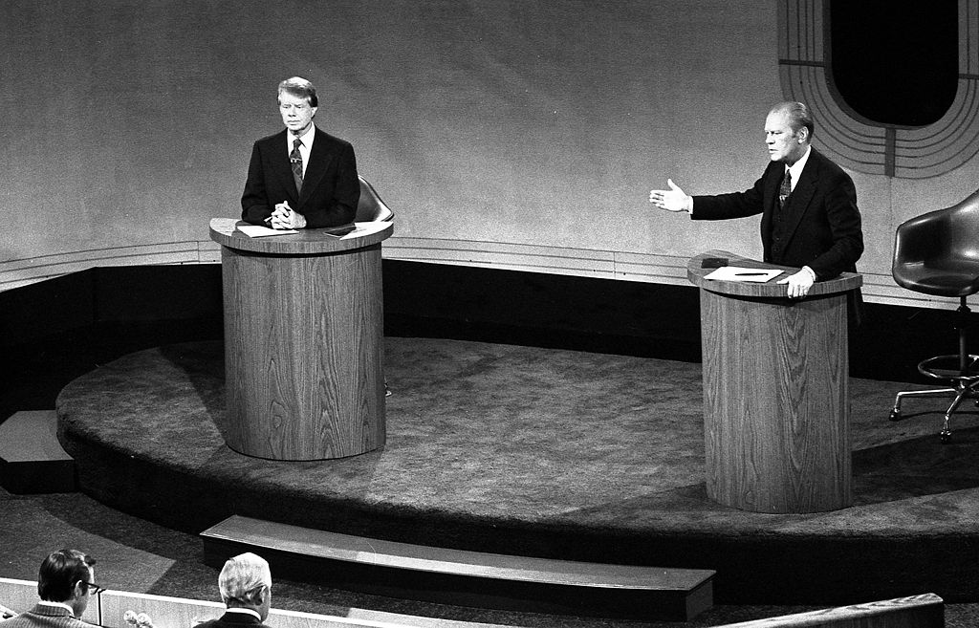

Jimmy Carter as President
“I will never lie to you.”
-- President Jimmy Carter
Expanded the national park system.
Created the Department of Education
Strengthened the Social Security system.
Appointed a record numbers of women, blacks, and Hispanics to government jobs.

An ineffective president?
He was seen as too nice.
He tried to micromanaged affairs
He played the outsider and alienated potential allies.
The economic problems too big to overcome

Was He Really a Do-Nothing President???? By the end of his presidency, he could claim…
…an increase of nearly eight million jobs and…
…a decrease in the budget deficit.

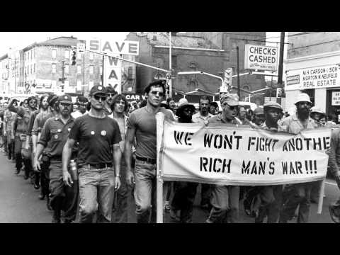
Vietnam Draft Dodgers
Issued a pardon to thousands of Vietnam War draft dodgers.
The U.S. government would not prosecute those men who avoided the draft by failing to register or fleeing the country, mostly to Canada.

Camp David Accords 1978
Led to the 1979 Israel-Egypt Peace Treaty…. A first between Israel and an Arab nation.
Carter’s greatest foreign-policy achievement
Egypt and Israel had been mortal enemies

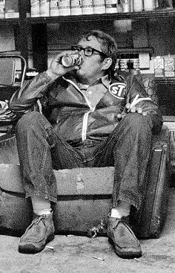
Returning the Panama Canal
American control of the canal had been a source of conflict between the two countries for years.
Panama wanted control of the canal.
- In 1977 Carter agreed that Panama would take control of the canal by the end of 1999.
- For some Americans, loss of control of the canal represented a decline in American power.

Billy Carter
The Carter Doctrine January 1980
Any interference with U.S. oil interests in the Persian Gulf would be considered an attack on the vital interests of the United States
Essentially… the United States would use military force if necessary to defend its national interests in the Persian Gulf.
A response to the 1979 invasion of Afghanistan by the Soviet Union
-----------------------------------------------------------------------------------------------------------------------------------------
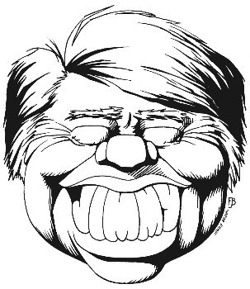
Carter’s Accomplishments
- Made Human Rights an issue
- Expansion of national parks
- Egypt-Israel Camp David accords
- Presidential Records Act of 1978
Changed the legal ownership of the official records of the President from private to public

Economic Problems
- Inflation = 14%
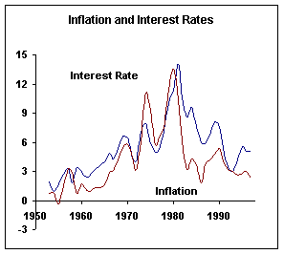
- Unemployment = 12%
Highest since the Great Depression.
- U.S. Goes from Manufacturing Jobs to Service Industry.
The Economy and Energy
- Carter made the development of a national energy policy a priority.
- Wanted to ease dependence on foreign oil through conservation, new energy supplies, and loosening government regulation of the American oil industry
- Asked Americans to conserve energy
- Promoted the development of alternative energy sources

The Results:
- The economy added many new jobs to help battle unemployment.
- Carter was unable to bring down inflation, in fact, it got worse.
- Carter’s energy policies were successful at helping reduce American dependence on foreign oil.
- American production of energy increased under Carter.

Carter’s Foreign Policy
Had little foreign-policy experience.
Promised that the concept of human rights would be at the forefront of his foreign policy.
Worked to strengthen ties between the United States and the Soviet Union and China.
Gave control of the Panama Canal back to Panama.
Camp David Accords: Egypt and Israel talks to resolve the conflicts between their countries.
***************************************************************************************************
The 1977 NYC Blackout
- The blackout, unlike the 1965 and 2003 blackouts, resulted in city-wide looting, arson, and crime.
- Looting of electronics stores during the blackout allowed a number of looters to steal DJ equipment.
- As a result of these thefts, the hip hop genre, barely known outside of the Bronx, grew at an astounding rate.
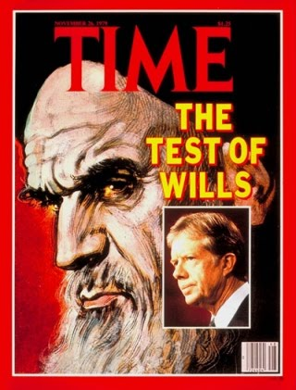
The Iran Hostage Crisis

Iran Became an Islamic State
- Shah Mohammed Reza Pahlavi's authoritarian rule sparks
demonstrations and riots.
- People rebel
- The U.S. supported dictator, the Shah of Iran, was overthrown.
- Ayatollah Khomeini, a religious leader, took over.
- Shah Mohammad Reza Pahlavi
- Came to U.S. for gallstone surgery….stayed for six weeks.
- Died six months later in Egypt.

The Iranian Hostage Crisis
November 4, 1979
- An angry mob of some 300 to 500 "students" who called themselves "Imam's Disciples," invaded the American Embassy in Teheran, Iran
- Took 66 U.S. citizens and diplomats hostage.
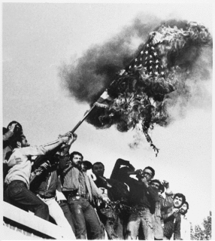
The Attempted Rescue: Operation Eagle Claw
- The plan was to land aircraft in the desert allowing Special Forces to free the 52 hostages.
- It was aborted, and a helicopter crashed into a transport plane as it was pulling out, killing eight soldiers

Hostages were released when Carter handed over the presidency to Ronald Reagan
January 20, 1981
At the moment Reagan completed his 20‑minute inaugural address after being sworn in as President, the 52 American hostages were released by Iran into U.S. custody, having spent 444 days in captivity.

Results
- U.S. seen as weak, ineffective in the Middle East
- U.S. people still see Iran in a negative light
- The Iran–Iraq War?
- The Iraq invasion of Iran occurred less than a year after the embassy employees were taken hostage.
- One theory is the change of U.S.–Iranian relations from ally to enemy played a part in Saddam Hussein plan to invade…he no longer feared the U.S. protecting Iran.
- A successful invasion of Iran would enlarge Iraq's petroleum reserves and make Iraq the region's dominant power.
- U.S. anger with Iran led the U.S. to aid Iraq after the war turned against Iraq.
- The U.S. supplied Iraq with, weapons, gas, and satellite intelligence used in selecting bombing targets

============================================================================
Jonestown
- November 18, 1978….909 people died in the settlement..all but two by drinking Kool-Aid with cyanide
- The poisonings in Jonestown followed the murder of five others by Temple members at Port Kaituma, including United States Congressman Leo Ryan.
- Actually was the Peoples Temple Agricultural Project, an intentional community in northwestern Guyana formed by the Peoples Temple, an American cult led by Jim Jones.
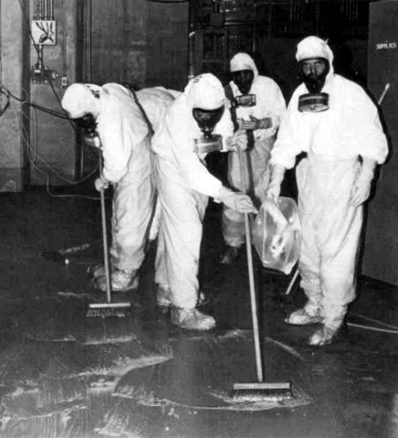

The Three Mile Island Accident March 28, 1979
A partial nuclear meltdown that occurred on in one of the two Three Mile Island nuclear reactors in Pennsylvania.
It was the worst accident in U.S. commercial nuclear power plant history
The accident crystallized anti-nuclear safety concerns among activists and the general public, resulted in new regulations for the nuclear industry

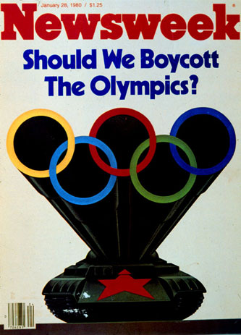
U.S. boycott of the Moscow Olympics 1980
- In response to the 1979 Soviet invasion of Afghanistan, Carter decided to boycott the 1980 Summer Olympics in Moscow, which raised a bitter controversy.
- It was the only time since the founding of the modern Olympics in 1896 that the United States had not participated in a Summer or Winter Olympics.
- The Soviet Union retaliated by boycotting the 1984 Summer Olympics in Los Angeles. It did not withdraw troops from Afghanistan until 1989 (eight years after Carter left office).

