Ronald Reagan’s Agenda
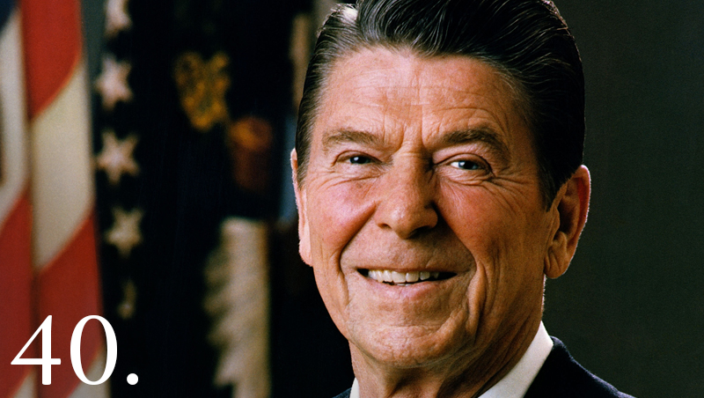
Introduction- Ronald Reagan was inaugurated president on January 20, 1981, and entered the White House from a position of great political strength. Reagan believed that his overwhelming electoral victory-he earned 480 Electoral votes to Carter’s 49- signaled a clear mandate to implement his brand of conservatism called neoconservatism. Reagan’s ambitious agenda included plans to stimulate the economy, lower taxes, cut liberal social programs and dramatically lesson the federal government’s role in people’s everyday lives. Reagan also wanted to increase American military might, stem the growth of communism, and advance his conservative philosophy on social issues.
- Was President Reagan a conservative or a liberal?
- Why did Reagan feel he had unusually strong support from the American people for his conservative policies?

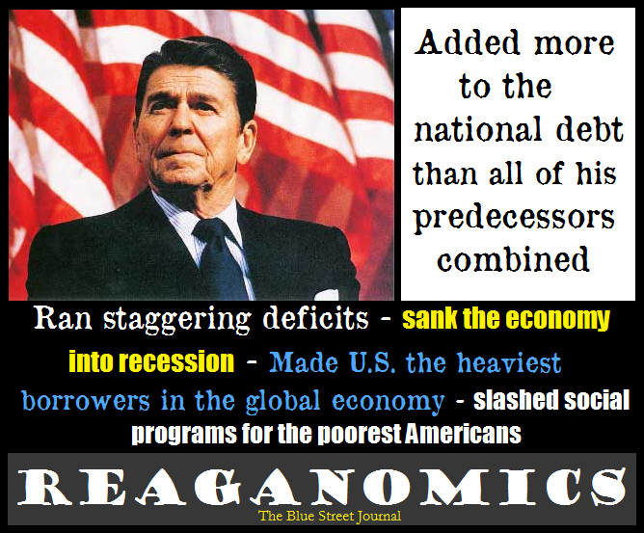
The Economy- Economic revival was Reagan’s first priority. To stimulate the economy, his administration used a conservative approach called supply-side economics. This new theory argued that massive tax cuts- especially for wealthy individuals and corporations- would encourage personal savings and investment, which would then lead to business growth and the creation of more jobs. The result would be a larger supply of goods for consumers, who would have more money to spend, and thus stimulate the economy. Reagan applied the supply-side theory to his 1981 federal budget. Since he was committed to cutting taxes and increasing military spending, his budget also called for reduction of spending on social programs. As a result, in his first budget, welfare benefits, Medicare benefits, and children’s lunch programs were slashed, and one million recipients of food stamps lost their allocations.
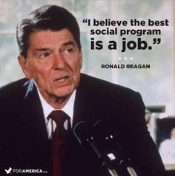
The results of eight years of Reagan’s supply-side approach to economics, dubbed Reaganonmics, were mixed. After a recession in the early 1980’s, interest rated leveled off, investment began to rise, and, while unemployment reminded high at 9%, productivity rose and new jobs were created. Inflation was finally subdued and remained low through the rest of the decade. Once the economy was on the road to recovery, the Reagan approach won newfound praise. Ultimately, though, the wealth generated by the supply-side approach did not “trickle down” to most Americans.(this type of idea did not end up helping the poor) Rather, tax cuts mostly benefited the rich, and cuts in social spending drove the poor deeper into poverty. The number of children living in poverty, one in five, had grown by 24% during the 1980s. By 1989, the wealthiest two fifths of American families received 67.8 percent of the national income, while the bottom two fifths earned a mere 15.4 percent. This represented the largest gap between the “haves” and the “Have nots” in American since 1945. Reagan critics charged that his policies had led to the deep divide.
One glaring failure of Reaganomics-cited by both Reagan supporters and detractors-was its inability to balance the federal budget, which led to an unprecedented federal deficit, and a soaring national debt of $4 trillion by 1988. Reagan cut taxes and dramatically increased defense spending, but-despite some success at reducing domestic spending-was unable and unwilling to push Congress to slash the largest of the social programs, Medicare and Social Security. Prior to the 1980’s, the biggest single-year government debt had been $66 billion; by 1986, it had skyrocketed to $221 billion, and continued to grow each year thereafter. In the 1990’s, some political analysts proposed that Reagan deficits effectively put pressure on Congress to reduce domestic spending and slow the growth of the government. Others added that Reagan budget deficit was a good investment, asserting that his military buildup ultimately helped bring down the Soviet Union and thus reduced the threat of nuclear war.
- What is supply-side economics?
- What were Reagan’s most glaring economic successes?
- What were Reagan’s most glaring economic shortcomings?

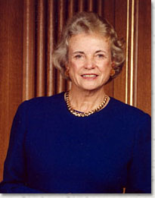
Social Issues- During his first term, Reagan captured the support of many Americans by taking a conservative stand on social issues. Reagan opposed policies such as court-ordered busing of students to integrate schools, gun control, the Equal Rights Amendment, and the right of women to have legal abortions. These views drew together a large, diverse coalition of supporters that swept him to a landslide reelection victory in 1984. At the same time, the president lost favor with many women who had previously supported him because he paid little attention to women’s issues. Despite his states opinions on controversial social issues, the president had little influence regarding most of them.
One way he was able to influence social issues was through judicial appointments to the Supreme Court. Reagan firmly opposed two historic Supreme Court decisions: that prayer in public schools is unconstitutional and that women have a constitutional right to abortion. Reagan’s appointments to the Supreme Court-including the 1981 appointment of Sandra Day O-Conner, the court’s first ever women justice-led to a more conservative court. As a result, ultimately some of the liberal decisions of the 1960’s and 1970’s were reversed. For example, one decision limited affirmative action hiring programs that had benefited minorities. By the end of Reagan’s second term, however, the original school prayer and abortion decisions remained intact.
Deregulation To fulfill his promise to “get the government off of people’s backs,” Reagan worked to deregulate business. He believed that businesses needed fewer restrictions so they could operate more freely. In the drive to cancel many of the rules governing businesses, the fuel-efficiency standards for cars became more lenient, growth in the cable television industry was almost unlimited, and airline fares and routes were far less regulated.
While many praised the freedom that business owners and industry leaders felt after deregulation, some opposed the process. Environmentalists, for example, felt that it undermined their hard-won gains to create restrictions preventing companies from polluting the air or water or dumping hazardous wastes. The Reagan administration asserted that some damage to the environment was a price Americans might have to pay to have strong economy. A 1985 poll, however, revealed that two thirds of the public did not accept Reagan’s approach to the environment, and would have been willing to make some financial sacrifices in exchange for less pollution.
- What was Reagan’s Stand on abortion and prayer in schools?
- Why did Reagan lose support among some women?
- How did Regan influence the Supreme Court?

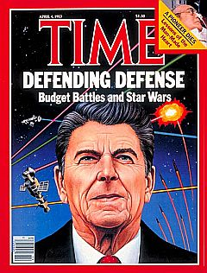
The Military- To restore the nation’s power and prestige around the world, Reagan believed the United States needed to plya a more active role in the struggle against communism. Relations with the Soviet Union grew increasingly tense as Reagan used more extreme language- such as evil empire- to describe the United States’ Cold War adversary. Believing that the military had been badly underfunded during the Carter years, Reagan launched an unprecedented peacetime arms buildup designed to strengthen U.S. defenses in case of a war with the Soviet Union. The result was a spending increase of more than 50 percent over his two terms. Despite a growing antinuclear movement in Europe and the United States, Regan resisted most efforts aimed at arms control. He also proposed the Strategic Defense Initiative (SDI), a new laser-beam-operated defense shield-popularly known as “Star Wars”-that could protect the United States from nuclear attack by destroying enemy missiles in space. Scientists disagreed as to whether such a system could be perfected. Nonetheless, billions of dollars went into its development.
Anticommunism- Regan also renewed American efforts to support-secretly as well as openly-opponents of communism around the world. The policy, called the Reagan Doctrine, was designed to stamp out communism. The policy led to successes such as the Soviet Union’s withdrawal from Afghanistan. It was in Latin American, though, that the policy had its most significant impact. The administration sent massive amounts of aid to El Salvador, a small country in the midsts of a civil war between the ring-wing government and left-wing rebels. While the White House pointed out that the rebels were receiving aid from the Soviet Union, some American criticized U. S. support of the Salvadoran government, which was one of the world’s most murderous regimes.
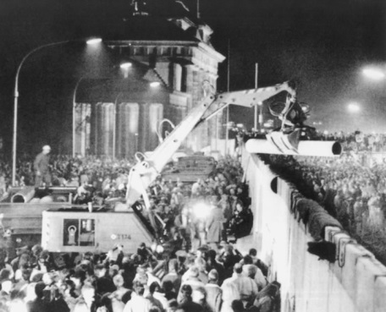
Global Politics- In the final years of Regan’s Presidency, world politics began to change dramatically. Soviet Military strength lessened, the economy of Eastern Europe fell apart, and the leadership of Mikhail Gorbachev brought dramatic political and economic changes to the Soviet Union. This ultimately paved the way for the fall of the Soviet Empire in 1990 and the End of the Cold War. Many credited Reagan with weakening the U.S.S. R. to the point where change-and even collapse- was inevitable. Others believed that the changes were the natural cycle of a system that did not work and the result of Gorbachev’s very different approach.
Conclusion- For much of his eight years as president, many considered Reagan a brilliant success. Seeing him as a vigorous, outdoorsy, grandfather figure, most Americans believed that he was a strong and active leader. Even though many who worked with him described him as a passive and detached leader, his public image and popularity was high. Even when things went wrong, few people criticized the president himself; typically his aides the Congress and others caught the blame. When he left office, Reagan believed he had done much to improve the political and economic shape of the nation. Then, with his humor he concluded, “All in all, I must say, not bad for a fellow who couldn’t get his facts straight and worked four hours a day.”
- What did Reagan do to ensure the United States took a more active role in fighting against communism?
- Why did Reagan increase the military budget 50 percent?
- How was Reagan viewed when he left office in 1989?

