Name:___________ Date:________
American WWI Propaganda Analysis
Use Inferences from class as well as what you see in the WWI Posters to understand the meaning of these Examples of Propaganda that were used during WWI.
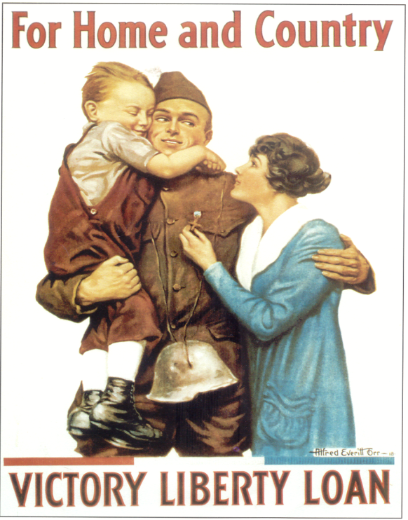
A
1. What do you see in this picture?

2. How is the artist appealing to the viewer’s emotions?

3. What common propaganda tools is this using? (Check Propaganda Obj.
And Tools sheet)

4. What is the goal of this poster?

__________________________________________________________________________________________________
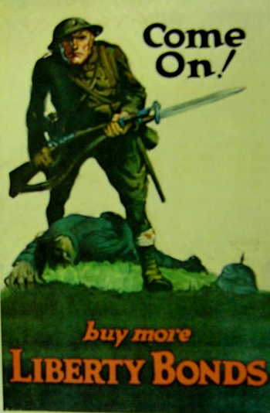
B

1. What do you see in this picture?

2. How can you tell that this is an American Soldier?

3. What common propaganda tools is this using?

4. What is the goal of this poster?

1. What is the plant sitting in?
C

2. What is the “Sixth?”

3. Where would someone in the “Sixth” Get one of these pots?

4. What is the Goal of the poster?

__________________________________________________________________________________________________
D
1. What do you see in this poster?

2. What is the main idea of this poster?

3. Who could the saved coal be used to help?

4. How would more coal help the war effort?

1. What is happening to the Statue of Liberty?
E
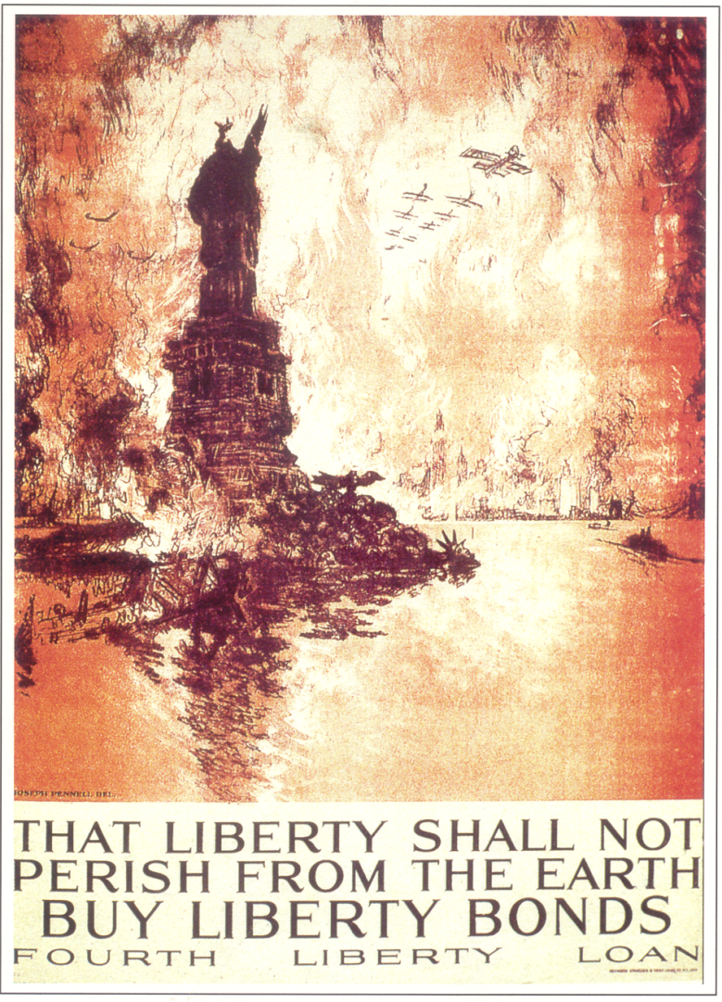

2. What is the cartoonist assuming will happen if we don’t’
Support the war?

3. What common propaganda tools is this using?

4. What is the goal of the poster?

__________________________________________________________________________________________________
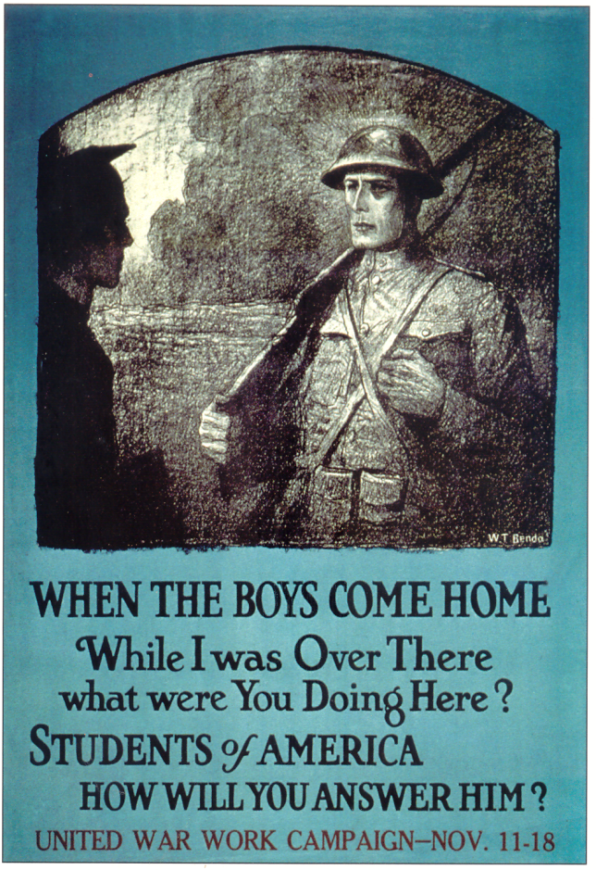
F
1. Who is the man on the left?

‘2. What is the soldier asking him?

3. Who is this trying to motivate to support the war?

4. Who is responsible for this poster?

