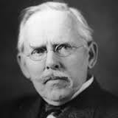
Muckraker Analysis
Jacob Riis
After Reading the excerpts of Jacob Riis “How the Other Half Lives” and viewing
Photographs in from his work, Respond to the following questions.
__________________________________________________________________________________________
Photo Responses
What do you see in these pictures?
Do you think these are trustworthy accounts of what life was really like in this time period? Why or why not? (Hint: it took minutes to take a photograph at this time)
What do you think Riis wanted the Audience to take away from these photos?
What might these photographs tell you about the middle class Americans who bought Riis’ books and attended his lectures? What did his audience believe about children?

Before Reading
What type of document is this? Who wrote it?

Do you think that Riis was Bias (had a preference) about the topic he was writing about?

After Reading
What is Riis’s attitude towards poverty?

What was his attitude toward these immigrants?

Riis thought he was helping the immigrants and supporting them. After reading this do you feel like he was helping the immigrants?

What do these photos and excerpts tell you about life in cities at the turn of the century?

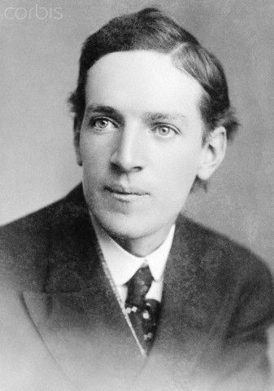
__________________________________________________________________________________________
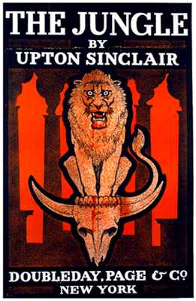
Upton Sinclair
After Reading Parts of Upton Sinclair’s book “The Jungle” answer the
Following questions.

What Impact do you think this writing had on Americans?
____________________________________________________________________________________________________________________________________________________________________________________________________________________________________________________________________________________________________________________________________________________________________________________________________________________________________________________________________________________________________________________________________________

Describe the specific event that stuck out the most to you from the
Reading and why.
___________________________________________________________________________________________________________________________________________________________________________________________________________________________________________________________________________________________________________________________________________________________________________________________________________________________________________________________________________________________________________________________________________________________

What happened to the contaminated meat?
___________________________________________________________________________________________________________________________________________________________________________________________________________________________________________________________________________________________________________________________________________________________________________________________________________________________________________________________________________________________________________________________________________________________

How would you expect the government to fix this situation?
___________________________________________________________________________________________________________________________________________________________________________________________________________________________________________________________________________________________________________________________________________________________________________________________________________________________________________________________________________________________________________________________________________________________

How would you personally react if you found out the food used at CHIPOTLE was made this way?
___________________________________________________________________________________________________________________________________________________________________________________________________________________________________________________________________________________________________________________________________________________________________________________________________________________________________________________________________________________________________________________________________________________________

