Mainstream Culture and Counterculture in the 1960s-1970s
The Mainstream Culture: Background
Mainstream Americans believed that their shared beliefs in traditional American values were the foundation of a better life. First, they were typically very patriotic, as evidenced by a popular bumper stick that appeared during the mid to late 1960’s “America: Love It or Leave It.” Second, men and women who said they were in love got married-and stayed married. For unmarried couples to consider living together was not only unacceptable, but almost unheard of. Third the mainstream generally believed that the “American dream”-a good education, a good job, and a good home-could come true for anyone who worked hard, was dedicated and honest, and believed in the United States. Anyone who challenged this kind of thinking was accused of being “un-American.” Fourth, mainstream Americans believed people should conform to traditional values in everything from personal behavior to fashion and grooming. For example, many people expected men to have short hair, be clean shaven, and wear suits. Women were expected to wear tasteful amounts of makeup, have their hair down and mostly wear dresses, even while relaxing at home.
The Counter Culture
In the 1960’s a group of mostly young, white Americans born just before or just after the war began to challenge the established values of the older mainstream culture. This group soon came to be called the counterculture. The counterculture movement encouraged the pursuit of personal freedom and alternative lifestyles, rebellion against rigid conformity and materialism (the desire to accumulate wealth), and political activism to stop racism, war, and poverty. Counterculture is a broad term used to describe many different movements and lifestyles explored by young people in the 1960’s. What follows are six common characteristics.
Communal Living- Many counterculture youth settled in urban neighborhoods, such as Haight-Ashbury in San Francisco and New York’s East Village. However, another segment left city life altogether and set up communes in isolated places such as the mountains of California and the wide-open spaces of New Mexico. These communes rejected the competitive mainstream lifestyle and tried to construct a totally self-sufficient environment. They attempted to base their lives on cooperation and love, and to live in harmony with nature rather than to conquer it. Many communes were established on farms, where people grew their own food, baked their own bread, and set up their own schools. Some also shared drugs and engaged in “free-love,” Or causal sex, defying traditional concepts of marriage and the family. While many women who joined the communes were able to live more independently and self-sufficiently, they were also dismayed to learn that, just as in mainstream American society, male supremacy was an integral part of the structure of most communes.
Drugs- For many counterculture youth, drugs were an important part of rebellion and personal freedom. The most popular drug was marijuana. Timothy Leary, a former Harvard University Psychology instructor, advocated a new mind altering drug called LSD. He urged people to “turn on, tune in, and drop out,” a phrase that became the motto for many drug users. LSD was a strong hallucinogenic drug that sent users on dreamlike “acid trips,” which could be exciting and sometimes deadly. While drug use had long been part of life for some Americans, the counterculture brought drug use to new heights. By the late 1960’s, but was impossible to attend a rock concert without smelling marijuana or seeing concertgoers “tripping out.” Newspapers frequently published stories of young people who had died from drug overdoses. In the face of intense criticism from the mainstream, counterculture youth pointed out that alcohol was the mainstream drug of choice. They also said that their actions did not hurt anyone besides themselves and so should be left to their own.
Fashion- Counterculture youth called themselves hippies, from the slang expression “hip,” which meant knowledgeable or “with it.” Hippies dressed in outrageous, colorful, controversial, and sometimes ridiculous clothes that shocked the mainstream. They wore beads around their necks, and shirts tie-dyed in crazy colors or covered with odd designs, even replicas of the American flag. Young men wore fringe jackets and army surplus clothes. Young women often went braless and wore blouses that left their midriffs exposed. Some women wore the mini, a skintight skirt that rose a full three inches above the knee. While short skirts were in, short hair was out-especially for men. Not since the colonial days had so many American males worn their hair in pony tails. Other let it grow halfway down their backs. Many adults claimed it was difficult to tell the boys from the girls. The hippies’ final fashion statement was flowers in their hair, a sign of “peace and love.” This trend earned the counterculture youth nickname “Flower Children.”
Political Activism- In the minds of many Americans- particularly the mainstream-the counterculture and antiwar protest movement of the 1960’s were inseparable. By the late 1960’s, the media showed images nearly every week of long-haired protesters marching against the Vietnam War. Despite what many Americans thought, these protestors never fit into one easily categorized group. Some protestors were confrontational, burning the U.S. flag and screaming “Stop the War,” as they cursed and goaded the police and National Guard troops who were on duty to protect the government property. Other protesters were more interested in making a gentle “statement for peace.” They often marched in silence, carrying peace signs, and frequently placing flowers in the gun barrels of government troops to show their nonviolent nature. This “dual nature” of the protest movement was often lost on mainstream Americans. They saw all student protestors as “long-haired, filthy, drug crazed,” disloyal Americans who were betraying their country.
Music- The folk, pop, and rock music of the 1960s challenged mainstream values. Bob Dylan’s folk-rock ballads became counterculture anthems. In “The Times They Are A-Changin’,” he told parents that children were “beyond their command” and not to “criticize what they can’t understand.” Beatles wrote songs like “Revolution” and “Why Don’t We Do It in the Road,” inspiring young people to chart a new course. During the late 1960’s, “psychedelic” rock became a major musical genre. Groups such as Jefferson Airplane and the Doors, and artists like Jimi Hendrix, combined a heavey guiter and drums-based rock rounds with lyrics that often glorifed drug experience. In 1969, all these elements came together at a famous musical event: Woodstock. More than 500,000 young people spent a weekend camping out, getting high on drugs, engaging in “free” love and listening to a continuous stream of rock and roll.
Sexuality- There was a sexual revolution during the 1960’s, and the counter culture was largely responsible for it. Counter Culture youth saw themselves as sexually liberated. They scoffed at sexual inhibition of their parents’ generations, and replaced them with casual sex, or “free love.” Medical advances such as the birth control pill made it easier for young women and their partners to becomes sexually active and not be concerned about unwanted pregnancies. Thousands of unmarried young people engaged in one sexual relationship after another, many of them never lasting more than a night. At Rock festivals, on communes, on the beaches, in parks-everywhere it seemed- the youth of America were flaunting their open attitude about sexual conduct. Soon, the entire country underwent a change in attitude about sex. Women went braless, or burned their bras. Movies showed men and women in graphic love making scenes. Music references to sex-almost unheard of a decade before-became common. The counterculture’s rejections of mainstream American sexual values was widely criticized and condemned. However, the counterculture continued, unperturbed, saying: Make love, not war.”

Mainstream Culture of the 1960’s and 1970’s

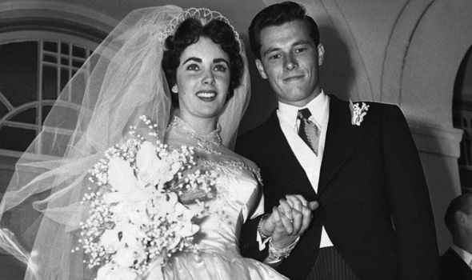

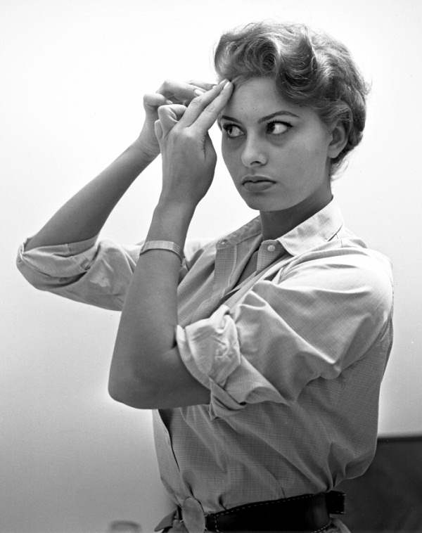
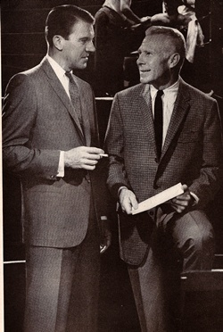

Communal Living 1960s
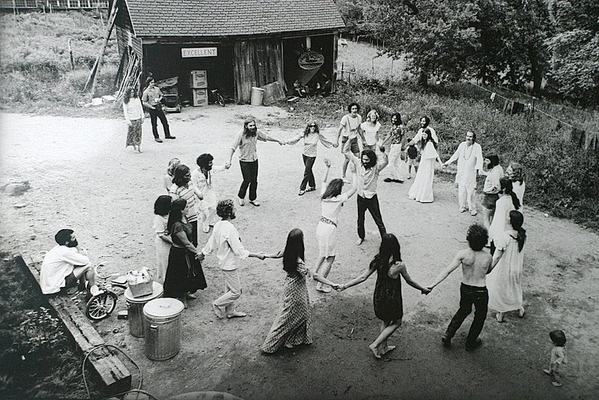

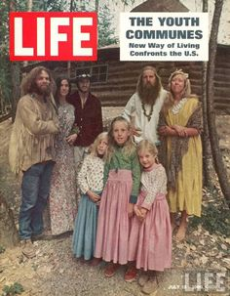

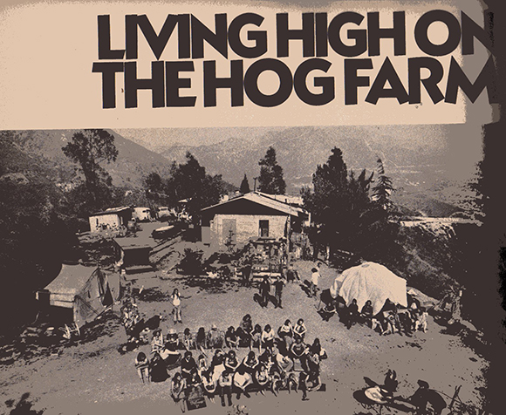

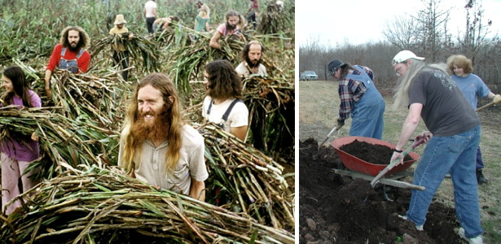

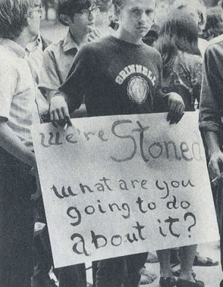
Drugs in the 1960’s

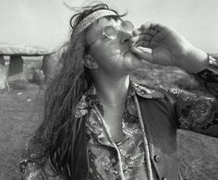

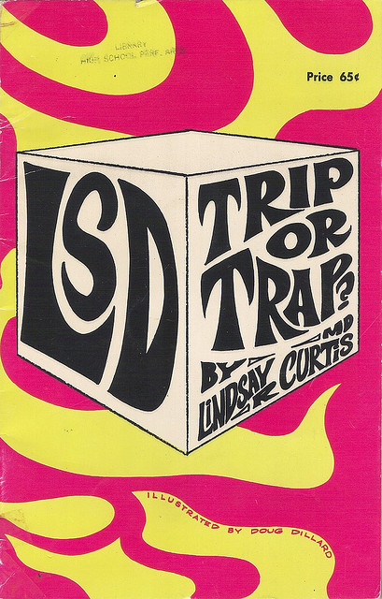

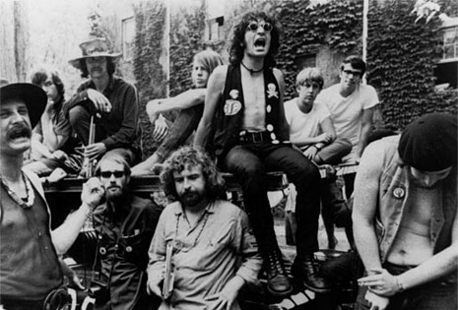

1960’s Fashion
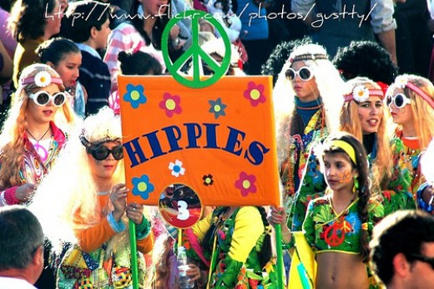

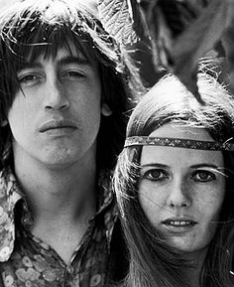

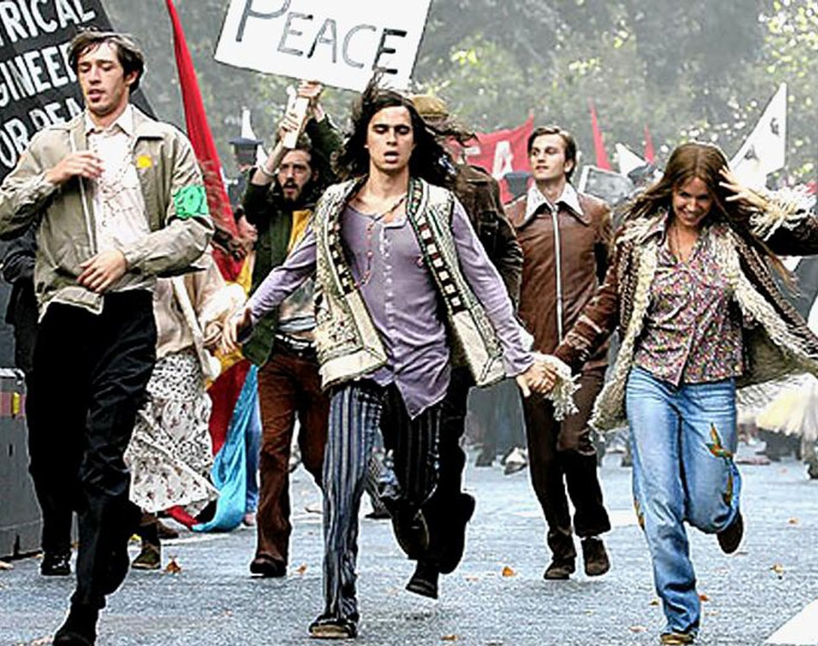

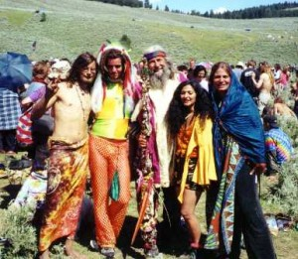

Political Activism in the 1960’s
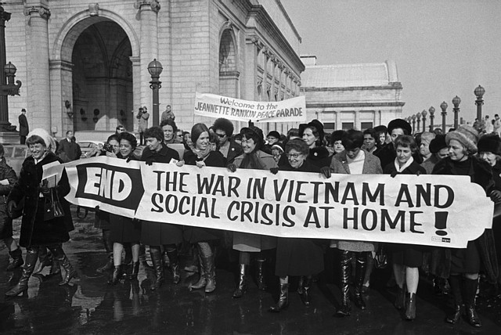

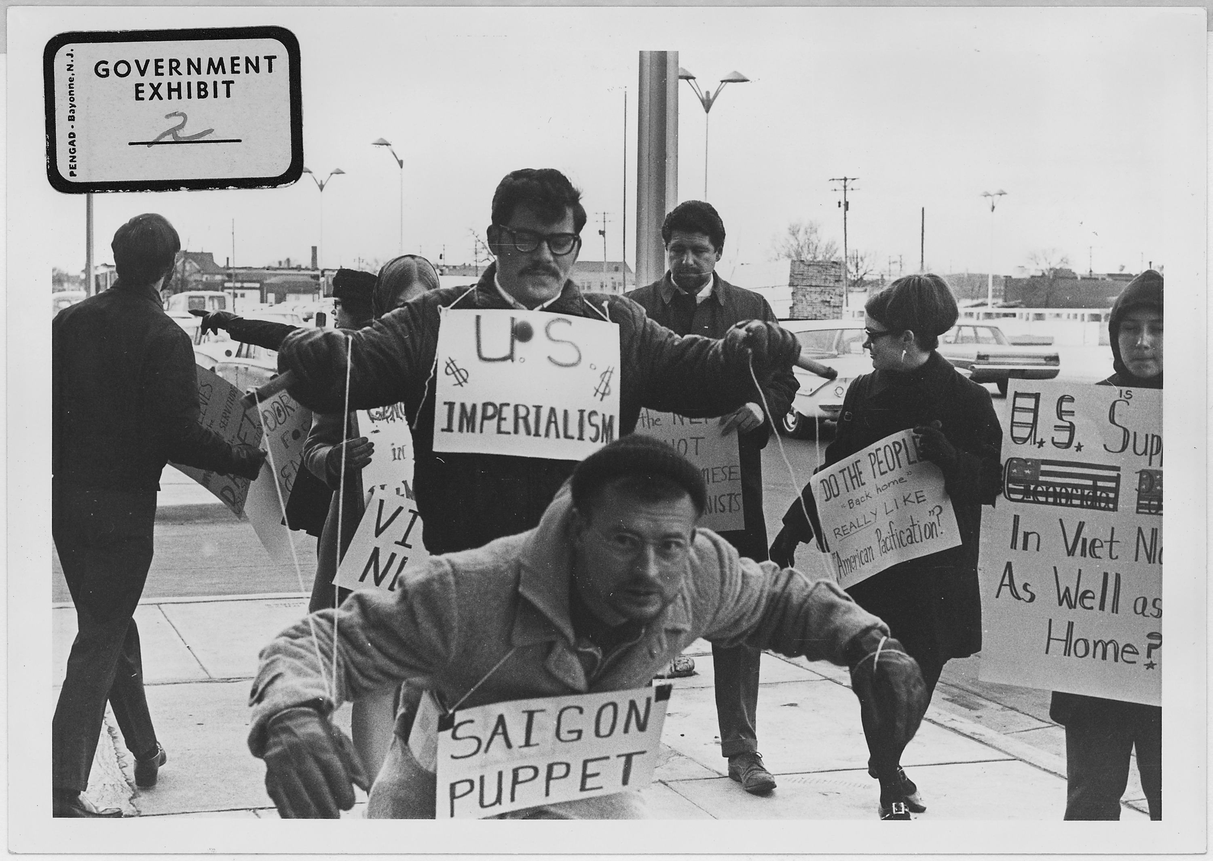
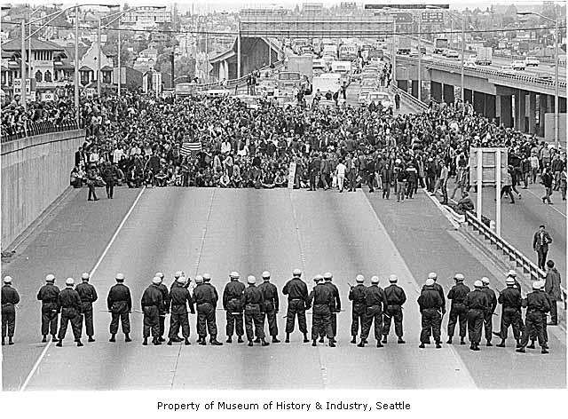

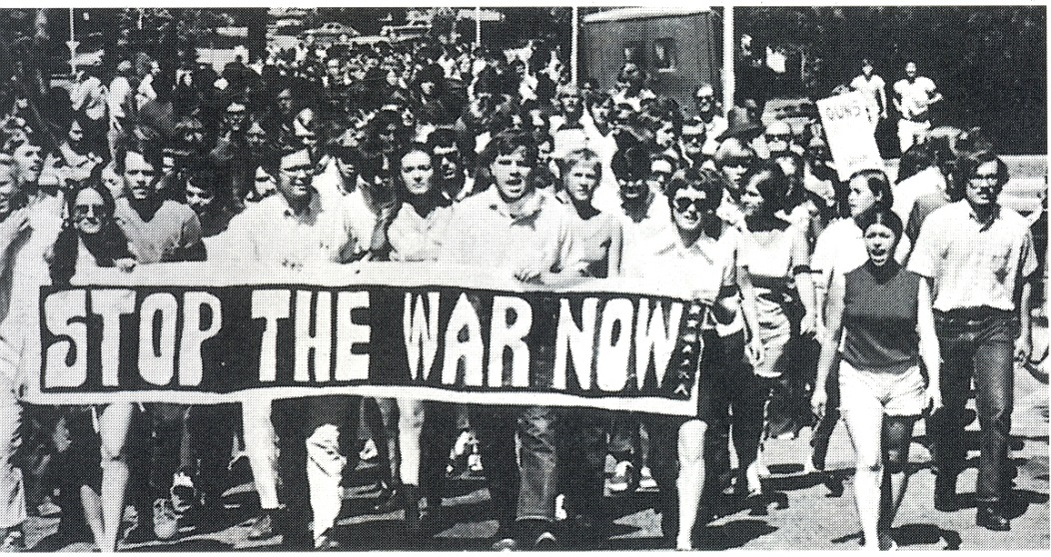

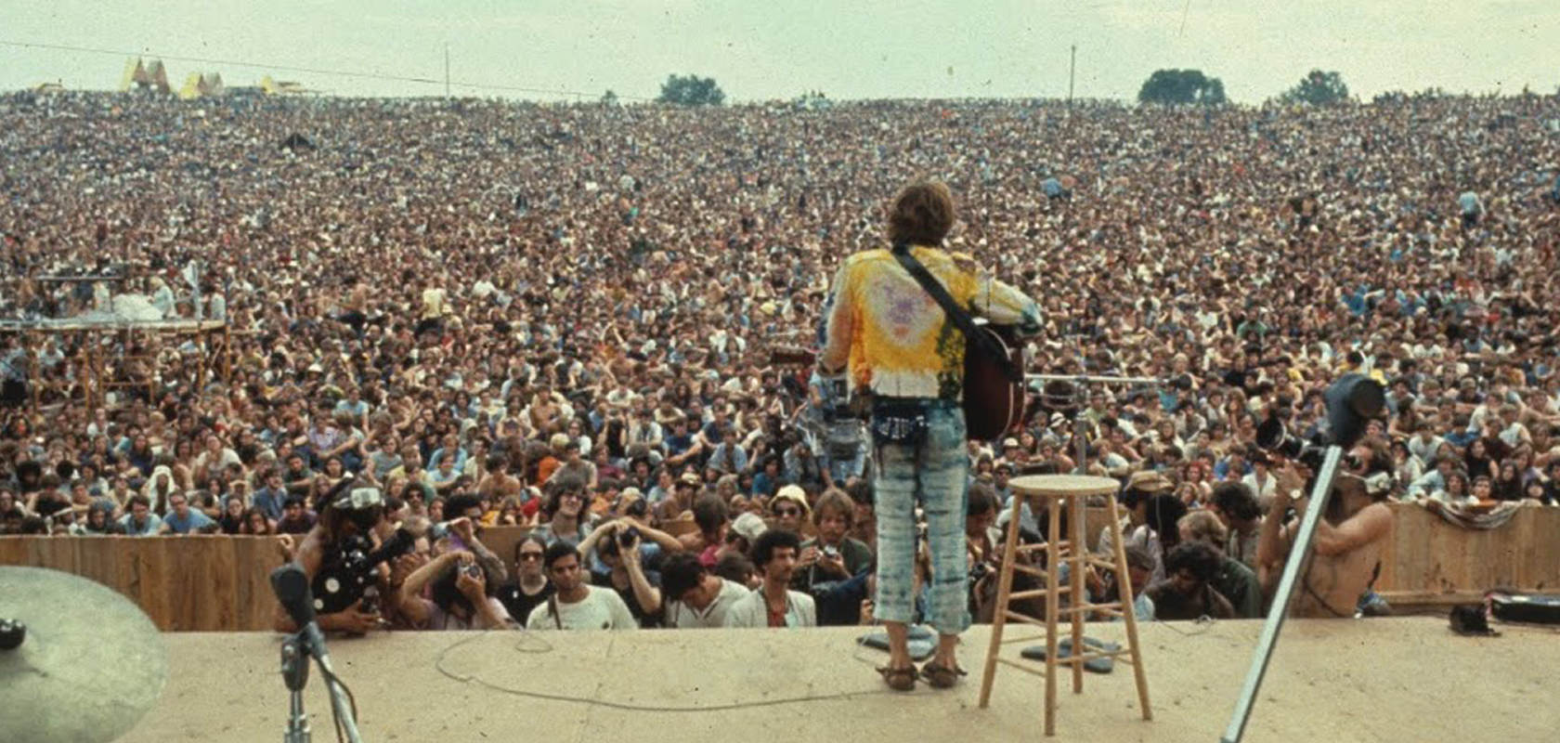
Music in the 1960’s

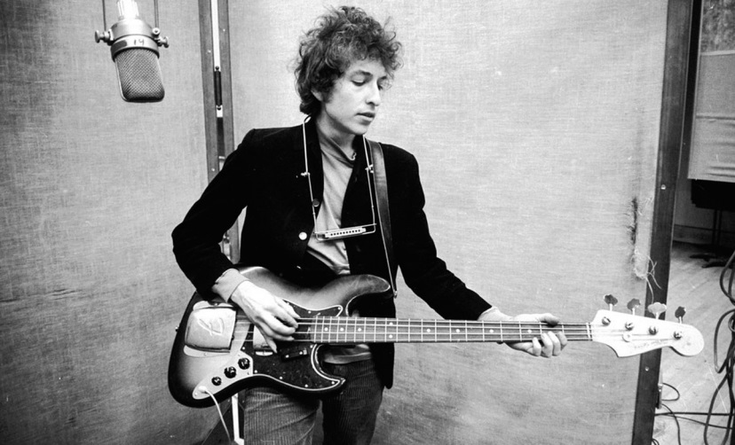
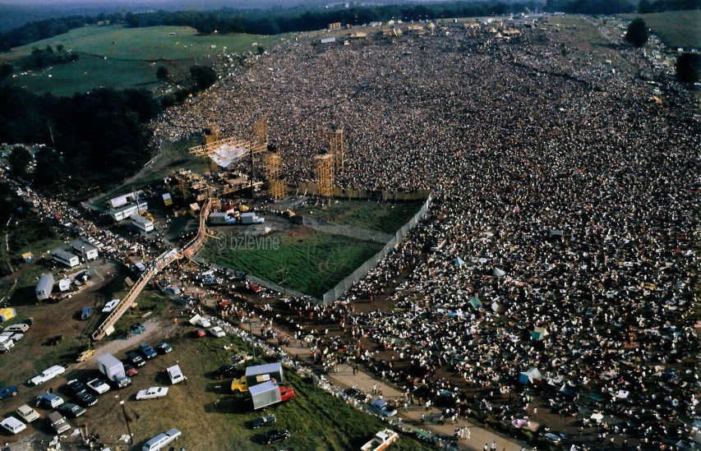

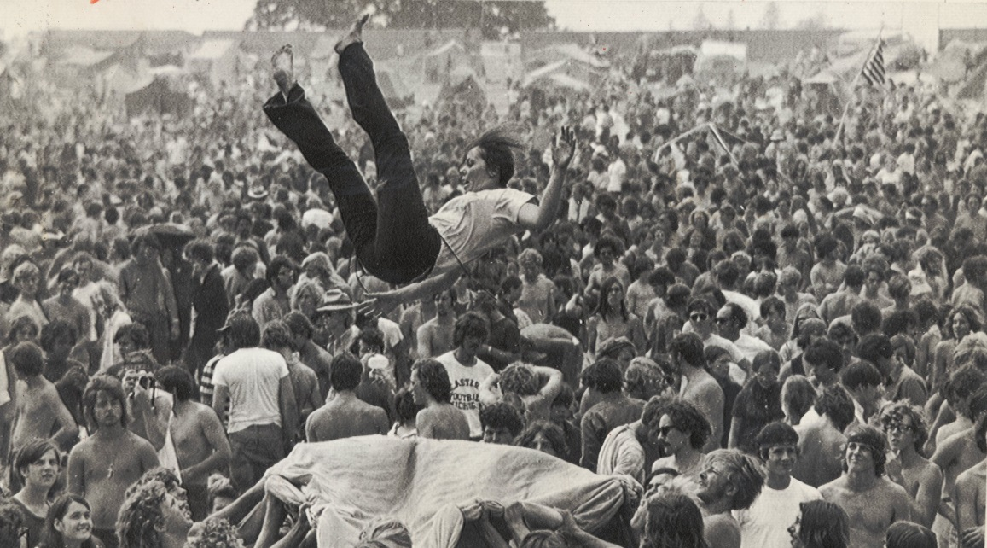

Sexuality in the 1960’s
