Key Events in the Early Cold War
The Beginning: The World War II Alliance Between the Soviet Union and the United States- The Soviet Union and the United States formed an unlikely alliance during WWII after Adolf Hitler invaded the Soviet Union in 1941. Up to this time, the Soviet Union and the United States had been enemies due to their different ideas and beliefs about political and economic systems. While the communist Soviet government believed in socialism, one-party rule, and the social goal of equality, the United States valued capitalism, democracy, and individualism. However, after Hitler’s occupation of France and subsequent invasion of the Soviet Union, the United States, Great Britain and the Soviet Union put aside their differences and formed an alliance to attend to the urgent business of defeating Hitler.
Europe after WWII
West are with the US, East and with the USSR
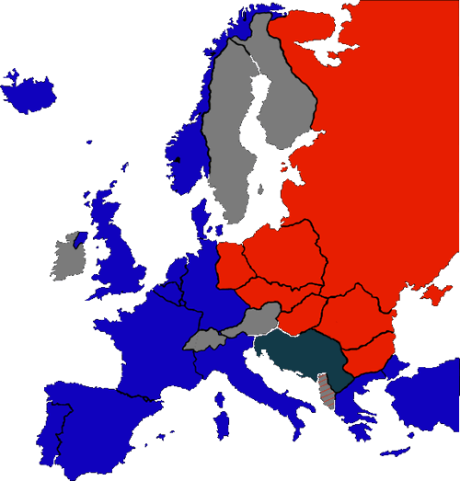
At a 1945 conference in Yalta in the Soviet Union, British prime minister Winston Churchill, U.S. president Franklin D. Roosevelt, and Soviet premier (leader) Josef Stalin agreed on a military plan to end the war and a joint occupation of Germany. Stalin promised to allow free election in Poland, in accordance with Roosevelt’s desire for independent and democratic Eastern Europe (Never Happened). At a later conference in Potsdam, Germany, the Soviet Union and the United States agreed to recognize each others’ influence over regions where their respective troops remained at the end of the war. After the Allies defeated Germany in June 1945, Stalin established Soviet-controlled governments in Eastern European countries occupied by his Red Army, including Poland. The United States objected to these communist governments, but couldn’t do much to prevent them. It became increasingly clear that postwar Europe would be divided into two spheres of influence-East and West- which paralleled the positions of Allied troops following WWII.

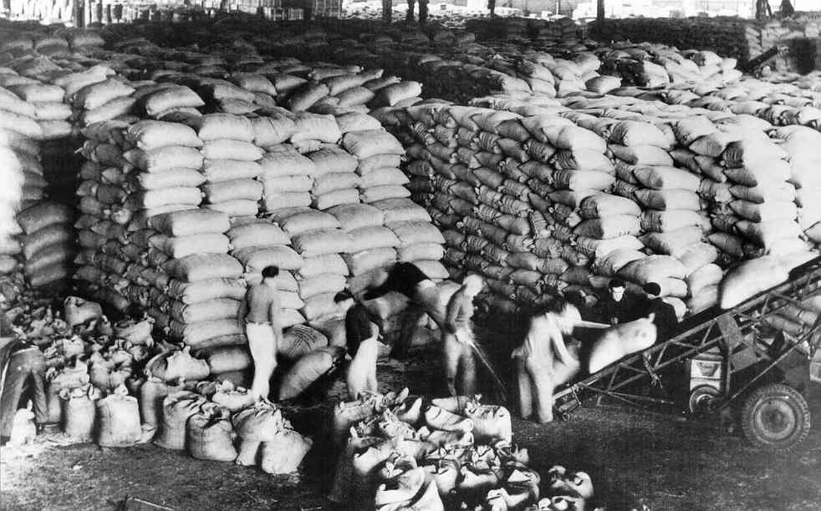
Alliances After WWII-As the Soviet Union tightened its control over Eastern Europe, Roosevelt’s successor, President Harry S. Truman, feared that the entire continent of Europe-devasted by war- was on the brink of economic collapse. Truman was concerned that such a collapse would leave European countries vulnerable to a socialist or even a Soviet-style Communist government. Therefore, in 1947 the United States introduced the Marshall Plan to provide $17 billion in aid for the economic recovery of Europe. Truman stated: “We must be prepared to pay the price of peace, or assuredly we shall pay the price of war.”
Marshall Plan food Shipments In Europe
U.S. leaders promoted the Marshall Plan as an effort to promote world peace and stability. The Soviets, however, perceived it as a clever attempt to support American capitalism by economically enslaving Europe. According to the plan, when accepting American loans European countries agreed to buy American products, thus strengthening the U.S. economy. The Soviet Union refused to let Eastern European nations accept loans from the Marshall Plan. Instead the Soviet Union developed an economic pact of their own, called the Molotov Plan, which was designed to support war-torn Eastern Europe.
In 1949 the United States joined western nations such as Canada, France, Great Britain, Italy, and the Netherlands to form the North Atlantic Treaty Organization (NATO). NATO’s member nations formed a military alliance to protect each other from Soviet aggression. In 1955 the Soviet Union formed a similar military alliance with Eastern European nations such as Czechoslovakia, East Germany, Hungary, Poland, and Romania, known as the Warsaw Treaty Organization, or Warsaw Pact.

Attempted Communist Take Overs in Greece and Turkey- In early 1947 the governments of Greece and Turkey were fighting off Communist rebellions. Great Britain had been supporting the Greek government in its fight against the Communists. However, British funding soon ran dry and Britain appealed to the United States for help. As a result President Truman made a speech on national TV stating that it was the obligation of the United States to “support free peoples who are resisting attempted enslavement by Communists of outside pressures.” The Truman Doctrine, as the speech became known, outlined the Cold War policy of Containment, in which the United States committed itself to containing the spread of Soviet communism. As a result, Truman asked for and received from the U.S. congress $400 million to provide assistance to Greece and Turkey. Helped by U.S. aid, both countries successfully defeated the attempted Communist takeovers.
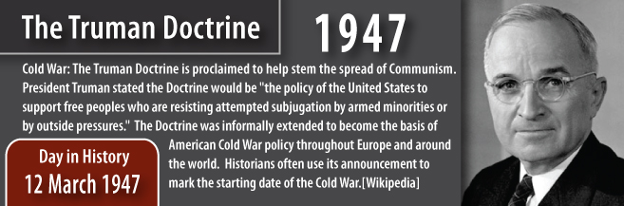

U.S. intervention in Greece and Turkey was one of the first of many times that the Soviet Union and the United states fought each other proxy, or via countries that represented their respective interests. During the Cold War, the Soviet Union and the United States used economic, political, diplomatic, and covert (secret) means to gain influence in or control a region. Then, the superpowers fought proxy wars in which political groups or nations-aligned with either the Soviet Union or the United States-battled to achieve the superpower’s foreign policy. As a result, regional struggles between Communist and non-Communist groups represented the greater, global struggle between the Soviet Union and the United States.

The Development of Nuclear Weapons- On July 16, 1945, the United States successfully tested the world’s first atomic bomb, or A-bomb, in Alamogordo, New Mexico. In August, the United States dropped atomic bombs on the Japanese cities of Hiroshima and Nagasaki, killing thousands of people and ending the war with Japan. The use of the bomb dramatically increased the consequences of armed conflict between the Soviet Union and the United States. This threat forced the Soviet Union and the United States to consider carefully the use of force around the globe, and encouraged both sides to develop their nuclear strength.

In 1947 President Harry S. Truman’s National Security council drafted NSC 68, a secret document that would be, as one historian noted, a “blueprint for American policy in the Cold War.” The authors of NSC 68 warned that Soviet military capability was now “substantially superior to that of the West and continuing to improve at a more rapid rate.” They asserted the United States had “no alternative but to quickly increase its atomic capability.” As a result, the council recommended that Truman increase U.S. military spending to $50 billion a year, which he did within two years.

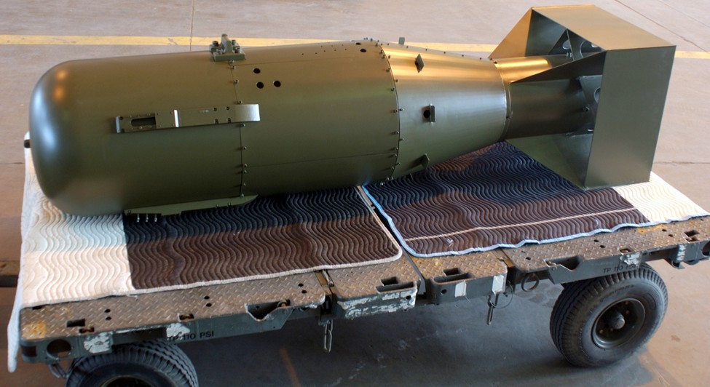
The American monopoly (total control by one group) on nuclear weapons ended in 1949 when the Soviets perfected their nuclear technology and developed a nuclear weapon of their own. In 1952 the United States successfully tested an even more powerful nuclear device, the hydrogen bomb, and the Soviet Union followed suit in 1953. Both sides now competed in a race to build enough nuclear weapons to defeat the other in the event of war. Soon each superpower was armed with enough destructive power to destroy an entire continent, and, later the world.

The Berlin Crisis- At the end of the World War II in 1945, Germany was placed under military rule and divided into zones broadly reflecting the positions of the occupying armies. The Soviets were stationed in the east, the Americans took the south, and the British controlled the northwest. France also controlled parts of the American and British zones. The victors also divided Berlin, the capital of prewar Germany into four separate sectors and established the Allied Control Council to rule Germany. Because Berlin was located deep in Soviet-held territory, Stalin disagreed with the decision to divide Berlin into zones, but Great Britain and the United States refused to compromise.
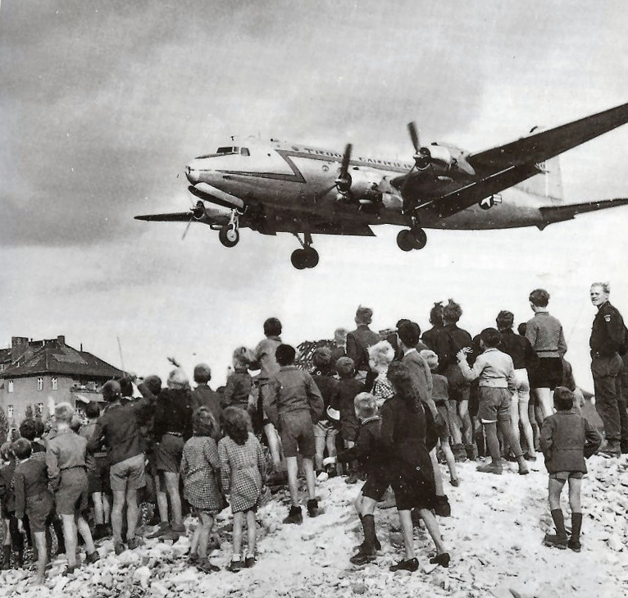
Photograph of the Berlin Airlift when the United States Dropped off Food to Berlin
The Soviets became increasingly certain that the Americans were preparing to create a separate West German state that would be hostile toward communism. In 1948 France, Great Britain, and the United States announced plans to introduce a new form of currency in Germany. In retaliation for not having been directly consulted, the Soviets formally withdrew from the Allied Control Council. When the Allies introduced the new currency in West Berlin, the Soviets protested by instituting a formal blockade of Berlin on June 24, 1948, closing all road, rail and water routes to and from the city. Shortly afterward, Stalin cut off the inhabitants of West Berlin from all supplies of fuel, power, and food. In August 1948 the United States began airlifting supplies to Berlin in an attempt to aid West Berlin without starting an armed conflict with the Soviet Union. This effectively became known as the Berlin Airlift. After almost a year, Stalin reopened all routes into Berlin on May 12, 1949. However, Berlin remained a divided city, and in 1961 the Soviet Union built a wall, called the Berlin Wall, between East and West Berlin to prevent people from escaping to the west.

The Korean War- In 1949, Mao Zedong successfully led the Communist Revolution in China. Mao’s Communist government quickly allied itself with the Soviet Union, and both countries signed a mutual defense and economic aid agreement. China had been allies with the United States during WWII’s Pacific war against Japan, and the United States had supported the Chinese nationalist government defeated by Mao during the Communist Revolution. Consequently, the United States looked upon China’s alliance with the Soviet Union with alarm and hostility.

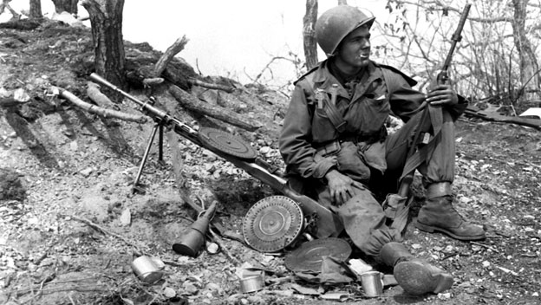
The Korean War in 1950 increased American alarm over the spread of communism in Asia. After WWII, the northeast Asian country of Korea was divided at the 38th parallel into two countries. North Korean, supported by the Soviet Union, and South Korea, supported by the United States and the United Nations. One June 25, 1950, with arms provided by the Soviet Union, Communist North Korea invaded South Korea. The United Nations quickly condemned the invasion and authorized sending troops to the region under the leadership of U.S. general Douglas MacArthur. Following a brilliantly planned amphibious invasion, MacArthur’s troops pushed the North Koreans northward almost to the Chinese border and made plans for a Christmas victory celebration. At this point, the nervous Chinese sent one million “volunteers” into the fighting. U.S. troops were pushed back into South Korea, even losing Seoul, the southern capital. General MacArthur called for all-out war against China. “In war,” decaled the general, “these can be no substitute for victory.” Truman disagreed. He advocated limited war. He feared that the Soviets might be drawn into the fighting and the onset of a third world war. MacArthur was fired for taking his stand public. The Korean War Ended in a stalemate in July 1953.

