Lesson 24 - The Rise of Industry Section 3 - Improved Technology
By the 1860s, many of the factors necessary for the rapid industrialization of the United States were already in place. Machines had taken over much of the work once done by hand. Work had moved from homes to factories. Railroads had begun to connect customers and manufacturers with an efficient transportation system.
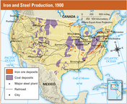
After the Civil War, new inventions and improved technology prompted the growth of new industries. Some of these innovations, or new ideas, helped businesses to grow and become more efficient. Others made daily life easier for many Americans.
The Age of Steel Before the Civil War, the nation’s railroads ran on iron rails that wore out quickly. Railroad owners knew that rails made of steel—a mixture of iron, carbon, and sometimes other metals— were stronger and would last longer. Steel, however, was difficult and costly to make.
In 1872, a Scottish immigrant named Andrew Carnegie went to England to study a less expensive method of making steel, a method invented by Henry Bessemer. Carnegie owned a company that made iron bridges for railroads. He knew that his bridges would be better if they were made of steel. Carnegie was so impressed by the Bessemer process that he brought it back to the United States. “The day of iron has passed,” he announced. “Steel is king!”
Carnegie was right. Within a decade, steel was replacing iron in rails, locomotives, and bridges. Other industries took advantage of steel, which was less expensive than iron. Steel nails, needles, and knives became common household items.
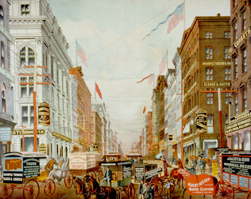
Many steel companies competed fiercely to supply steel for such products. To remain the leader, Carnegie hired scientists to improve the quality of his company’s steel. He employed good managers to make his steel mill run efficiently. His recipe for success was “adopt every improvement, have the best machinery, and know the most.”
To keep costs low, Carnegie set out to control every step in the steelmaking process. He purchased iron mines to supply his ore, coalfields to fire his furnaces, and railroads to ship his finished steel to customers.
To reduce his competition, Carnegie also bought up several rival steel companies. He then combined them all to form the giant Carnegie Steel Company. By 1900, Carnegie Steel produced a quarter of the nation’s steel.

Electric Power In 1876, Thomas Edison opened an “invention factory” in New Jersey. With a team of workers, he set out to create a “minor” invention every ten days and a major one “every six months or so.”
Edison succeeded brilliantly. More than any other inventor, he helped turn electricity into an everyday source of light and power. His workshop turned out the first practical electric lightbulb, the phonograph (record player), the motion picture projector, and many other inventions.
In 1882, Edison built the first electrical power station and distribution system in New York City. His team invented everything the system required, including generators, regulators, meters, switches, light sockets, fuse boxes, and underground electric cables. When he finally turned the generator on, electricity began to flow to homes, stores, and factories. The age of electricity had begun.
By 1900, some 25 million lightbulbs were glowing across the country. Many factories were replacing waterwheels and steam engines with electric motors. Streetcars powered by electricity carried workers and shoppers along city streets. New electric-powered devices, such as washing machines and vacuum cleaners, were making housework easier.
The Telephone The telephone was invented by a Scottish immigrant, Alexander Graham Bell. In 1876, as he was getting ready to test his “talking machine,” Bell spilled acid on himself. “Watson—come here—I want to see you,” he commanded his assistant. Thomas Watson, who was in another room, heard every word over Bell’s telephone.
Bell’s invention worked so well that, by 1915, Americans were communicating with one another over 9 million telephones. All these telephones made American industry more efficient and competitive by allowing producers, sellers, and customers to communicate quickly and easily.
New Production Methods New methods of organizing work were also making businesses more efficient. Factory owners adopted Eli Whitney’s idea of assembling a wide variety of products from interchangeable parts. They also used the assembly line. In a shoe factory, for example, one worker operated a heel-cutting machine. Another operated a sole-cutting machine. Another made shoelaces. Still other workers assembled, labeled, and packaged the shoes.
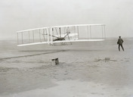
Henry Ford was one person who foresaw the great potential in the assembly line. Ford created a moving assembly line to mass-produce automobiles. In Ford plants, workers stood in place all day, while a conveyor brought the work to them. After each worker did one or two tasks, the belt moved the product to the next worker’s station.
These techniques of mass production enabled workers to produce more goods per day at a lower cost. As prices dropped, more Americans could afford to buy manufactured products. More customers meant more factories. By 1900, almost four times as many Americans worked in factories as had a generation earlier.
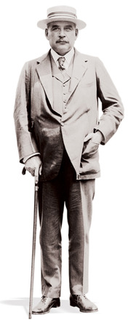
Air Transport While Henry Ford was turning out cars on the assembly line, brothers Orville and Wilbur Wright were experimenting with flying. In 1903, with his brother Wilbur running alongside, Orville successfully piloted the first “flying machine” in Kitty Hawk, North Carolina. Although the flight was only 12 seconds in duration, it sparked worldwide interest in flying.
By the late 1920s, an industry based on air travel had emerged. The U.S. postal service used planes to transport mail across the country while the military used planes for exploration and scouting. At the same time, wealthy Americans took their first commercial flights across the country.

Lesson 24 - The Rise of Industry Section 4 - The Rise of Big Business
When Andrew Carnegie opened his first factory in 1865, most businesses were still owned by one person or a few partners. Because the owners’ funds were limited, businesses were small. Owners knew their employees and often treated them like family.
Growth of Corporations A partnership might work well for a garment, or clothing, factory. But big businesses, such as railroads, needed much more capital (money to start a business) than a few partners could provide. To raise larger sums of money, entrepreneurs set up corporations. A corporation is a business that is owned by many investors, or people who help pay the business’s initial expenses.
A corporation raises funds by selling stock, or shares in a business. Investors who buy the stock are known as stockholders. In return for their investment, stockholders hope to receive dividends, or a share of the corporation’s profits.
The money invested by the stockholders is used to build the business. To make sure their money is used properly, stockholders elect a board of directors. The people on the board of directors oversee the running of the corporation.
After the Civil War, corporations attracted large amounts of money from investors. By the 1880s, thousands of corporations were doing business across the United States.
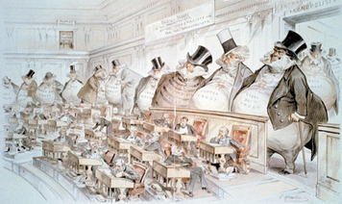
Rockefeller’s Oil Trust A giant in the oil business, John D. Rockefeller introduced another form of business organization, the trust. A trust is a group of corporations run by a single board of directors.
Rockefeller invested in his first oil refinery in 1862, at the age of 23. At that time, petroleum, or oil found underground, was just becoming a valuable resource. Oil refineries purify petroleum into fuel oil. During the 19th century, oil was used to light homes, cook food, and run engines and generators.
Before long, many small refineries were competing fiercely in the oil business. The amount of oil these firms produced rose and fell wildly, along with prices. Rockefeller saw this as wasteful and inefficient. To reduce competition, he did everything he could to drive his rivals out of business. Companies he could not destroy, he bought.
Like Carnegie, Rockefeller took control of every step of his business. He bought oil fields along with railroads, pipelines, and ships to move his oil. He built his own warehouses and even made his own oil barrels for storing oil products. By 1880, Rockefeller controlled 95 percent of the nation’s oil-refining industry. To manage his many businesses, Rockefeller combined them into the Standard Oil Trust. The trust made the oil industry more efficient than ever before. But, as a monopoly, the trust had the power to control oil prices. This worried people who depended on oil in their homes and businesses.
Following Rockefeller’s example, entrepreneurs created trusts in other businesses such as railroads, meatpacking, sugar, whiskey, and tobacco. The business leaders who controlled these huge trusts became fabulously wealthy. Because most had made their fortunes by crushing their competitors, critics called them “robber barons.”
The Evils of Trusts The growth of trusts alarmed many Americans. They saw these monopolies as a threat to the free-enterprise system. This system depends on free competition among businesses to provide the public quality products at fair prices. A monopoly, people argued, has little reason to improve its products or to keep prices low because it has no competition.
People also worried about the influence of trusts on the political process. Wealthy entrepreneurs, they complained, were using their enormous wealth to buy elections and corrupt public officials. As the Chicago Tribune warned, “liberty and monopoly cannot live together.”

