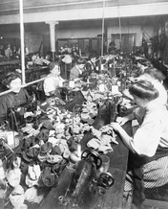
Lesson 24 - The Rise of Industry Section 1 - Introduction
On Saturday, March 25, 1911, the quitting bell had just sounded at the Triangle Shirtwaist Factory in New York City. Nearly 500 employees, most of them young immigrant women, headed toward the exit. It was Saturday, and they were looking forward to a day off with family and friends.
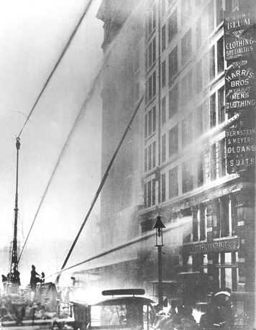
One woman sniffed the air. Something was burning! Another spotted flames leaping out of a pile of cloth scraps. Before she could react, the wooden table above the fabric was ablaze. From there, the flames jumped to the paper fabric patterns hanging above the table. Flaming bits of paper and fabric whirled around the room, setting other tables on fire.
The room filled with smoke. The air became so hot that it burst the windows. Fresh air poured into the room, sending the flames even higher. The fire started to scorch workers’ clothing and hair. “I heard somebody cry, ‘Fire!’ I left everything and ran for the door,” recalled one woman. “The door was locked and immediately there was a great jam of girls before it.” She could see at once that “if we couldn’t get out, we would all be roasted alive.”
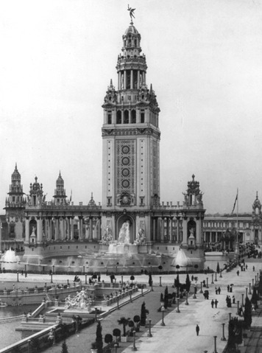
Factories and their dangers were a relatively new part of life in the United States. After the Civil War, new inventions and business methods allowed Americans to create industry on a much larger scale than ever before. The rise of industry brought great benefits. New inventions, such as the telephone, made life better for many people. New ways of making products, such as using the assembly line to make cars, made it possible for more Americans to raise their standard of living. The people who were employed in new industries often lived and worked in miserable and even dangerous conditions. In this chapter, you will learn about both the benefits and costs of industrialization.

24-2: The Rise of Industry – A Nation Transformed Industrialization clearly brought benefits to some. On March 26, 1883, Alva Vanderbilt threw a party to show off her family’s new home in New York City. It was not just a party, it was a grand ball—the most dazzling social event in the city’s history. And it was not just any home. The Vanderbilts had built a mansion in the style of a European castle, complete with medieval furniture, tapestries, and armor.
But then, the Vanderbilts were not just any family. Mrs. Vanderbilt’s husband was William Kissam Vanderbilt, a railroad industrialist. He was the grandson of Cornelius Vanderbilt, who had made a fortune in banking and shipping. The Vanderbilt clan was one of the country’s wealthiest and most powerful families.
More than 1,200 of New York’s social elite flocked to Mrs. Vanderbilt’s ball, dressed in glittering costumes. Many of the guests came as kings and queens. But Mrs. Vanderbilt’s sister-in-law decided to be more modern. She came dressed as the electric light. Mrs. Vanderbilt’s party reflected the way industrialization was transforming American life in the decades after the Civil War. Cities like New York were booming. Entrepreneurs in banking, commerce, and industry were gaining enormous wealth. Technological marvels like the electric light were changing how Americans lived and worked. But not everyone benefited from this progress.
The Growth of Big Business Families like the Vanderbilts made huge profits from the growth of big business after the Civil War. Businesses got bigger in part because of new technology and manufacturing practices. They also grew because the rise of banking and financial institutions gave people more opportunities to borrow money to start businesses. Bankers were happy to invest the necessary funds in hopes of earning large returns. Some of the money that fueled industrialization came from the large-scale mining of gold and silver in the West.
Government policies also contributed to the boom in big business. According to the theory of laissez-faire (leh-say-FAIR), economies work best with minimal government involvement. (Laissez-faire is French for “to let alone.”) The idea of laissez-faire was that government should not regulate the price or quality of goods, the working conditions of laborers, or the business practices of bankers and industrialists.
Some types of government involvement protected business and industry. Federal, state, and local governments helped business and industry through favorable laws and subsidies, such as the land grants given to railroads and farmers. A key exception during this period was the Interstate Commerce Act of 1887. The law targeted interstate commerce as practiced by the railroad industry, which operated across state lines and therefore was not under the authority of state laws. The act required railroads to make shipping rates fair for all customers, banning the practice of giving lower rates to companies who shipped large amounts.
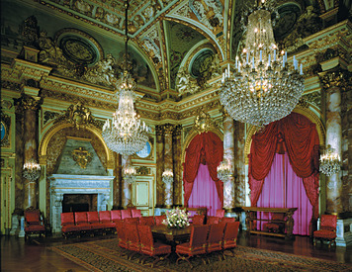
The business boom fed the growth of American cities. For 100 years, Americans had been going west to seek their fortunes. In 1890, the Census Bureau said that the frontier line no longer existed. This was the imaginary line on the continent beyond which the country’s population density was less than two persons per square mile. The 1890 census marked the closing of the frontier. The new “land of opportunity” was located in the cities of the Northeast and around the Great Lakes, where factories provided thousands of new jobs.
Outside cities, even farming was getting to be big business. Commercial farmers used new machinery and techniques to grow crops on a larger scale than ever before. “Nothing is too large for belief,” reported one writer in 1887. “Twenty and even thirty thousand acre farms . . . The New West . . . is a veritable ‘Wonderland.’”
The Gilded Age As businesses got bigger, so did the fortunes of those who owned or invested in them. Between 1860 and 1892, the number of millionaires in the United States grew from 400 to more than 4,000. The newly rich filled their palace-like homes with elaborate decorations and European art and antiques. In 1873, the great American writer Mark Twain dubbed this time of showy wealth “the Gilded Age.” (Gilded means overlaid with gold.) Twain’s name stuck, but it did not describe the lives of most Americans. While wealthy capitalists lived like royalty, many workers lived in dismal poverty. Those who were immigrants often faced discrimination. During business downturns, many workers lost their jobs. People were angry about the relationships between some business owners and politicians that resulted in widespread corruption. These conditions eventually sparked protests and calls for reform.

