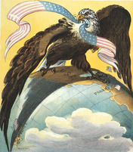
Section 1 - Introduction
William McKinley owed Theodore Roosevelt a big favor. Roosevelt had just helped him get elected president. Roosevelt had spoken all over the United States in 1896, promoting McKinley’s support of business and industry. With energy and inspiration, he attacked McKinley’s opponents. These were Democrats who had adopted some Populist ideas. With the nation in the midst of an economic depression, Roosevelt feared political instability. He cried that McKinley’s opponents planned nothing less than “revolution.”
Now Roosevelt wanted McKinley to appoint him to be assistant secretary of the navy. McKinley, who favored peace, feared that Roosevelt was too warlike. Still, he gave Roosevelt the job. As he took office, Roosevelt said, “No triumph of peace is quite so great as the supreme triumphs of war . . . It is through strife, or the readiness for strife, that a nation must win greatness.”
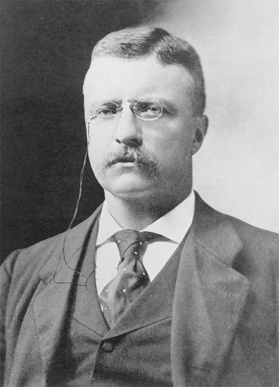
Some newspapers called Roosevelt patriotic. Others worried that he would push the country into war. Americans had mixed feelings about getting involved in international affairs. Expanding across the continent had given the United States territory to move into for decades to come. Recovery from the Civil War, followed by industrial expansion, had also given Americans plenty to focus on at home.
Now the West was more settled, and the United States was an industrial and agricultural leader. To keep the economy growing, business leaders wanted to market and sell products overseas. The national pride that had inspired Manifest Destiny was calling for new challenges.
Theodore Roosevelt agreed. He allied himself with expansionists— people who wanted to extend the nation’s power within the Western Hemisphere and around the world. In this chapter, you will learn how expansionists achieved their goals. As it flexed its muscles overseas, the United States gained new territories and became a world power.

The Nation Stretches Its Wings

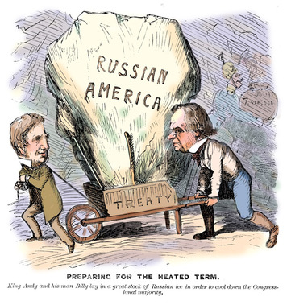
In 1867, Secretary of State William Seward arranged for the United States to purchase Alaska from Russia. At the time, few people thought that acquiring this vast wilderness was a good idea. Even at a price of just two cents an acre, many labeled the deal “Seward’s Folly.”
But the “arctic wasteland” turned out to have thick forests, plentiful fish and wildlife, and mild coastal climates. Eventually, settlers would discover gold, copper, coal, and other minerals there. With such natural resources at stake, expansionists felt that the United States should gain control over other areas of the world as well.
In addition to arranging the purchase of Alaska, Seward also secured the rights to the Midway Islands. Located in the Pacific Ocean between California and Asia, the Midway Islands were annexed by the United States in 1867.
Rise of Expansionism Some Americans objected to expansionism, saying that it was contrary to American values. Taking over other lands, declared former senator Carl Schurz, would mean that “our old democratic principle that governments derive their just powers from the consent of the governed will have to go overboard.”
Others warned that such takeovers would cause revolutions abroad. Some raised racist objections, arguing that nonwhites in other countries could never learn American values.
William Jennings Bryan, who had run for president against McKinley, believed that the United States could be powerful without taking over other lands. He said that the nation “has exerted upon the human race an influence more potent for good than all the other nations of the earth combined, and it has exerted that influence without the use of the sword or Gatling [machine] gun.”
By the 1890s, however, American business leaders were eager to dig mines and establish plantations in new places. Others wanted new markets for finished products. For years, European countries had been practicing imperialism, building empires by taking control of the governments and economies of other countries. U.S. expansionists wanted to follow their example. Senator Henry Cabot Lodge declared, “Commerce follows the flag . . . As one of the great nations of the world, the United States must not fall out of the line of march.”
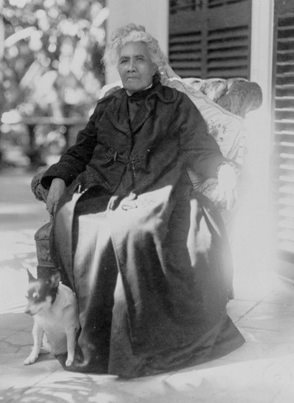
Annexing Hawaii Commerce drove U.S. expansionists to develop an interest in Hawaii, a group of islands located in the Pacific Ocean. Americans had first come to these islands in the 1820s as missionaries. Their goal was to convert the native Hawaiians to Christianity. The Hawaiians, whose ancestors had come from the South Pacific, had lived on these islands for more than a thousand years. They were ruled by their own kings and queens.
In 1835, a Boston merchant established a large sugar plantation in Hawaii. Before long, American-owned sugar and pineapple plantations dotted the islands. The planters brought laborers to Hawaii from China and Japan to work in their vast fields. Under pressure from the planters, the Hawaiians agreed in 1887 to let the United States establish a naval base at Pearl Harbor, on the island of Oahu (oh-AH-hoo). The planters also persuaded Congress to allow Hawaiian sugar to be imported into the United States without paying any tariff (import tax).
U.S. sugar growers objected that the law now favored Hawaiian sugar over domestically grown sugar. They convinced Congress to give a bonus to growers in the United States. Hawaiian planters wanted that bonus, too. So they asked the United States to annex Hawaii.
Meanwhile, native Hawaiians increasingly resented being pushed around by Americans. When Queen Liliuokalani (lee-LEE-uh-wohkuh-LAH-nee) took the throne in 1891, people rallied around her call of “Hawaii for Hawaiians.” Americans in Hawaii feared that they would lose their land. With help from U.S. marines in 1893, sugar planters forced Queen Liliuokalani to give up her throne. Now in control, the planters established a new government for the islands.
Despite the planters’ wishes, President Grover Cleveland refused to support the annexation of Hawaii. Cleveland, who opposed imperialism, said that Hawaii should be ruled by Hawaiians. But in 1898, under President McKinley, the United States did annex Hawaii.
U.S. Interest in Japan and China In the mid- to late 1800s, the United States turned its attention to Japan and China. The U.S. government signed a trade treaty with Japan in 1858. Several European countries had made efforts to control trade with China. The United States wanted to maintain its own access to Chinese markets. In 1899 and 1900, the U.S. government issued what became known as the Open Door Policy. It called on foreign nations to allow free trade in China.

“A Splendid Little War”
Closer to the United States, Americans established huge sugar plantations on the Caribbean island of Cuba, only 90 miles from Florida. Like nearby Puerto Rico, Cuba was still a Spanish colony.
By the 1890s, U.S. expansionists wanted to annex both of these islands. To support their ambitions, they argued that it was time for the United States to enforce the Monroe Doctrine. No European country, they said, should control territory in the Western Hemisphere.
Cubans Struggle for Independence The Cubans themselves had staged an unsuccessful revolt against Spain in 1868. In 1895, under the leadership of José Martí (ho-ZAY mar-TEE), Cubans again tried to win their independence.
To crush this movement, the Spanish herded men, women, and children into “reconcentration camps.” Forced to live with inadequate food and medical care, tens of thousands of people died.
U.S. newspapers jumped at the chance to report stories of Cuban suffering. Competing fiercely for customers, some newspapers resorted to yellow journalism, offering sensational and shocking reports. Some of these stories were based on rumors and untruths. One said that a Spanish general was “feeding prisoners to sharks.”
As sympathy for Cubans grew, more and more Americans were willing to go to war for Cuba. To help Americans in Cuba in case of trouble, President McKinley sent the new battleship USS Maine to the island’s capital city, Havana, in January 1898.
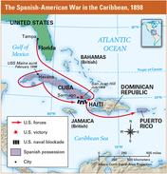
The Spanish-American War Trouble soon erupted in Havana. About three weeks after the Maine arrived, an explosion destroyed the battleship, killing 260 U.S. sailors. No one knew whether the explosion was caused by an accident, a mine, or a bomb. But many Americans were quick to blame Spain.
Young men rushed to join the army, raising the battle cry “Remember the Maine!” Senators shouted, “Free Cuba!” Hoping to avoid war, McKinley offered to work out a solution between the Spanish and Cubans. But the Spanish did not respond.
Under pressure from newspapers and members of Congress calling him a coward, McKinley asked Congress to declare war. Congress quickly agreed and, in April 1898, voted to go to war with Spain. At the same time, Congress approved a resolution stating that the United States intended “to leave the government and control of the Island [Cuba] to its people.”
The U.S. Army quickly grew from 30,000 to over 274,000 men. Roosevelt resigned from his position as assistant secretary of the navy and put together his own regiment. A mixture of powerful, wealthy men and seasoned ranch hands, it came to be called the Rough Riders.
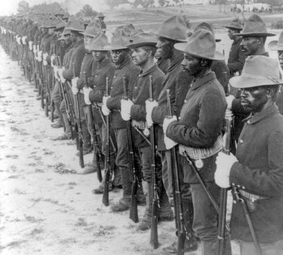
After long preparations, the Rough Riders and 17,000 other Americans arrived in Cuba in June 1898. Seeing that Cuban fighters lacked the strength or weapons to force the Spanish out of fortified cities and harbors, Roosevelt and his Rough Riders decided to capture Santiago, a major city. To do this, they had to capture nearby San Juan Hill, from which Spanish forces were able to defend the city.
The attacking force included the Rough Riders and African American troops from several regiments. Up the hill the troops charged, braving Spanish fire. “They walked to greet death at every step, many of them, as they advanced, sinking suddenly or pitching forward . . . but others waded on, stubbornly, forming a thin blue line that kept creeping higher and higher up the hill,” wrote an American reporter. “It was a miracle of self-sacrifice, a triumph of bull-dog courage.”
The Americans captured San Juan Hill. Realizing that Santiago was lost, the Spanish tried to save their ships, sending them steaming out of the harbor. But Americans sank or captured every ship. The Spanish soon surrendered.
The Spanish-American War lasted just four months. Only 345 Americans died in combat, although 5,500 died of disease. Many Americans agreed with Secretary of State John Hay that it had been “a splendid little war.”
Under the terms of the peace treaty between the United States and Spain, Cuba gained its independence from Spain, and Puerto Rico came under U.S. rule. Spain also ceded Guam, an island in the Pacific Ocean, to the United States. In a 1903 treaty with Cuba, the United States leased land in Cuba to establish a naval base at Guantánamo Bay.

The Philippines
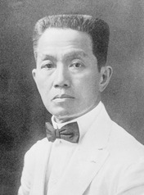
After the Maine exploded in Cuba, Assistant Secretary of the Navy Theodore Roosevelt sent a telegram to Admiral George Dewey, the head of the U.S. fleet in the Pacific. “In the event of declaration of war,” the telegram ordered, “[begin] offensive operations in Philippine Islands.” The Spanish-American War had expanded to include the Philippine Islands, halfway around the globe from Cuba.
Battle at Manila Bay The Philippines provided Spain’s main base in the Pacific. The islands’ people, called Filipinos, had tried many times to throw off Spanish colonial rule. In 1898, they were trying again. Led by General Emilio Aguinaldo (ah-ghee-NAHL-doh), they had begun attacking the Spanish army and government officials. Now their struggle was about to become part of the war between the United States and Spain.
Dewey’s fleet arrived in Manila, the Philippine capital, just five days after the United States declared war against Spain. At dawn on May 1, 1898, U.S. battleships faced Spanish gunships. As naval bands struck up “The Star-Spangled Banner,” sailors stood on deck and saluted the flag. These men were about to engage in what would be the first battle of the Spanish-American War.
By 11 A.M., the entire Spanish fleet was burning, sunk, or sinking. Spain’s old wooden ships were no match for the modern steel U.S. ships with well-trained crews. Only one American had died in the battle.
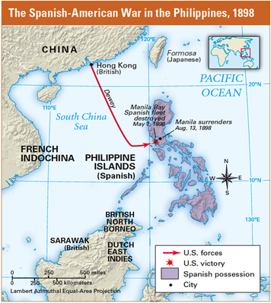
Defeating the Spanish Dewey blockaded Manila’s port until U.S. troops could arrive to take over the city. Filipino fighters, allied with Dewey, surrounded Manila. The Filipinos believed that the coming Americans would help them gain independence. While they waited, Aguinaldo issued the Philippine Declaration of Independence, formed a national government, and designed a national flag.
Once U.S. reinforcements showed up, the Spanish agreed to “lose” a fake battle and surrender to the Americans. They didn’t want to give themselves up to the Filipinos, who resented Spanish rule so intensely.
Fighting the Filipinos In a treaty negotiated after the surrender, the United States “bought” the Philippines from Spain for $20 million. Then, in 1899, Congress voted to annex the Philippines.
Aguinaldo’s government felt betrayed. Angrily, the Filipino leader called for “war without quarter to the false Americans who have deceived us! Either independence or death!” For three years, more than 80,000 Filipino fighters fought off better-trained and better-armed U.S. troops. Soldiers on both sides tortured prisoners. Americans became increasingly cruel, harming civilians and destroying villages.
Some Americans protested that denying independence to the Philippines violated U.S. ideals. Carl Schurz, a leader among anti-imperialists, said, “We shall, for the first time since the abolition of slavery, again have two kinds of Americans: Americans of the first class, who enjoy the privilege of taking part in the Government . . . and Americans of the second class, who are to be ruled . . . by the Americans of the first class.”
But the expansionists won the day. Senator Henry Cabot Lodge argued that “Manila with its magnificent bay . . . will keep us open to the markets of China.” President McKinley himself believed that the Philippines could become “a land of plenty.”
More than 20,000 Filipinos and about 4,000 Americans died in the struggle. When the revolt was finally put down, the Americans set up a nonmilitary government to “prepare Filipinos for independence.” Americans built roads, hospitals, and schools. But the United States did not grant the Philippines independence until 1946.

Section 5 - Panama and the Canal
In the 1900 presidential election, President McKinley won a second term in office. His vice president was Theodore Roosevelt, America’s favorite hero from the Spanish-American War. In September 1901, McKinley was shot and killed by an assassin, and Roosevelt became president.
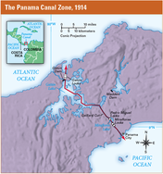
Roosevelt Calls for a Canal In his first speech to Congress as president, Roosevelt called for the United States to build a canal to join the Atlantic and Pacific oceans. “No single great material work which remains to be undertaken on this continent is of such consequence to the American people,” he told the lawmakers. President Roosevelt wanted to make the United States a great power that could exert influence around the world. A canal would be a way to achieve this goal. If ships could move between the Atlantic and Pacific, the U.S. navy would be better able to defend the nation’s new territories gained in the Spanish-American War. In addition, businesses would benefit from lower shipping costs.
Congress soon approved funding. In 1903, Roosevelt offered Colombia $10 million for land in their province of Panama, the narrowest part of Central America. The Colombian senate refused, believing that the United States was trying to take a weaker country’s valuable resources.
Furious, Roosevelt sent a U.S. warship to Panama. Roosevelt knew that Panamanians wanted independence from Colombia. The day after the ship arrived, a revolution started in Panama. With U.S. marines keeping Colombian soldiers from reaching Panama’s harbors, the rebels quickly won.
The new country of Panama agreed to accept $10 million in exchange for giving the United States control over a “canal zone” ten miles wide. Some U.S. senators and newspapers—and countries all over the world—objected to America’s “gunboat diplomacy.” But most of the public supported the president.
Roosevelt once wrote, “I have always been fond of the West African proverb: ‘Speak softly and carry a big stick; you will go far.’” He believed in working patiently to achieve goals overseas but using force if necessary. His strong approach to foreign affairs became known as the Big Stick Policy.
Building “The Big Ditch” Construction on the canal began in 1904. Workers faced terrible conditions. “We had to bathe, wash our clothes in the same river; drink the same river water and cook with it,” said one. A year later, three-quarters of American workers had quit the project.
The majority of employees were workers from the West Indies who could not afford to go home. To prevent deadly yellow fever and malaria, crews worked to eliminate the mosquitoes that carried these diseases. They drained ditches, spread oil on swamps, and screened doors and windows. Within two years, canal workers were no longer dying from these diseases.
A new chief engineer improved housing and strictly organized the huge project. Using dynamite and huge steam shovels, men made a wide, deep cut through Panama’s mountains. The excavated dirt was moved by railroad car to lower elevations. Here, workers created earthen dams to form three giant lakes. Engineers supervised the construction of locks, a type of gate that would allow water levels to be raised and lowered along the canal.
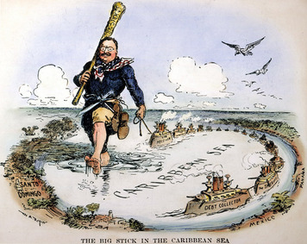

In 1904, when construction of the canal was underway, Roosevelt made another speech to Congress that made the Big Stick Policy an official part of his foreign policy. He reminded his audience that the Monroe Doctrine was issued by President Monroe in 1823 to prevent further European colonization in the Americas. Yet nearly a century later, Roosevelt noted, many countries in the hemisphere were still too weak to defend themselves. He said that the United States therefore must use “international police power” to preserve peace and order in the Western Hemisphere and protect American interests. He claimed that this power would help protect weak nations. Roosevelt described this power as a direct extension of the Monroe Doctrine. For that reason, his statement became known as the Roosevelt Corollary to the Monroe Doctrine.
By the time the 51-mile-long canal opened in 1914, Roosevelt had left office. His influence in the Panamanian revolution continued to be controversial. Roosevelt himself admitted, “I took the Canal Zone.” In 1921, Congress apologized to Colombia and gave it $25 million. But anti-American feelings remained high in Latin America, and Panamanians increasingly resented U.S. control of the Canal Zone. In 2000, the United States returned the zone to Panama.

Section 6 - The Outbreak of World War I
By the time the first ship sailed through the Panama Canal, the world’s attention was not on Panama, but on far-off Europe. In August 1914, German troops poured across Belgium, on their way to try to conquer France. Europe was at war.
Tensions in Europe European countries had long competed with each other for colonies, trade, and territory. By the early 1900s, nationalism was complicating these rivalries. Austria-Hungry had built an empire by taking over smaller countries in the part of eastern Europe known as the Balkans. Nationalism inspired in the Balkan people a burning desire to be independent of Austrian rule.
As tensions grew, European leaders looked for safety in militarism, a policy of glorifying military power and military ideas and values. When Germany built up its navy to challenge Great Britain’s fleet, Great Britain constructed more battleships. As Germany’s army grew, France built up its own army.
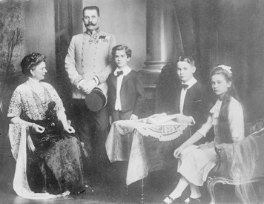
European countries also looked for safety in alliances. In secret treaties, Germany and Austria-Hungary agreed to help each other in case of attack. Great Britain, Russia, and France made similar agreements. Europe was dividing into what amounted to armed camps.
Assassination Leads to War An outburst of nationalism lit the fuse of war. On June 28, 1914, the heir to the Austro-Hungarian throne, Archduke Franz Ferdinand, was visiting the city of Sarajevo in the province of Bosnia. Many Bosnians were Serbs who wanted to be part of nearby Serbia instead of Austria-Hungary. A Serbian nationalist jumped out of a crowd and fatally shot the archduke and his wife.
Outraged, Austria-Hungary accused Serbia of having a hand in the assassinations and pressured Serbia to give up most of its independence. When the Serbs refused, Austria-Hungary declared war. The Russians stepped in to defend the Serbs. The Germans came to the aid of Austria-Hungary by declaring war on Russia. Russia’s ally, France, began to prepare for war.
Eventually, more than a dozen countries took sides in the “Great War.” Decades later, people called the conflict World War I. Austria-Hungary and Germany headed the Central Powers. France, Russia, and Great Britain led the Allied Powers.
Like most Americans, President Woodrow Wilson wanted to stay out of the war. Declaring that the United States would remain neutral, Wilson begged citizens to be “impartial in thought as well as deed.”

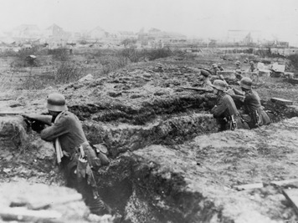
Section 7 - A New Kind of Warfare

By September 1914, approximately 6 million soldiers were on the march across Europe. On Germany’s Eastern Front, German troops fought Russians. On the Western Front, German forces advanced quickly before being stopped by French and British troops at the Marne River, about 40 miles outside the city of Paris. With neither army able to advance, both sides dug long, narrow ditches called trenches to protect their soldiers.
Trench Warfare For the next three years, the war in the west was fought from two parallel lines of trenches. Men ate, slept, fought, and died in these miserable ditches. Eventually, the lines of trenches stretched for 600 miles across France.
Each side protected its front trench with barbed wire and booby traps. The land between opposing trenches was a deadly “no-man's-land.” Attacking soldiers came under intense fire from the men in the trenches. Thousands upon thousands of soldiers died trying to advance their line of trenches a few yards.
The trenches were wretched places, infested with rats, lice, and disease. “We are not leading the life of men at all,” wrote an American who had volunteered to fight with the British forces, “but that of animals, living in holes in the ground, and only showing outside to fight and to feed.”
New Weapons New weapons added to the horror of trench warfare. “We never got anywhere near the Germans,” one English corporal remembered. “The machine-guns were just mowing the top of the trenches.” These new machine guns fired hundreds of bullets a minute. By the end of 1914, the French had lost 300,000 men. Germany lost more than 130,000 soldiers in a single battle.
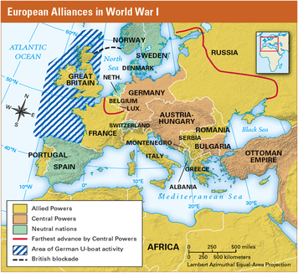
The next spring, a green cloud floated over the Allied lines. Soldiers gasped and died, their throats and noses burning. The Germans had invented poison gas. Soon both sides were using chemical weapons.
The armies’ new technology and strategies were effective for defense, but not for decisive attack. In the First Battle of the Somme, fought in France in 1916, the British tried for six months to advance their lines. They gained only five miles and lost about 420,000 men.
War at Sea To supply soldiers in the trenches with food, ammunition, and other supplies, the warring nations bought goods from neutral countries. Each side tried to cut off the flow of supplies to its enemy.
Most trade, especially with the United States, was by sea. Great Britain had the world’s greatest fleet and numerous ocean ports. Germany had a strong navy, but its only access to the ocean was through the North Sea. To close German ports, Great Britain laid mines in the North Sea. This blockade stopped most of the neutral shipping and kept the German fleet bottled up in harbors for most of the war.
Unable to use its surface ships, the German navy tried to blockade Great Britain using submarines, called U-boats (for “underwater boats”). Fearing that the British would try to disguise their ships as neutral, Germany announced that it might sink vessels flying the flags of neutral countries. Because submarines on the surface were easy targets for enemy fire, German submarines began sinking vessels on sight, instead of rising to the surface to give warning, as was expected even in wartime.
Germany Sinks the Lusitania The German embassy in the United States placed newspaper ads warning passengers not to sail to Great Britain and specifically not to take the Lusitania, a British luxury liner. On May 7, 1915, six days after leaving New York, the Lusitania neared the coast of Ireland. Suddenly a ship’s lookout shouted, “Torpedo coming on the starboard side!” Within moments, the ship exploded and quickly sank, killing 1,198 people, including 128 Americans.
Americans were outraged. One newspaper called the German attack “wholesale murder.” When President Wilson protested, Germany said that the Lusitania had been carrying arms. Still, Germany apologized and offered to pay for damages. Hoping to keep the United States out of the war, Germany also promised not to attack merchant and passenger ships without warning in the future.
Protected by this promise, U.S. manufacturers increased their trade with the Allies. Trade with Allied countries swelled to $3.2 billion in 1916, while trade with the Central Powers dropped to $1 million. Americans were not fighting in the war, but they had definitely taken sides.

Section 8 - To Make the World “Safe for Democracy”
After the sinking of the Lusitania, Wilson decided that the United States needed to prepare in case war became necessary. He worked with Congress to get money to improve the army and navy. Still, neither Wilson nor the country wanted war. In 1916, Wilson won reelection under the slogan, “He Kept Us Out of War.”
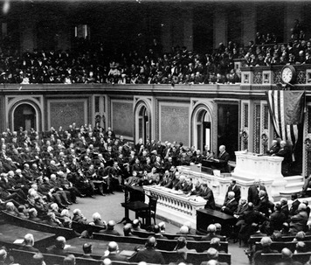
In a speech to the Senate in January 1917, Wilson declared that he wanted to find a way to end the stalemated war in Europe. He called on the warring powers to accept a “peace without victory.” He also spoke of forming a “league of honor” to help nations settle conflicts peacefully. Germany’s response to Wilson’s peace efforts was to launch an all-out effort to win the war, including a return to unrestricted submarine warfare.
The Zimmermann Note Wilson had hoped the Germans would back down, but his hopes were dashed in late February 1917. Britain had gotten hold of a note sent in code by the German foreign minister, Arthur Zimmermann, to the German minister in Mexico. Zimmermann suggested that if the United States entered the war, Mexico and Germany should become allies. Germany would then help Mexico regain “lost territory in New Mexico, Texas, and Arizona.” The Zimmermann note created a sensation in the United States and stirred anti-German feeling across the nation.
The United States Enters the War On April 2, 1917, Wilson spoke to a special session of Congress and called for a declaration of war. America would join the Allies in the fight to defeat Germany, he said, not just to protect shipping but because “the world must be made safe for democracy.” Congress greeted Wilson’s speech with applause.

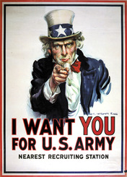
Americans Prepare to Fight On April 6, 1917, Congress declared war. The Allies rejoiced, hoping for U.S. supplies—and soldiers. To get U.S. supplies delivered safely, convoys of U.S. warships started escorting cargo vessels, protecting them from attack. U.S. destroyers also helped the British navy assault U-boats. These strategies dramatically reduced shipping losses.
When the United States entered the war, it had only 200,000 soldiers, and most of those had limited training. Congress quickly authorized a national draft. Soon, 3 million men had been drafted. Another 2 million volunteered.
Fighting and Winning U.S. troops who sailed overseas were called the American Expeditionary Force (AEF). As they began arriving in Europe in June 1917, AEF soldiers soon learned from the Allies about trench warfare. The U.S. commander, General John J. Pershing, hated these terrible conditions for soldiers. He also realized that trench warfare was not winning the war. He worked on a plan for driving the Germans out of the trenches and forcing them to retreat into open country.
Meanwhile, Russia had dropped out of the war. With millions of soldiers dead and starvation spreading across the country, Russians had revolted against their ruler, the czar. The Russian Revolution ended 400 years of monarchy and led to the creation of a communist government. Russia’s new government made peace with the Germans. This enabled Germany to bring soldiers back from the east, swelling their western forces to 3,500,000 men.
The German forces rushed to capture Paris before large numbers of Americans could arrive from overseas. Starting with the Second Battle of the Somme in the spring of 1918, German forces opened a series of offensive attacks. They pushed quickly through the village of Château-Thierry and a nearby forest called Belleau Wood. They were within 50 miles of Paris when Americans reinforced the exhausted French. Gradually, U.S. machine guns and artillery enabled the Allies to push the Germans back.
By the summer of 1918, more than a million Americans were in Europe. Pershing set his Allied offensive into motion. His plan took advantage of several new technologies that had been developed during the war. Tanks could advance through trenches. Airplanes could deliver machine-gun fire and drop bombs. Carefully coordinating huge numbers of forces in a final series of battles known as the Hundred Days Offensive, the Allies forced the weakened Germans back to their own border.
To avoid the invasion of their own country, German leaders agreed to an armistice, or cease-fire. On November 11, 1918, for the first time in four years, the guns were silenced. The costs of the war horrified the world. More than 9 million people died, including about 116,000 Americans.

Section 9 - World War I on the Home Front
The military draft approved by Congress in May 1917 made sure the country had enough soldiers to fight in Europe. But Wilson and other government leaders realized that all Americans, not only those who were sent overseas, would be needed to win the war. “It is not an army that we must shape and train for war; it is a nation,” President Wilson said. He considered the people at home to be just as much a part of the army as the soldiers in France “beneath the battle flags.” Once the United States entered the war, the federal government turned to the task of organizing Americans at home to support the war effort.
Propaganda and Patriotism When President Woodrow Wilson called the nation to war, he knew that not all citizens would respond with enthusiasm. As the war raged in Europe, pacifists had formed peace groups to keep the United States out of the conflict. Pacifists are people who oppose war for political, moral, or religious reasons. Other opponents took an isolationist view. They said that the United States should fight to defend itself, but not become involved in what they saw as a European conflict.
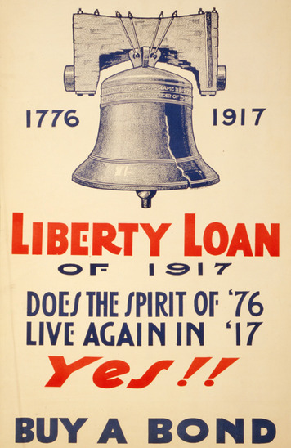
To win support for the war effort, the government used propaganda. Wilson created a government agency that carried out a campaign to “sell” the war to the public. The agency produced films, posters, and books that promoted the war. It sent thousands of men into towns and cities to make speeches on such topics as why the United States was fighting and the need to save food and fuel.
Americans responded by showing their support for the war effort. Families saved tin cans, paper, and old toothpaste tubes for recycling into war materials. Women met in homes or churches to knit blankets and socks for soldiers. Many people joined local Red Cross chapters, where they rolled bandages and packed supplies to send to Europe.
Propaganda and patriotism sometimes stirred up anti-German hysteria. Almost all German American communities supported the war effort once the United States entered the conflict. However, they often suffered as the result of the suspicions of others. Some employers in war industries fired German American workers, fearing they might wreck machinery or report plans to the enemy. Music groups stopped playing music written by German composers. Libraries removed books by German writers.
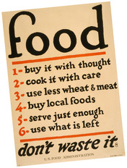
Raising Money for the War Once the United States entered the war, the government had to find ways to pay for it. World War I ended up costing the United States about $35.5 billion. About one third of that cost came from taxes. The government raised the rest of the money by selling bonds. A bond is a document issued by a government or a company that promises to pay back an amount of money, plus an additional amount. Thousands of citizens worked to sell Liberty Bonds in their hometowns.
Organizing Industry for the War As the nation geared up for war, industries began to produce fewer consumer goods and more war supplies. In the past, the government had left businesses alone to make this transition. World War I was different. For the first time, the federal government worked with industries to make sure they made what the military needed. This included the power to tell factories what goods to produce and how much to make.
Efforts to Conserve Food and Fuel The United States faced the huge job of feeding its armed forces, as well as the people at home. To meet the challenge, farmers produced more food. The government began a campaign that urged Americans to conserve food so that more could be sent to U.S. troops in Europe. Families took part in Meatless Mondays and Wheatless Wednesdays. They increased the food supply by planting “victory gardens” in their backyards and public parks.
The government encouraged Americans to conserve fuel to help make sure factories had the coal and oil they needed to increase production of war supplies. To save energy, Americans turned down their furnaces on “heatless Mondays.” On “gasless Sundays,” they walked instead of driving their cars. The government introduced daylight savings time during World War I. By having an extra hour of daylight at day’s end, households used less electricity for lighting.
Efforts to Enforce Loyalty Most Americans supported the war, including most of the people who had emigrated to the United States. Immigrants wanted a chance to show their loyalty to their country. They bought war bonds, took part in conservation efforts, and worked in wartime industries.
Nevertheless, recent immigrants became targets of patriot groups like the American Protective League. These groups tried to enforce what they called “100 percent Americanism.” Their members sometimes walked around immigrant neighborhoods looking for signs of disloyalty. They also sent the Federal Bureau of Investigation (FBI) names of people they suspected of disloyalty.
Fear of espionage, or spying, led Congress to pass the Espionage Act in 1917. This law made it a crime to try to interfere with the military draft. It also set severe penalties for spying.
In 1918, Congress further cracked down on opposition by enacting the Sedition Act. This law made it a crime to say anything that was disloyal about the government. Hundreds of people were arrested for offenses such as criticizing the military draft or wartime taxes.

Section 10 - The Struggle for Peace
Less than two months after the fighting ended in Europe, President Wilson traveled to Paris to take part in the Paris Peace Conference. He was cheered by huge crowds. The United States had saved the French from endless war. And many Europeans welcomed Wilson’s eagerness to prevent future wars.
Fourteen Points for World Peace Months earlier, Wilson had presented to Congress a 14-point proposal for a postwar agreement. The first five points aimed to prevent conflict. Nations were asked to avoid secret treaties, to practice free trade, and to reduce their weapon supplies. Wilson asked that new borders be drawn based on self-determination, or the will of the people in each area.
Points 6 through 13 described new boundaries for many European countries. Finally, the ambitious Point 14 called for nations to join a general association of countries to protect each other’s independence. Wilson called this organization the League of Nations. With the League of Nations, Wilson believed, the world could achieve a lasting peace.
Germany had surrendered, believing that Wilson’s “Fourteen Points” would be the basis for a fair and just peace. But after years of fighting and dreadful losses, some Allied leaders were not satisfied with a just peace.
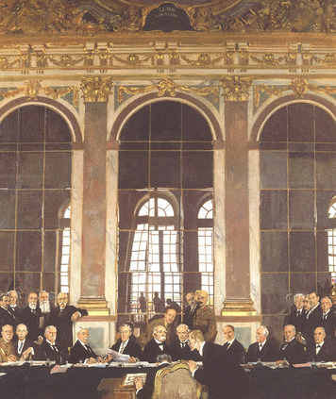
The Treaty of Versailles On January 18, 1919, delegates from dozens of countries assembled at a French palace outside Paris called Versailles (vehr- SIGH). In addition to Wilson, three Allied leaders dominated the treaty talks. They were David Lloyd George of England, Georges Clemenceau (kleh-mahn-SOH) of France, and Vittorio Orlando of Italy.
The German representatives were not allowed to speak. This reflected the Allies’ anger and their determination to punish Germany and remove it as a future threat. They created a treaty that forced Germany to disband almost all of its armed forces, give up its colonies, and surrender territory in Europe.In addition, they called on Germany to pay reparations, or money to make up for damages and war deaths. The amount of these reparations was later set at $33 billion.
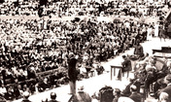
President Wilson opposed such harsh treatment of Germany. However, he eventually accepted the Allied leaders’ demands for punishment in order to win their support for his Fourteen Points.
The Allies rejected some of Wilson’s points, including freedom of the seas. But the peace conference did create new national boundaries in Europe based on self-determination. Most important to Wilson, the Treaty of Versailles established a League of Nations. Wilson thought that this agreement would make the peace treaty successful. The League of Nations, he believed, could fix any problems created by the treaty.
Struggling for Senate Ratification Wilson needed the approval of two-thirds of the U.S. Senate to ratify the peace treaty. He quickly ran into opposition, especially to the League of Nations. Some senators worried that other countries would force U.S. soldiers to fight in international conflicts. They argued that only Congress had the constitutional power to send Americans to war.
The struggle over the treaty became a fight between political parties. Republicans held a majority in the Senate. They felt that Wilson, a Democrat, had made his Fourteen Points a political issue by not appointing any Republicans to his negotiating team.
Anxious to increase public support for the League of Nations, Wilson undertook an intense speaking tour. In 22 days, he toured 29 cities. He spoke up to four times a day, with hardly any rest. Finally, he collapsed with severe headaches. He was rushed back to Washington, D.C., where he suffered a massive stroke.
Recovering slowly, Wilson was less willing or able to compromise with opposition senators. In March 1920, the Senate rejected the Treaty of Versailles.
A Return to Isolationism Once again, the United States was heading toward a policy of isolationism. When the League of Nations opened in Geneva, Switzerland, the United States did not participate. In later years, when crises developed in Europe, the League lacked the power that Wilson hoped it would have.
In Germany, the Treaty of Versailles left a bitter legacy. Germans—notably Adolf Hitler, a corporal who had been temporarily blinded by gas during the war—felt betrayed by the treaty. Hitler’s rise to power in the 1930s would pose a fresh challenge to U.S. isolationism. Only after a second world war would the United States take on the role of world power that it continues to fill today.

