Lesson 25 - The Great Wave of Immigration

Section 1 - Introduction
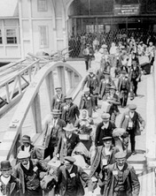
In the early 1880s, a young American Jew named Emma Lazarus saw a boatload of Jewish immigrants who had just arrived in New York City. The Jews on the boat were fleeing a religious massacre in Russia. Inspired by their suffering, Lazarus wrote a poem in which the Statue of Liberty welcomes immigrants. The poem begins,
Give me your tired, your poor,
Your huddled masses yearning to breathe free.
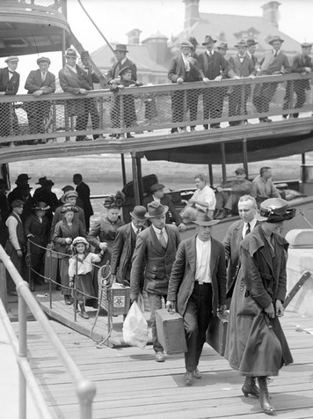
In 1903, a plaque inscribed with Lazarus’s poem was attached to the base of the statue. Her words expressed the hopes of millions of people who made their way to the United States during a great wave of immigration between 1880 and 1920. Over those 40 years, more than 23 million immigrants arrived in the United States. Many were escaping poverty, political violence, and religious persecution. Others came seeking economic opportunity in a land of seemingly boundless promise.
Most of the newcomers flocked to cities, where industry was booming and jobs were plentiful. The sheer number of immigrants changed the face of the nation. The newcomers often clustered in rapidly growing ethnic neighborhoods. In both New York and San Francisco, for example, “Little Italy” districts grew up alongside “Chinatowns.”
The new arrivals spurred the growth of the nation’s cities and industries. Their languages, customs, music, and food made cities like New York, Chicago, and San Francisco more diverse and exciting places. Yet many native-born Americans responded to the new arrivals with suspicion and prejudice. For immigrants, these attitudes added to the challenge of starting life in a new country.
In this chapter, you will learn about the experiences and contributions of immigrant groups from around the world. You will also discover how Americans’ attitudes toward immigration changed by the 1920s.

Section 2-Immigration from Around the Globe
Patterns of immigration to the United States changed in the 1880s. Before this time, most immigrants came from northern Europe, particularly Ireland and Germany. By 1890, most were coming from countries in southern and eastern Europe, such as Italy, Greece, Russia, and Poland. Other people came from China, Japan, Korea, and the Philippines. Still others crossed the borders from Canada and Mexico.
Many of these newcomers were refugees escaping violence or poverty in their homelands. Compared to earlier arrivals, they tended to be poorer, less well educated, and less likely to speak English. Among these refugees were many Jews and Catholics, as well as Buddhists and Confucianists—a major change for a country that had always been largely Protestant.
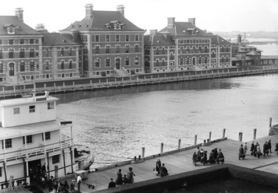
The Struggle for Acceptance Americans wondered how the throngs of immigrants would affect the country. Most favored the assimilation of foreign-born people into the culture of their new homeland. They expected immigrants to become “Americanized”—to talk, dress, and act like their native-born neighbors. Others believed that the new immigrants, especially nonwhites, were too “different” to be assimilated. Their prejudices were reinforced when ethnic groups clustered in their own towns or neighborhoods, in part for mutual support and in part because they were not accepted elsewhere.
Many immigrants were eager to adopt American ways. Others had little choice. Public schools taught in English, and most stores sold only American-style clothes, food, and other goods. Many employers demanded that their workers speak English on the job.
Some immigrants did cling to their own languages and ways of life. But even those who tried hardest to assimilate often met with abuse and discrimination. Immigrants also faced resentment from workers who saw them as competing for jobs. Many Americans developed a sense a Nativism, an extreme dislike for immigrants. Many Americans refused to hire immigrants for certain jobs and felt like America should shut the door on immigration completely.
Contributions of Immigrants The new immigrants made vital contributions to the nation’s rapidly industrializing society. As you know, immigrants helped to build the railroad. They worked in oilfields; in gold, silver, and coal mines; and in rubber and steel mills. They labored in meat-packing plants, manufacturing plants, and clothing factories. Without the immigrants’ skills and labor, the nation’s cities and industries would not have grown nearly as fast as they did.
Immigrants also brought a vibrant diversity to their adopted land. The United States became a society enriched by the customs, foods, languages, and faiths of people from around the globe. However, Immigrants struggled quite a bit when they reached the United States. They tended to live in Tenement housing with was crowding, dangerous and very unsanitary. Typically they worked very low paying jobs with long hours and terrible working conditions. While they struggled to learn English and Assimilate into American culture, they also realized they were typically doing much better than in their home countries. One reaction to Immigrant struggles was the Creation of the Hull House by Jane Addams in Chicago. The Hull House was a settlement house that helped immigrants learn English, have some forms of entertainment and even get a meal if they needed it. The existence of the Hull House is an example of how difficult life for Immigrants really was.

Section 3 - Italian Immigrants
When Pascal D’Angelo heard that his father was leaving their poor Italian village to work overseas, he was angry. “America was stealing my father from me,” he later said. His mother tried to soothe him, saying that soon Papa would return, “laden with riches.” But Pascal begged his father to take him along. His father agreed. The two of them boarded a steamship bound for the United States.

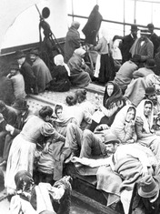
From Italy to America Like millions of other Italians, Pascal and his father came to the United States to escape poverty. In the late 1800s, much of Italy, and especially southern Italy, could not support the country’s rapidly growing population. Farmers struggled to make a living on worn-out, eroded land where crops too often failed. There were few factories to provide other jobs.
Poor immigrants like Pascal and his father usually made the ocean passage in “steerage.” Steerage was a deck, deep in the ship, that was reserved for the passengers who paid the lowest fares. These passengers were given narrow beds in crowded compartments that smelled of spoiled food, human waste, and sweating people who had nowhere to bathe.
Steerage passengers were allowed on deck only once a day. The rest of the time, they tried to amuse themselves by playing games, singing, and making music with accordions, mandolins, and other instruments.
After almost two weeks, the travelers arrived at the immigration station on Ellis Island in New York Harbor. There they had to pass medical examinations and answer questions about how they planned to support themselves in the United States. People who did not pass these inspections could be sent home, even if other family members were allowed to enter. So many families were forced to separate that Italians started calling Ellis Island “The Island of Tears.”
Starting a New Life Judged healthy and ready to work, Pascal and his father arrived in New York City. A fellow Italian, a work agent called a pardone (puh-DROH-nee), helped them to find jobs building roads. Padrones helped many Italian immigrants get unskilled work building sewers, subways, and roads; cleaning streets; and laying bricks for new tenement buildings. By 1890, Italians made up 90 percent of New York’s public works employees and 99 percent of Chicago’s street workers.
Many Italian immigrants were “birds of passage”—young men who came to earn some money and return home. When several coworkers died in a work accident, Pascal’s father decided to return to Italy as well. “We are not better off than when we started,” he said.
Pascal, however, decided to stay in his new country. He settled in an Italian neighborhood in New York, one of the many “Little Italys” that sprang up in U.S. cities. These mostly Italian neighborhoods bulged with residents who could afford only the cheapest tenement housing. Crowded together in tiny apartments, most families had no privacy.
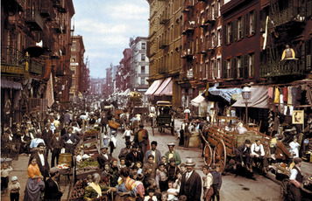
Fortunately, Italian neighborhoods also offered opportunities for fun. Most Italians were Catholics who celebrated saints’ days as they had in Italy. They strung colored lights, flags, and streamers along the shops and streets. Families strolled among booths that offered food and games. Fireworks, music, and dancing reminded everyone of life back home.

Above everything else, Italians valued family closeness. Some Italian parents didn’t send their children to school because they feared that learning English would separate their children from the family. Besides, a child in school wasn’t earning money to help the family. As a result, many immigrant children never learned the skills they needed for better jobs.
Because many Italian newcomers were poor and uneducated, Americans tended to look down on them. When a few Italians turned to crime and became notorious gangsters, some people started thinking of all Italians as criminals. As a group, however, Italian immigrants were generally more law-abiding than average Americans.
Some Americans feared that immigrants from Italy would always be poor and illiterate. Pascal D’Angelo was one of many who proved them wrong. After coming to the United States, Pascal bought himself a dictionary and learned to read and write English. In time, he became a well-known poet whose work was published in national magazines.

Section 4 - Jewish Immigrants from Eastern Europe
Maryusha Antonovksy was no more. In her place stood Mary Antin, the same immigrant Jewish girl but with a new “American” name. Mary had also bought “real American machine-made garments” to replace her “hateful” homemade European-style clothes. “I long to forget,” she said. “It is painful to be conscious of two worlds.”
Fleeing Persecution Mary Antin’s first world had been a Jewish village in Russia. For centuries, Russians had discriminated against Jews, who dressed, worshiped, and ate differently from their Christian neighbors. By the 1800s, Russia had hundreds of anti-Jewish laws. Jews could live only in certain areas. They couldn’t live in big cities or own land.
In 1881, assassins killed the Russian monarch Czar Alexander II. Nervous government leaders blamed Jews for his murder, even though the assassin was not Jewish. Angry Russians raged through Jewish villages, burning, looting, and killing. These attacks, called pogroms, happened repeatedly for more than 30 years. The word pogrom comes from Russian words meaning “like thunder.”
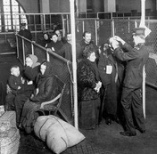
Many Jews fled such persecution, hoping to find refuge in America. Between 1881 and 1924, some 2.4 million Jews came to the United States from Russia and other countries in eastern Europe. Mary Antin’s father was one of them.
Mary’s father left for America in 1891, hoping to earn enough money to send for his family. In his first letter home, Mary sensed “an elation [joy], a hint of triumph . . . [Her] father was inspired by a vision. He saw something—he promised [them] something. It was this ‘America.’”
When her father sent a steamship ticket for his family to join him, the people in Mary’s village gathered together, filled with longing. “They wanted to handle the ticket,” Mary remembered, “and mother must read them what is written on it.”
After long rides in overcrowded trains and weeks of delay, her family finally boarded a ship in Hamburg, Germany. Although richer immigrants enjoyed comfortable cabins, the Antins were crowded together with hundreds of other passengers deep down in the ship. Seasick at first, they frequently came up on deck for fresh air, where “sailors and girls had a good many dances.”
Like most European immigrants, the Antins entered the United States by way of New York Harbor. Wealthier passengers in first-class and second-class cabins were questioned briefly before being admitted to their new country. But the majority of arrivals were taken on crowded barges to the immigration station on Ellis Island. Often they had to wait for hours while inspectors and doctors examined each person. Fortunately, most new arrivals spent less than a day on the island before proceeding to shore and the beginning of their new life in America.
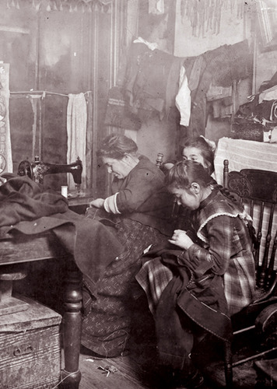
Jewish Life in America From Ellis Island, Jews headed for New York City’s Lower East Side neighborhood. There they established shops, newspapers, religious schools, and synagogues (community centers and places of worship). The Lower East Side became the most densely populated neighborhood in the city. People lived packed into cheap tenements, often sleeping three or four to a room.
Some Jews worked as street vendors, using pushcarts to sell everything from coal to secondhand clothes. Pushcart vendors saved their money to buy horse-drawn carts and then small stores. Although most Jews were poor, they arrived in the United States with a wide range of skills. Jews worked as cobblers, butchers, carpenters, and watchmakers. Almost half found jobs in the city’s garment factories.
Jewish immigrants did whatever they could to keep their children in school. In Europe, Jews had honored educated people, but schooling had cost money. As a result, many Jews had never learned to read and write. In America, Mary Antin wrote, “Education was free . . . It was the one thing that [my father] was able to promise us when he sent for us: surer, safer than bread or shelter.”
Parents who made a little money often sent their sons, and sometimes their daughters, to the city’s inexpensive public colleges. By 1910, more Jewish youths over the age of 16 were still in school than were young people of any other ethnic group.
Like other immigrant groups, Jews faced prejudice and discrimination. Most private schools and clubs refused to accept Jews. Hospitals would not hire Jewish doctors. The New York Bar Association would not admit Jews as lawyers. Many ads for jobs stated simply, “Christians only.”
Still, eastern European Jews were grateful to be in their new country. One immigrant recalled, “There were markets groaning with food and clothes . . . There was no military on horseback and no whips.”

Section 5 - Chinese Immigrants
The first Chinese immigrants came to the United States to seek gold in California. Later, many helped to build the country’s first transcontinental railroad. Some of these immigrants returned to China with money they had earned. Their good fortune inspired 16-year-old Lee Chew to leave his poor village for the United States in 1880.
Traveling to California Lee paid 50 dollars for a bunk on a crowded steamship to make the month-long voyage to San Francisco, California. On the ship, he got his first taste of foreign food and marveled at machinery he had never seen before. “The engines that moved the ship were wonderful monsters,” he wrote, “strong enough to lift mountains.”
Lee arrived just in time. In the United States, discrimination against the Chinese had been growing ever since whites had pushed Chinese off their mining claims. As the number of Chinese immigrants increased, U.S. labor leaders warned of Chinese workers who would work for less pay than whites and take away their jobs. In 1882, Congress passed the Chinese Exclusion Act, which banned Chinese laborers from immigrating to the United States. The law also denied Chinese immigrants the right to become citizens.
As a result of the Chinese Exclusion Act, Chinese immigration slowed to almost nothing. Then, in 1906, an earthquake and fire destroyed much of San Francisco, including most birth records. Suddenly, many Chinese men could claim to be native-born citizens. As citizens, they were allowed to bring their wives and children to the United States.
Chinese claiming American birth started arranging for people in China to immigrate to the United States as their relatives. On the long ship voyage, the newcomers studied hundreds of pages describing their “families.” When they reached San Francisco Bay, they threw the papers overboard.
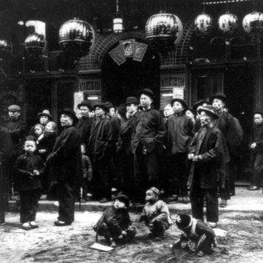
These “paper relatives” landed at Angel Island in San Francisco Bay. Government immigration officials “locked us up like criminals in compartments like the cages in zoos,” said one Chinese immigrant. Chinese usually remained on the island for three to four weeks, but sometimes they spent months or even years there. To pass the time, they carved poems on the wooden walls with silverware smuggled from the dining halls. One wrote,
Why do I have to sit in jail? It is only because my country is weak
and my family is poor. My parents wait at the door in vain for
news. My wife and child wrap themselves in their quilt, sighing with loneliness.
Before being allowed to leave Angel Island, each immigrant faced detailed questioning by officials. “How many steps are there in your house?” “Where do you sleep in your house?” “Who lives next door?” Then they asked a “family” witness from San Francisco the same questions. If the answers didn’t match, officials could deport the newcomer. Nearly one in ten Chinese who came to the United States was sent back to China.

Chinese Life in the United States When Lee Chew arrived in San Francisco, he worked first as a servant and then set up his own laundry. Many Chinese started laundries because, as Lee explained, “It requires little capital and is one of the few opportunities that are open. Men of other nationalities who are jealous of the Chinese . . . have shut him out of working on farms or in factories or building railroads.”
Like Lee, most Chinese settled in city neighborhoods like San Francisco’s bustling Chinatown. Here, they could find work at Chinese laundries, restaurants, and stores. Chinese newspapers, herbal medicines, foods, and festivals provided familiarity, comfort, and support.
For many years, most Chinese immigrants were men. In 1900, only about 1 in 20 Chinese on the U.S. mainland was female. With so few women and families, the Chinese population began to decline. In 1880, about 105,000 Chinese lived in the United States. By 1920, there were 61,600.
Gradually, more women and children arrived, especially in San Francisco. Housing was closed to Chinese in most areas, so Chinatown became more and more crowded.

Section 6 - Mexican Immigrants
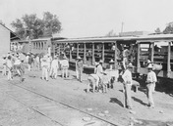
Soldiers were shooting all around. A flying bullet almost hit him. That was when Pablo Mares (PAH-blow MAHR-ess) decided he had to get out of Mexico. “I had to come to the United States,” he said later, “because it was impossible to live down there with so many revolutions.”
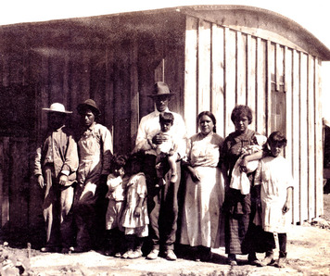
Mares had been caught in the middle of a bloody civil war. The conflict began when Mexico’s president allowed wealthy landowners to take over the lands of 6 million Indians and 8 million poor farmers. In 1910, landless farmers rebelled, breaking up large landholdings and giving the land to poor families. In response, soldiers attacked villages, killing thousands of peasants.

Crossing the Border The Mexican Revolution dragged on for ten years. Between 1910 and 1920, about 500,000 Mexicans entered the United States. They entered freely, without passports or money.
Many Mexicans walked hundreds of miles to reach the border, carrying all they owned on their backs. In just one day, a Texas reporter saw “hundreds of Mexicans, all journeying northward on foot, on burroback and in primitive two-wheel carts.” Others traveled north by rail. By 1900, railroad lines connected American and Mexican cities. Railroads provided both transportation and jobs for Mexican immigrants. One Mexican newspaper reported, “There is not a day in which passenger trains do not leave for the border, full of Mexican men who are going in gangs to work on railroad lines in the United States.”
Mexicans in America Many American employers welcomed the Mexicans. Expanding railroads and large-scale farms and ranches in the Southwest depended on laborers who were willing to work hard for little pay. After Congress banned Chinese immigration in 1882, these employers looked to Mexico for new workers. “Where I came from,” said one Mexican construction worker, “I used to work ten hours for $1.25 . . . Then I came here and they paid $1.25 for eight hours—it was good.”
Some Mexican immigrants found jobs with railroads, mines, factories, and canneries. But most found work in agriculture. Mexican farmworkers moved from region to region, harvesting crops as they ripened. They picked oranges in southern California, almonds in central California, and then apples in Oregon. They harvested cotton in Texas and Arizona and then moved on to sugar beets in Colorado.
Farmwork paid very little. One Texas farmer paid “Pancho and his whole family 60 cents a day . . . He worked from sun to sun.” Children worked in the fields with their parents to help support their families. Few of them had a chance to attend school.
Farmworkers often lived in camps that they built near the fields. “Shelters were made of almost every conceivable thing—burlap, canvas, palm branches,” said one visitor. Some farms and ranches provided housing for their workers. Either way, these temporary homes usually lacked running water and basic sanitation.
After harvest season, farmworkers sometimes moved to nearby towns. Barrios, or Mexican neighborhoods, sprang up on the edges of cities near such farming areas as Los Angeles, California, and San Antonio, Texas. Food stands and grocery stores in the barrio offered familiar tastes and smells. Residents helped each other take care of the sick and find jobs. On Mexican religious holidays, Catholic churches held special ceremonies. On those days, the barrio was filled with singing, dancing, and fireworks.
Many Mexican immigrants originally planned to return to Mexico once the revolution was over. Whites who believed that Mexicans were taking their jobs encouraged such returns. One wrote, “I wish the Mexicans could be put back in their country.”
Mexicans who remained in the United States often faced strong prejudice. Compared to whites, they earned very low wages, and they had little say in their working conditions. In schools, white children were sometimes taught to “boss” their Mexican classmates, as they were expected to do when they grew up.
Despite these problems, many Mexican immigrants chose to stay. Like Isidro Osorio, a farm and railroad worker, they hoped for a better future in their new homeland. “I have worked very hard to earn my $4.00 a day,” reported Osorio. “That is why I want to give a little schooling to my children so that they won’t stay like I am.”

Section 7 - Closing the Door on Immigration
In 1920, a mob stormed through the Italian neighborhood of West Frankfort, a small town in Illinois. The crowd was frustrated by a mining strike and angered by bank robberies that Italian criminals were rumored to have committed. For three days, mobs beat up Italian immigrants and burned their homes. This attack reflected a surge of nativism, or anti-immigrant feeling, that peaked in the United States around this time.
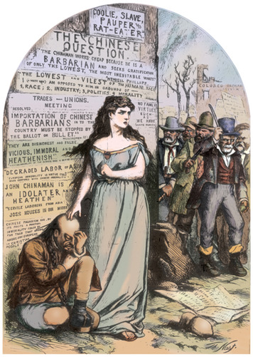

The Tide Turns Against Immigrants The United States has always been a nation of immigrants, yet time and again nativism has sparked actions and policies directed against newer arrivals. Sometimes nativism is rooted in economic competition. Sometimes it stems from ethnic, religious, and other differences. In the 1830s, for example, Protestant nativists charged that Catholic immigrants were enemies of democracy. They feared that Catholics had more loyalty to the pope in Rome, who was the head of their church, than to the U.S. government.
The surge in immigration that began in the 1880s fueled another rise in nativism. Some native-born Americans blamed immigrants for everything from slums and crime to hard times. Fearing competition for jobs, many labor leaders discriminated against nonwhites. In 1909, for example, the president of the United Mine Workers wrote of Asians that “as a race their standard of living is extremely low, and their assimilation by Americans impossible.”
Restricting Immigration Politicians responded to the growing prejudice against immigrants. As you have read, in 1882 Congress passed the Chinese Exclusion Act, banning further immigration by Chinese laborers.
In 1907, Japanese immigrants were forbidden entry to the United States. In 1917, Congress required immigrants to prove they could read and write in at least one language before they were allowed into the United States.
To further limit immigration, Congress established a quota system in 1921 and refined it in 1924. Under this system, by 1927 only 150,000 immigrants were allowed to enter the United States each year. People from East Asia were completely excluded. In addition, quotas limited immigration from any one country to 2 percent of the number of people from that country who lived in the United States in 1890. Most eastern and southern Europeans had arrived after that year. As a result, most of the quota spaces were reserved for immigrants from England, Ireland, and Germany.
The new laws did not limit Mexican immigration. However, Mexicans now needed passports and visas to enter the United States. Visas allow people from other nations to stay in the United States for a limited period of time. For the first time, the nation was closing its doors.

