Lesson 30 - The Cold War

Section 1 - Introduction
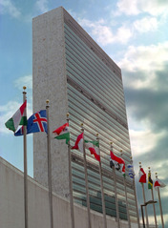
Even before World War II came to an end, the Allies were preparing for peace. In April 1945, delegates from 50 nations met in San Francisco to establish a new organization called the United Nations (UN). The UN was founded to preserve world peace by promoting international cooperation.
A generation earlier, the United States had refused to participate in the League of Nations after World War I. This time, America’s response was quite different. The United States not only joined the UN, but also gave it a home. Since 1952, the UN’s headquarters has been located in New York City.
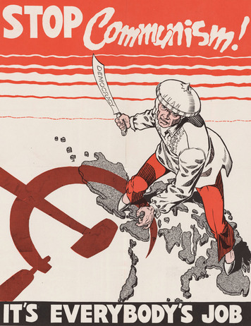
Hopes for a more peaceful world, however, faded quickly as the United States and the Soviet Union emerged from World War II as bitter rivals. Tensions increased when the dictator of the Soviet Union, Joseph Stalin, seized control of several Eastern European nations in 1945. The people in these nations were denied the freedom to choose their own governments, to travel, and even to speak freely.
Stalin’s takeover of these countries alarmed leaders in the United States and Western Europe. Former British prime minister Winston Churchill warned that “an iron curtain has descended across the continent.” In the view of Western democracies, that iron curtain divided the free world of the West from the Soviet-dominated world of the East.
This rivalry between Western democracies and the Soviet Union led to the Cold War, an intense competition for global power and influence that lasted more than 40 years. The conflict was called a “cold” war because the United States and the Soviet Union engaged in intense military competition without ever fighting each other directly.

Section 2 - Choosing Sides: A Bipolar World

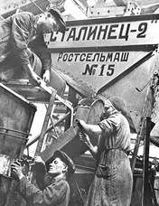
After World War II, the once-mighty nations of Japan, Germany, and Great Britain lay in ruins. The Soviet Union was also devastated by the war. But the Soviet Union still maintained a strong military presence because of its key role in defeating Nazi Germany and its occupation of Eastern Europe after the war.
Two nations came out of the war strong enough to dominate world affairs. These superpowers were the United States and the Soviet Union. There were some signs that the superpowers might work together after World War II, such as the Soviet Union’s decision to join the United Nations. However, because the ideals and ambitions of the two superpowers were as opposite as the North and South poles, cooperation did not last for long. The rivalry that emerged between the United States and the USSR created a bipolar world—a world deeply divided into two warring camps.
The Soviet Union The Soviet Union was born out of the Russian Revolution of 1917. That year, revolutionaries known as Bolsheviks overthrew the Russian government and later killed Russia’s royal family.
The Bolsheviks were inspired by the writings of a German philosopher named Karl Marx. In his Communist Manifesto, written in 1848, Marx called on the workers of the world to unite and overthrow the capitalist economic system. Under capitalism, farms and businesses are privately owned by individuals with money, or capital. According to Marx, wealthy capitalists took advantage of the labor of workers to enrich themselves.
Marx claimed that the future belonged to an economic system he called communism. Under communism, workers would own all farms and businesses and run them for the benefit of everyone. The result, Marx predicted, would be a workers’ paradise.
The Bolsheviks called the ruling councils of workers “soviets.” But in the new Soviet Union, power became concentrated in the central government rather than in committees of workers.
When Joseph Stalin took over the government in the 1920s, he was determined to transform the Soviet Union from a backward rural nation into a modern industrial giant. Stalin stamped out all individual ownership of farms and businesses. The government took over all economic planning. The Soviet people were forced to work for government-run farms and factories.
To protect his power, Stalin turned the Soviet Union into a vast police state. No one was safe from the prying eyes and ears of Stalin’s spies and secret police. “Enemies of the people”—those suspected of opposing Stalin—were ruthlessly eliminated. During the 1930s, at least 8 million people were executed in the Soviet Union. Millions more were imprisoned in labor camps. Instead of a workers’ paradise, the Soviet Union became a brutal dictatorship.
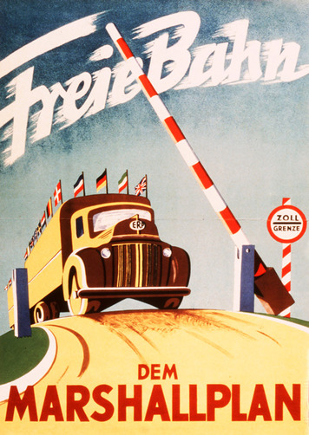
Containing Communism Most Americans were appalled by what was happening in the Soviet Union. They saw communism as a cruel system that took away people’s property and denied them such basic rights as freedom of speech and religion. Even worse, the Soviet government was doing all it could to spread communism to other countries. Americans saw Stalin’s takeover of Eastern Europe as proof that he intended to convert the whole world to communism.
President Truman responded to this threat with a foreign policy known as containment. The goal of this policy was to keep communism from spreading any further by containing, or limiting, it to the countries where it had already taken hold.
Truman first turned his attention to Europe, where World War II had left many people homeless and hungry. In 1947 George Marshall, Truman’s secretary of state, developed a plan to help Europe recover from the war. Under the Marshall Plan, the United States sent vast amounts of money to 16 nations in Europe for rebuilding cities, railroads, factories, and electric systems. As life in these countries improved, the appeal of communism weakened. Both Americans and Europeans hailed the Marshall Plan as a success.
The effort to contain communism suffered a major setback in 1949 when Mao Zedong’s communist revolutionaries seized control of China, the world’s most populous nation. With the success of this revolution, over 500 million people came under communist rule.
The Third World The Cold War created a new set of divisions in the world. The United States and its democratic, industrialized allies came to be known as “First World” nations. The Soviet Union and its communist allies were seen as a “Second World.”
There was also a “Third World” of poorer, less-developed nations in Latin America, Africa, and Asia. Many of these countries gained their independence from colonial rulers in the 1950s and 1960s.
Both the United States and the Soviet Union tried to convince these nations to join their “team” in the Cold War. Both superpowers also intervened, often secretly, in Third World nations throughout the Cold War when they felt the interests of their side were threatened. But many Third World countries, such as India, remained nonaligned nations—countries that refused to line up with either side.

Section 3 - Forming Teams: Cold War Alliances
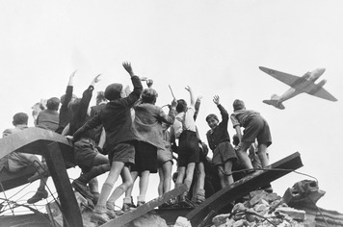
The Cold War saw powerful new alliances led by the United States and the Soviet Union. These alliances came about as a result of the first great confrontation of the Cold War—the Berlin Blockade.
A Divided City When Germany surrendered in 1945, it was divided in two. Soviet troops occupied East Germany, while American, British, and French forces controlled West Germany. The capital city of Berlin, located in East Germany, was also split into western and eastern parts.
The Soviets set up a communist government in East Germany and demanded that the Western Allies leave West Berlin. When the Western Allies refused to budge, Stalin ordered a blockade of Berlin in 1948. Hoping to starve the Western Allies out of the city, Stalin closed all roads and railroads leading to West Berlin. He also cut electrical power to West Berlin.
The Western Allies faced a tough choice. They did not want to give into Stalin and abandon West Berlin. But they feared that efforts to break through the blockade on land might lead to war. Instead, American and British planes began to airlift food, clothing, medicine, and fuel into West Berlin.
At first people worried that the Soviets would try to end the airlift by shooting down the Western Allies’ planes. But the Soviets also wanted to avoid war. Stalin bided his time, hoping that the Allies could not afford to continue flying in supplies for 2 million people.
For ten long months, the airlift continued. Finally, the Soviets gave up and removed the blockade. The lights went back on in Berlin.
Berlin continued to be a potential flashpoint throughout much of the Cold War. In 1961, East Germany and the Soviet Union tried to stem the tide of East Germans fleeing to West Berlin by putting up a wall between the two parts of the city. On the eastern side of the Berlin Wall, armed guards stood ready to shoot anyone trying to escape to freedom in West Berlin. For the next 30 years, the Berlin Wall served as a grim symbol of a divided Europe.
NATO: The Western Alliance The Berlin Blockade convinced the United States and its allies to form a more permanent alliance for their mutual protection. In April 1949, ten Western European countries, the United States, and Canada formed the North Atlantic Treaty Organization (NATO). An attack upon any NATO country, they agreed, would be treated as an attack against them all.
Ratification of the NATO treaty was a big step for the United States. For the first time in its history, the United States had gone against George Washington’s warning to “steer clear of permanent alliances with any portion of the foreign world.” With the creation of NATO, American aid to Europe began to shift from economic assistance to military assistance.
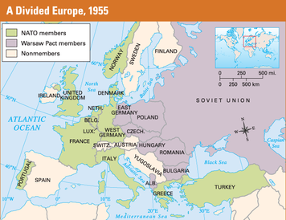

The Warsaw Pact: The Eastern Alliance Despite the failure of the Berlin Blockade, the Soviets still hoped to unite Berlin—and Germany—under a communist government. Twice in the 20th century, German armies had invaded Russia. Soviet leaders believed that the best way to prevent future invasions was to gain firm control over all of Germany.
The Soviets’ hopes for a united, communist Germany soon began to fade. In 1949, West Germany became an independent nation with a democratic government. Six years later, West Germany was allowed to join NATO and rebuild its military.
The prospect of West Germany building a new army pushed the Soviets to create their own military alliance in 1955. The Warsaw Pact (named after the capital of Poland) called for military cooperation among the Soviet Union, Albania, Bulgaria, Czechoslovakia, Hungary, Poland, Romania, and East Germany. If any one of these nations was attacked, the others promised to come to its defense. As part of this agreement, Soviet troops were stationed throughout Eastern Europe.
With the establishment of NATO and the Warsaw Pact, Europe had been divided into two opposing teams. The alliances made members of each team feel more secure. At the same time, the alliance system increased the risk that a dispute between two small nations could trigger a third world war—a war fought with terrifying new weapons.

Section 4 - The Cold War at Home
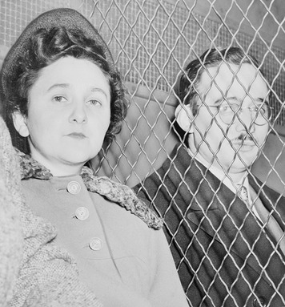
When the United States dropped atomic bombs on Japan in 1945, a frightening new age began—the Atomic Age. Four years later—aided by spies who had worked on America’s secret atomic bomb project—the Soviet Union successfully tested its own bomb. Suddenly, the world was faced with the threat of unthinkable destruction if a war broke out between the superpowers. This threat made the Cold War an age of anxiety in the United States.
Spy Cases Raise New Fears The role of spying in the Soviet Union’s acquisition of the atomic bomb fueled American fears that communist spies were everywhere. During this time, the U.S. Federal Bureau of Investigation (FBI) took a central role in the search for communists and communist spies within the United States. The FBI began intensive surveillance of known and suspected American communists.
In 1950, a British physicist named Klaus Fuchs, who had helped to develop the atomic bomb during World War II, confessed that he had spied for the Soviet Union. Fuchs passed information to Soviet scientists that likely helped to speed their development of atomic weapons. The FBI began to investigate people who associated with Fuchs. They followed a trail of evidence to the Americans Ethel and Julius Rosenberg. The Rosenbergs were arrested and charged with passing atomic secrets to the Soviet Union.At the Rosenberg trial, the couple was found guilty of espionage. They were executed in 1953, becoming the only American civilians to be put to death for spying during the Cold War. At the time, many people protested that the evidence against the suspects was inconclusive. But when Soviet records became available after the fall of the Soviet Union, it was proven that the Rosenbergs were indeed guilty.
Hollywood Comes Under Suspicion Like the FBI, Congress also searched for communist influence within the United States. In 1938, Congress formed the House Un-American Activities Committee (HUAC) to investigate organizations suspected of being a danger to the country. In 1947, HUAC began to look for communist influence in the film industry. The committee charged that many Hollywood films showed sympathies toward communist ideas. HUAC called on writers, actors, and directors to testify about their political beliefs.
The heads of Hollywood movie studios grew concerned about the impact the HUAC investigation would have on their industry. They stated that they would not hire anyone with communist sympathies. To carry out this pledge, they created a blacklist of people thought to be Communist Party members or communist sympathizers. Anyone whose name appeared on this blacklist could no longer find work making films.
McCarthyism Investigations by the FBI and HUAC did not ease Americans’ fear of communism at home. In fact, they may have added to the atmosphere of anxiety within the United States. Senator Joseph McCarthy took advantage of Americans’ fears to gain political power. He launched a well-publicized campaign to uncover suspected communists. Without any real evidence, McCarthy accused many people of being communists and working for the Soviet Union. Those who questioned McCarthy or his charges were branded communist sympathizers. The senator’s practice of publicly accusing people of being disloyal with little or no evidence became known as “McCarthyism.”
During McCarthy’s spy hunt, many Americans lost their jobs and reputations after being accused of being communists. McCarthy finally lost public support for his crusade in 1954, when he made false charges against the U.S. Army on television. But those who had been hurt by McCarthyism were among the casualties of the Cold War.
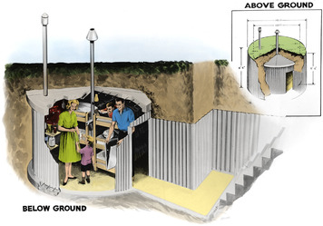
Living with Nuclear Anxiety In addition to fearing communist spies, Americans worried about the threat of nuclear attack. The government believed that a Soviet nuclear attack on the United States was a very real possibility. It warned Americans that the “back yard may be the next front line.” Millions of manuals were distributed to help people prepare for nuclear war with the Soviet Union. These publications made it clear that Americans could not rely on the military to protect them from a surprise nuclear attack. People would have to be prepared to protect themselves as best they could.
Nuclear preparedness soon became part of daily life. Many communities set up bomb shelters in public buildings. These shelters were stocked with emergency food and water supplies and offered people refuge during an attack. Children also took part in nuclear preparedness training. In school, students were led through duck-and-cover drills to prepare them for how to react in case of attack. Some families took preparedness a step further by constructing underground shelters in their backyards or basements. Several companies sold premade “fallout shelters” for single-family use. The shelters were designed to shield families from an atomic explosion. They also offered protection from the radioactive dust that “falls out” of the sky afterward. Authorities advised families to remain sealed in their fallout shelters for several weeks after an attack to let this toxic dust settle.

Section 5 - The Nuclear Arms Race
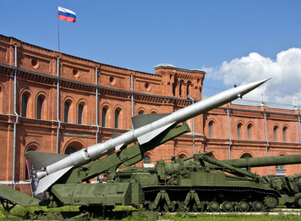
Soon after the Soviet Union acquired the atomic bomb, both sides began developing even more powerful nuclear weapons. In 1950, President Truman announced plans to develop a hydrogen bomb. This was a nuclear weapon that would be hundreds of times more powerful than the bomb that had destroyed Hiroshima in 1945. The Soviets set to work to match this goal. The result was a nuclear arms race, a competition to develop and manufacture ever more powerful and destructive weapons.
Mutual Assured Destruction By 1953, both superpowers had tested their first hydrogen bombs. Both nations also began work on long-range missiles that could carry nuclear weapons to any point on Earth. By 1960, both superpowers could launch nuclear missiles at each other from the land, air, and sea. When John F. Kennedy became president in 1961, it was clear that neither side could win the arms race. By then, each superpower had enough nuclear weapons to destroy the other many times over. In the face of this overwhelming threat, the United States adopted a military policy known as Mutual Assured Destruction (MAD). MAD was based on the belief that Soviet leaders would not order a nuclear attack on the United States if doing so meant the certain destruction of their own country. The way to ensure such destruction was to build so many missiles that they could not all be wiped out by a surprise Soviet attack. The surviving missiles would then destroy the Soviet Union. As one writer summed up MAD, “Whoever shoots first, dies second.”
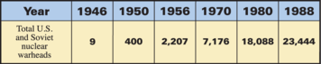
Opposition to the Arms Race The nuclear arms race inspired “ban the bomb” protests in both the United States and Europe. Most protesters were deeply concerned that the effects of a nuclear war could destroy all life on Earth. Many were also upset by the huge amounts of money being spent on the arms race. As President Eisenhower once noted, “Every gun that is made, every warship launched is a theft from those who hunger and are not fed, from those who are cold and are not clothed.” Protesters also focused on the radioactive fallout generated by the testing of nuclear weapons, because it is potentially harmful to living things. As testing increased, scientists began to detect radioactive material in drinking water, in crops, and in the bones of children. Demands for the superpowers to stop testing weapons grew louder year by year.
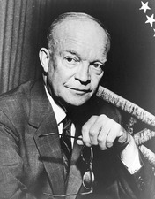
In 1961, President Eisenhower warned Americans of the growing influence of what he called the military-industrial complex. Eisenhower worried that the military was too closely allied with American companies that produced weapons. These companies relied on the U.S. military to buy their goods. Therefore, they supported increased military spending. Eisenhower feared that the military-industrial complex would encourage the nuclear arms race. He didn’t think the arms race was in the nation’s best interests.
Toward Arms Control In 1963, the superpowers took their first step toward controlling the arms race when they signed the Limited Test Ban Treaty. This agreement banned nuclear testing in the air, the ocean, and outer space. Underground tests were still permitted. Kennedy called the treaty “an important first step—a step toward reason—a step away from war.” But despite this step, both sides continued to spend vast sums of money developing new weapons.

Section 6 - The Cold War Heats Up
As the superpowers armed themselves with nuclear weapons, war between them became something neither side could win. Instead of confronting each other directly, they competed in proxy wars. A proxy war is a conflict between nations, or within a single country, in which the superpowers backed opposite sides without fighting each other directly. The superpowers supplied advisers, weapons, and sometimes troops to their “proxies,” or substitutes. Most of these proxy wars took place in small nations in Asia, Africa, and Latin America.
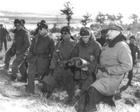
The Korean War The first major proxy war erupted in Korea in 1950. At the end of World War II, the Korean Peninsula was occupied by both American and Soviet troops. Unable to agree on what kind of government the Korean people should have, the superpowers divided the country. The Soviets installed a communist government in North Korea, while in South Korea the Americans encouraged a government that favored capitalism.
In 1950, North Korean troops armed with Soviet tanks and weapons overran most of South Korea. Their goal was to unite the country under a communist government. President Truman ordered the U.S. military to support South Korea. The United Nations also took action by calling on member nations to assist South Korea. In all, 15 nations sent more than half a million troops to Korea. More than 90 percent of the UN forces were American.
The UN forces pushed the communist invaders back into North Korea almost as far as its border with China. At that point, 300,000 Chinese soldiers poured into North Korea and drove the UN troops back into South Korea. Fearing that the struggle in Korea could widen into a world war, Truman pushed for a peace settlement.
The agreement ending the Korean War left Korea as divided as it had been before the war. Americans were pleased that communism had been contained in North Korea without starting a third world war. But the costs of containment were high. About 54,000 Americans died in a war that cost the nation over $20 billion. More than a million Koreans also lost their lives.
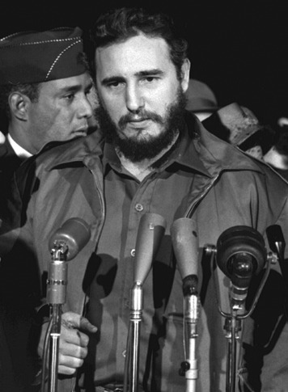
Communism Comes to Cuba The United States and the Soviet Union nearly came into direct conflict over Cuba. The United States first became involved in Cuban affairs during the Spanish-American War of 1898. Even after Cuba gained its independence, the United States maintained a naval base on the island. Americans also invested heavily in Cuba. By 1956, Americans owned 90 percent of Cuba’s mining wealth and 40 percent of its sugar crop. U.S. influence was so great that the American ambassador was reported to be “the second most important man in Cuba, sometimes more important than the [Cuban] president.”
In 1959, rebels led by Fidel Castro took control of the island and promised “to revolutionize Cuba from the ground up.” President Eisenhower tried to maintain friendly relations with the new Cuban government. But when Castro declared himself a communist and seized control of American-owned farms and businesses, Eisenhower broke off relations with Cuba.
The president also allowed the Central Intelligence Agency (CIA) to begin training Cuban exiles living in the United States for an invasion of Cuba. The CIA hoped that the invasion would trigger a massive revolt against Castro.
Soon after taking office in 1961, President John F. Kennedy approved the CIA’s invasion plan. On April 17, about 1,400 Cuban exiles landed on a Cuban beach in the Bay of Pigs. Nothing went as planned. The Cuban people did not rise up in revolt, and the invaders were quickly killed or captured.
One observer commented that the bungled invasion made Americans “look like fools to [their] friends, rascals to [their] enemies, and incompetents to the rest.” An embarrassed President Kennedy promised that one day the invaders’ flag would fly over a “free Cuba.”
The Cuban Missile Crisis Cuban president Fidel Castro had a powerful ally in Nikita Khrushchev, the leader of the Soviet Union. Khrushchev sent Soviet advisers and weapons to Cuba, including nuclear missiles.
In October 1962, U.S. spy planes photographed secret missile bases built by the Soviets in Cuba. Missiles launched from these bases could reach U.S. cities in a matter of minutes.
President Kennedy met this challenge head-on. He demanded that the Soviets remove their missile bases in Cuba. He also declared that the United States would consider any missile attack from Cuba as an attack by the Soviet Union.
Next, Kennedy ordered a naval blockade of Cuba to prevent Soviet ships from delivering any more missiles to the island. Finally, he ordered the U.S. military to prepare for an invasion of Cuba to remove the missile bases by force if necessary.
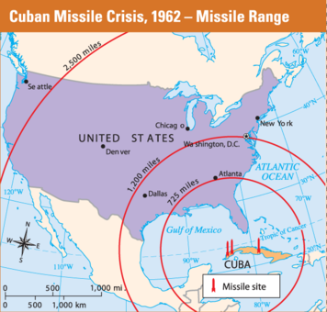
For the next six days, tensions mounted unbearably as Soviet ships, which were thought to be carrying more missiles, steamed toward Cuba. “We were on the edge of the precipice [cliff] of nuclear war,” Khrushchev later said of that terrifying week. “Both sides were ready to go.”
To the relief of the entire world, the Soviet ships stopped when they reached the U.S. blockade. “We’re eyeball to eyeball,” observed Dean Rusk, Kennedy’s secretary of state, “and I think the other fellow just blinked.” The Cuban missile crisis ended when Khrushchev agreed to remove the missile bases in exchange for Kennedy’s promise not to invade Cuba and to remove U.S. missile bases recently installed in Turkey.
The Vietnam War Half a world away from Cuba, a new communist threat appeared in the Southeast Asian country of Vietnam. Once a French colony, Vietnam won its independence from France in 1954.
As part of Vietnam’s independence agreement, elections were to be held in 1956 to determine who would rule the new country. The most likely winner of the elections would have been Ho Chi Minh, the leader of Vietnam’s independence movement and a supporter of communism. The elections, however, were never held. U.S. advisers agreed with the leader of South Vietnam, Diem, on the need to back out of the agreement so that the elections would not end in a communist victory.
Backed by a few hundred military advisers from the United States, anticommunist leaders took control of the southern half of Vietnam. By the time Kennedy took office, communist rebels backed by North Vietnam were waging a guerilla war against the South Vietnamese government. The rebels, known as the Viet Cong, attacked suddenly and then faded away.
“The Free World,” President Kennedy declared, “must increasingly protect against and oppose communist subversive [rebellious] activity . . . in Southeast Asia.” To back up his words, Kennedy increased the number of U.S. military advisers in South Vietnam to more than 16,000.
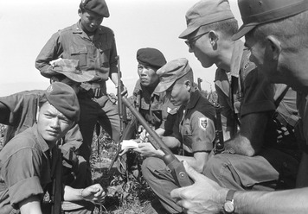
Johnson Sends More Troops Lyndon Johnson, who became president after Kennedy was assassinated in 1963, was faced with the problem of how far to go in supporting the government of South Vietnam. Many argued that, in the end, South Vietnam would have to win its own fight. But Johnson decided that the United States could not afford a communist overthrow of the South Vietnamese government.
Johnson used reports of a North Vietnamese attack on an American destroyer to win approval of a Congressional resolution that, he argued, authorized him to increase the American military presence in Vietnam. By the end of 1965, there were 180,000 U.S. troops in Vietnam. Two years later, the number had increased to 500,000. The United States was involved in a full-scale war.
Despite this massive buildup of troops, the war did not go well for South Vietnam and its American ally. U.S. soldiers were often unable to tell friends from enemies. Sometimes they burned entire villages in their search for Viet Cong rebels. After shelling one village, an officer explained, “It became necessary to destroy the town in order to save it.” Many Americans protested the Vietnam War, calling it unfair, destructive, and unwinnable. Nixon Ends the War Johnson’s successor, President Richard Nixon, promised to get the United States out of Vietnam. He carried out part of this promise by bringing all but 150,000 troops home by 1972.
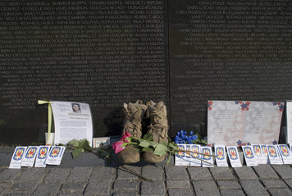
At the same time, Nixon secretly expanded the war into the neighboring countries of Laos and Cambodia. In 1971 alone, the U.S. dropped 800,000 tons of bombs on Vietnam and other Southeast Asian countries. When the air raids became public, massive protests erupted throughout the United States.
A peace agreement was finally worked out in January 1973. In April, the final American troops withdrew. In 1976, North Vietnamese troops reunified Vietnam under a communist government.
For both the United States and Vietnam, the human costs of this long war were huge. More than 58,000 Americans died in the conflict. Hundreds of thousands more came home wounded, disabled, or suffering from emotional and mental problems. In Vietnam, up to 2 million people died, while millions more were wounded and left homeless.
For the United States, perhaps the greatest cost was a loss of faith in the nation’s leaders. For the first time in its history, the United States had lost a war. While people argued over the cause of this defeat, the Vietnam War left many wondering if containment was worth so many lives and a deeply divided nation.

Section 7 - The End of the Cold War

President Ronald Reagan, who took office in 1981, had no doubts about fighting communism. Reagan publicly denounced the Soviet Union as an “evil empire” and greatly increased military spending. In his second term, however, Reagan’s attitude toward the Soviet Union softened. The reason was a new leader in the Soviet Union named Mikhail Gorbachev.
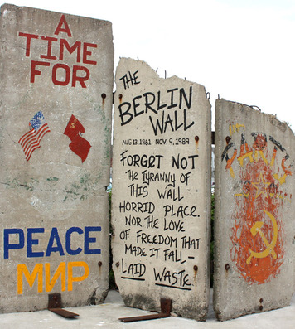
A New Soviet Leader When Gorbachev took office in 1985, the Soviet economy was not working well. Heavy military spending had kept the nation from meeting the human needs of the Soviet people. Farms and factories owned by the government were inefficient and unproductive.
Gorbachev came into power hoping to reform the communist system and make it work better. He began a policy of glasnost (openness), which led to increased freedom of the press, speech, and religion. He started an economic program called perestroika (restructuring) that was supposed to improve the economy. And he reduced the size and power of the Soviet military.
Reagan and Gorbachev met twice to discuss ways to end the arms race. For the first time ever, both sides agreed to reduce the number of their nuclear weapons.
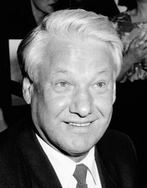
Communism Collapses Gorbachev’s policies gave hope to reformers throughout Eastern Europe. In June 1989, Poland freely elected a noncommunist government. In November, bulldozers tore down the Berlin Wall. As one country after another overthrew its communist government, Gorbachev told his people, “We have no right . . . to interfere.”
Then the uprisings against communism spread to the Soviet Union itself. In August 1991, a second Russian Revolution took place as supporters of democracy, led by Boris Yeltsin, seized power. One of Yeltsin’s first official acts was to ban communists from power.
With the end of communist rule, the Soviet Union collapsed and all of the 15 republics that had made up the USSR declared their independence. In December, a Russian official announced that “the Soviet Union has ceased to exist.”
After more than 40 years, the Cold War was over. Americans rejoiced that the free world had won. Still, communism survives in such countries as China, Vietnam, North Korea, and Cuba.

