Section 4 - The 1970s: A Time of Distrust
By the 1970s, the oldest of the baby boomers were raising their own families, and the counterculture began to fade. Younger boomers seemed to turn away from social causes, earning the label of the “me generation.” Still, much of the idealism of the 1960s lived on—and so did distrust of government.
The Environmental Movement During the 1970s, a new cause attracted millions of Americans: protecting the environment. Environmentalists focused attention on air pollution caused by factories, cars, and power plants. They also sought remedies for the water pollution from city sewage, factory wastes, and agricultural chemicals.
On April 22, 1970, environmentalists organized the first Earth Day to encourage people to protect the environment. Later that year, Congress responded to public pressure by creating the Environmental Protection Agency (EPA) to help create and enforce laws to clean up the nation’s air, soil, and water.
Growing Distrust of Government Distrust of government leaders, which had begun with the antiwar movement, grew stronger during the 1970s. One reason for this growing distrust was President Richard Nixon’s policy in Vietnam. Nixon was elected in 1968 on the promise that he would quickly end the Vietnam War. Instead, the fighting dragged on. Still trying to win a “peace with honor,” Nixon ordered the bombing of the enemy’s supply lines in Cambodia.
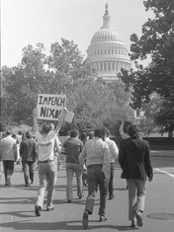
In May 1970, students at Kent State University in Ohio gathered to protest Nixon’s expansion of the war into Cambodia. Ohio’s governor called on the National Guard to restore order. The Guard arrived on campus wearing gas masks and carrying loaded rifles. The next day, guardsmen fired into a crowd of students in a parking lot. Fifteen students were injured, and four were killed.
President Nixon blamed the protesters for the deadly incident. “This should remind us,” the president said, “that when dissent turns to violence, it invites tragedy.” But many Americans, horrified by the killing of unarmed students, put the blame on the government.
The Watergate Scandal Distrust in the nation’s government reached a peak during a series of events known as the Watergate scandal. The scandal began in the presidential election year of 1972. In June, five men were arrested after breaking into Democratic Party headquarters at the Watergate Hotel in Washington, D.C. The burglars were trying to steal documents and plant electronic equipment that would allow them to listen to private telephone conversations.
At first, the break-in seemed like a minor story. Then the news media learned that the Watergate burglars worked for the Committee to Re-Elect the President, Nixon’s campaign organization. Worse, people with important White House jobs had arranged for the burglars to be paid to keep silent.
Led by two reporters for the Washington Post, journalists started to uncover evidence of widespread wrongdoing among people who worked for Nixon and his campaign organization. Congressional committees began holding hearings. A special prosecutor was appointed to investigate the scandal that everyone now called “Watergate.”
In 1973, a Senate committee learned that President Nixon regularly taped conversations in the Oval Office. The special prosecutor immediately demanded the audiotapes for his investigation. Eventually, the Supreme Court ordered a defiant Nixon to surrender them.
The tapes proved that Nixon himself had been deeply involved in trying to stop investigations into Watergate. When a committee of the House of Representatives recommended impeachment, Nixon resigned from office rather than face trial and almost certain conviction in the Senate.
The Watergate scandal left many Americans deeply disillusioned. When a 1974 poll asked people how much faith they had in the executive branch of government, 43 percent answered “Hardly any.”
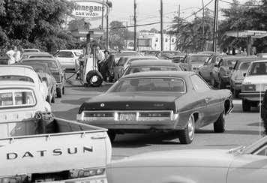
Energy Crisis Another problem that grabbed the nation’s attention during the 1970s was the energy crisis. By the late 1960s, American consumers depended on oil imported from other countries to heat their homes and fuel their cars. Most of these oil-producing countries were located in the Middle East and were members of the Organization of Petroleum Exporting Countries (OPEC).
In 1973, U.S. support for Israel during a war in the Middle East caused OPEC suppliers to cut production and exports and to stop exporting oil to the United States. Suddenly, Americans faced an “energy crisis.” Gas shortages forced drivers to spend hours waiting in line at gas stations. Homeowners worried about the rising cost of heating their houses.
The immediate crisis ended in 1974, when OPEC members resumed supplying oil to the United States. However, the price of oil continued to rise, and Americans remained concerned about their dependence on foreign oil and the need to conserve energy.
A Washington Outsider Taking over the presidency after Nixon’s resignation, Gerald Ford struggled with the oil crisis and a poor economy while in office. The 1976 presidential election pitted Ford against former Georgia governor Jimmy Carter. Hoping to take advantage of Americans’ distrust of their government, Carter appealed to voters as a Washington outsider. He promised Americans, “I will never lie to you.”
Carter won the election by a small margin. Once in the White House, Carter maintained his outsider status. Rather than hiring experienced Washington insiders, he surrounded himself with staff from Georgia. Carter also failed to establish close relations with Congress. As a result, his efforts to enact new reforms were largely unsuccessful.
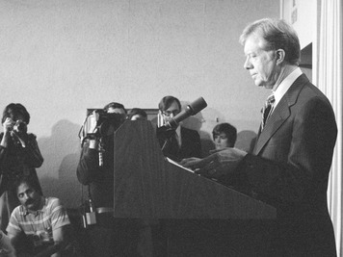
Emphasizing the need for a new energy policy, the new president called on Americans to “face the fact that the energy shortage is permanent.” Congress and the American people were not moved by this message. The Iranian revolution in 1979 led to a second energy crisis. This pushed up oil prices again and damaged Americans’ confidence in their president.
A Hostage Crisis in Iran Early in the 1970s, the United States had increased military aid to Iran. In return, it expected Iran’s royal ruler, Shah Mohammed Reza Pahlavi, to help maintain stability in the Persian Gulf region. In January 1979, however, a revolution swept through Iran. Under a religious leader, the Ayatollah Ruholla Khomeini, the revolutionary army declared Iran an Islamic republic. It forced the shah from the throne and into exile.
Later that year, Carter allowed the exiled shah to enter the United States for medical treatment. This decision angered many Iranians. On November 4, 1979, armed Iranian students stormed the U.S. embassy in Tehran, Iran’s capital. The students took 66 Americans hostage, parading the hostages through the streets of the city. Soon the Iranian government threw its support behind the students.
For more than a year, Carter struggled to bring the hostages home. In April 1980, Carter attempted a military rescue. The mission failed. Two helicopters had engine trouble, a third was damaged while landing, and a fourth crashed, killing eight Americans.
The hostage crisis angered Americans. Some directed their rage at Iran. Other Americans blamed Carter’s “fairness, not force” approach to foreign policy. Fifty-two of the hostages were not released until Carter left office in January 1981. By then, they had spent 444 days in captivity.

Section 5 - The 1980s: A Return to Optimism
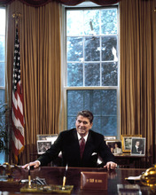
When Ronald Reagan ran for president in 1980, the majority of baby boomers were old enough to vote. By this time, the energy crisis, the Watergate scandal, and a sharp downturn in the economy had left many Americans deeply pessimistic about the future.
In the face of this gloom, Reagan, a former actor and governor of California, was optimistic and hopeful. “There is nothing wrong with America,” he said, “that—together—we can’t fix.” Voters agreed. In 1981, Reagan took office as president declaring that it was “morning in America.”
Reaganomics Reagan believed that the best way to get the economy moving again was to lower taxes on the individuals, particularly the wealthy, and on businesses. This policy, he argued, would encourage people to invest more money in businesses. As businesses expanded, new jobs would be created for working people. This economic policy came to be known as “Reaganomics.”
In 1981, Congress passed the largest income tax cut in the nation’s history. At Reagan’s urging, Congress also relaxed many government regulations that limited what businesses could do. As a result of these changes, business boomed and new jobs were created.
Critics of Reaganomics, however, pointed out that not all Americans were benefiting from the economic boom. When Congress cut taxes, it also cut spending on many programs that helped the poor, such as food stamps and free school meals. In addition, unemployment remained high among African Americans, Latinos, and unskilled workers.
A New Wave of Immigration Optimism about the future helped fuel a new wave of immigration into the United States during the 1980s. More than 7 million newcomers entered the United States, more than in any other decade since 1910.
In 1965, Congress ended the immigration quotas that it had passed back in 1924. This action made it easier for non-Europeans to enter the country. The result was a dramatic increase in immigrants from South America, Asia, and the Caribbean.
The most popular destination of these new immigrants was California. A student who came to California from Mexico in the 1980s observed,
I was surprised when I arrived to see so many kinds of people—Black people, Asians. I found people from Korea and Cambodia and Mexico. In California I found not just America, I found the world.
Social Problems Despite the optimism of the 1980s, the nation faced serious social problems. With cutbacks in social programs, homeless people began appearing on city streets. The gap between the wealthiest and poorest Americans seemed to be widening. Crime rates, which first began to increase in the 1960s, continued to rise. In 1983, a presidential commission reported that American schools were failing at their job of educating all students.
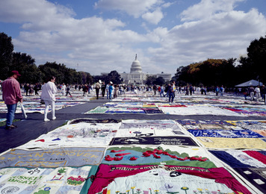
Another serious issue was drug abuse. In 1980, only 10 cities reported serious problems with gangs selling crack cocaine and other illegal drugs. By 1990, more than 125 cities had serious problems with drug abuse and crime stemming from the illegal drug trade.
The Reagan administration responded to the rise in drug abuse by declaring a “war on drugs.” New laws increased penalties for people caught with illegal drugs. The armed forces were used to patrol the nation’s borders to reduce the smuggling of illegal drugs into the United States. As the war on drugs continued into the 1990s, more and more people were jailed for selling or possessing illegal drugs. Many Americans questioned whether harsher penalties were helping to reduce drug abuse.
Another troubling issue was the appearance of a frightening new disease called acquired immune deficiency syndrome (AIDS). AIDS is caused by a virus known as HIV, which attacks the body’s ability to fight off disease. The HIV virus is spread through sexual intercourse or by bodily fluids, such as blood, entering the body. By 1995, more than 270,000 Americans had died of AIDS. An estimated 1 million more were infected with HIV.
As more information about AIDS became available, Americans organized to raise money for research and treatment. In 1988, a huge quilt honoring AIDS victims toured the nation. By 2012, the AIDS Memorial Quilt had more than 47,000 panels, each one honoring the life of a loved one lost to this terrible disease.

