The D.C. Sniper Story
This is the story of the snipers that held America hostage with a nationwide murder spree that culminated in a three-week string of shootings near Washington D.C. John Allen Muhammad, 42, and Lee Boyd Malvo, 17, started murdering their way across the U.S. in February of 2002. They set off from Washington state in a blue 1990 Caprice, attacking 14 people on their way across the U.S., 7 of whom died.
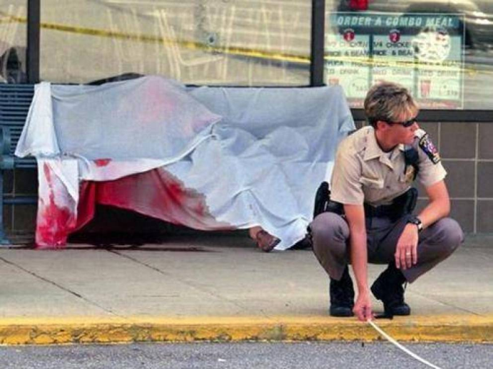
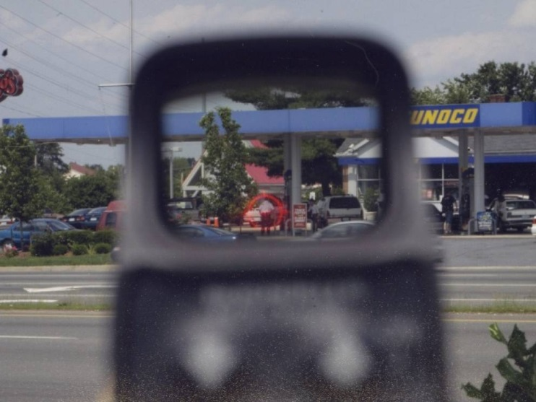

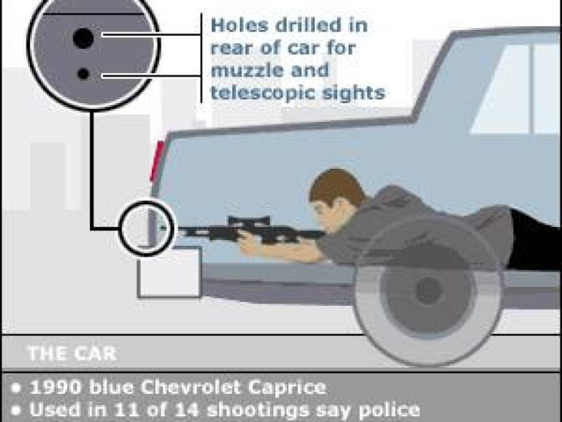
The two continued the rampage over three bloody October weeks in the Washington D.C. area. The shootings were concentrated around the Beltway highway that surrounds D.C. and runs through parts of Maryland and Virginia. Muhammad and Malvo shot 13 people over the three weeks, killing ten. Muhammad and Malvo had connived a deadly system for murder. The duo made holes in the trunk of their blue Caprice to fire out of. They modified the back seat to allow a shooter to lay across the seat and trunk and snipe unsuspecting victims from the cover of the car. On October 3, 2002 they shot and killed five people in the space of 2 hours using this method.

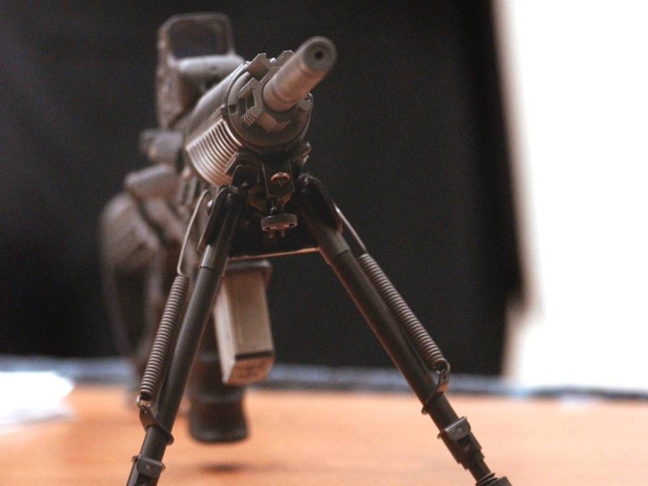
Muhammad and Malvo used a Bushmaster XM-15, a civilian version of the military assault rifle favored by police forces. It had a holographic sight and was fitted with a 20-round magazine plus a bipod. It's heavy duty firepower. The snipers began leaving cryptic notes, letters and demands near the scenes of the shootings that taunted police and made demands. The sniper attacks received massive media attention and it had people living around the beltway on edge. News teams swarmed the crime scenes after each shooting, sometimes dedicating hours of coverage. The apparent random string of victims made people incredibly nervous to stand around in parking lots or at gas stations. Naturally, government offices and officials were on high alert as well.
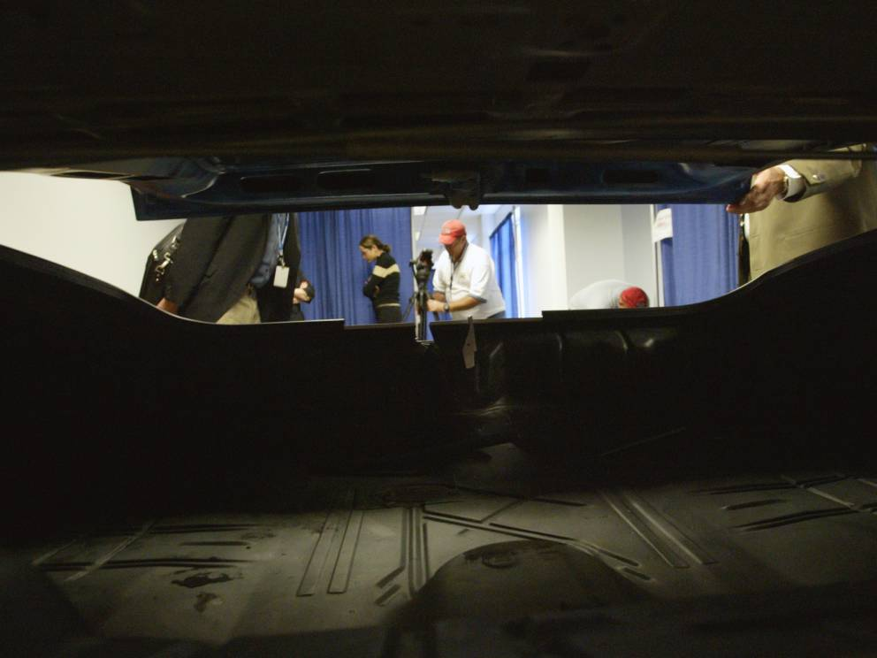
A Massive Manhunt
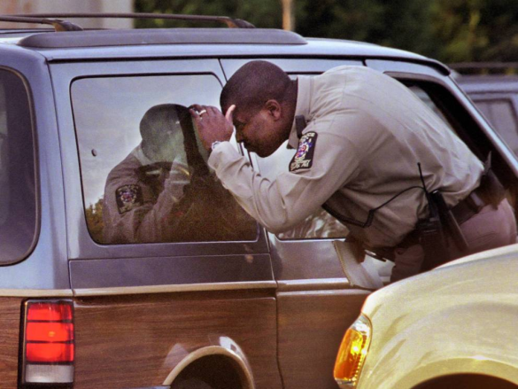
Police established a massive dragnet, stopping major roads in the region and inspecting vehicles after each shooting. Initially they were looking for one suspect driving a white box van. Soon police determined the shootings had all been from a distance and from the same weapon. They were able to determine the suspected car was actually a blue Caprice after pooling various police agencies including local cops, the FBI, the ATF, and the Secret Service.

Sniper Arrests
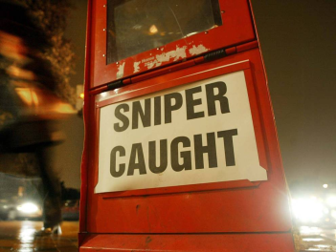
A newspaper box headline reading "Sniper Caught" is seen on a Georgetown street a day after suspects John Allen Muhammad and John Lee Malvo were arrested October 25, 2002 in Washington, DC. The suspects were arrested while sleeping in a car at a rest stop in Myersville, Maryland.

John Allen Muhammad
John Allen Muhammad, was 42 at the time of the murders. There was never a clearly established motive for the senseless murders, though some thought he could have terrorist connections. Another theory was that he wanted to murder his ex-wife over a custody battle and wanted to make it appear that she would be just another victim in a murder spree.
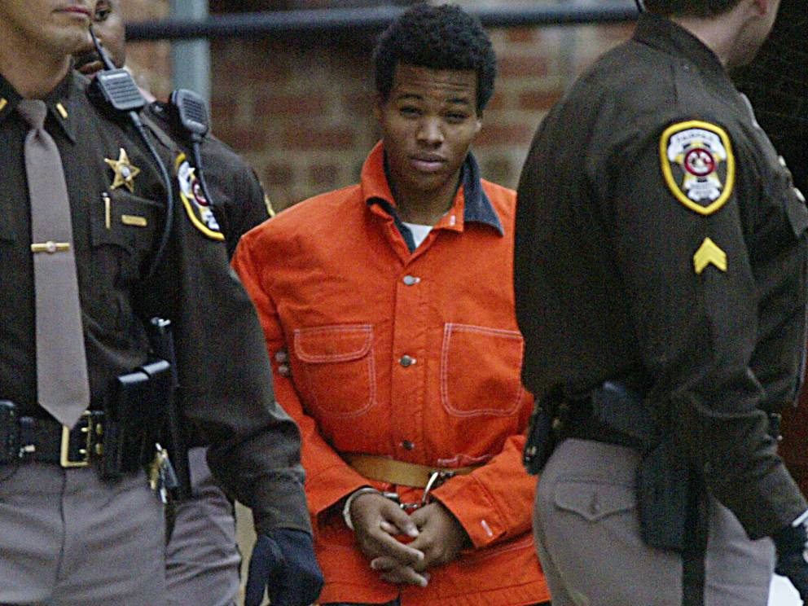
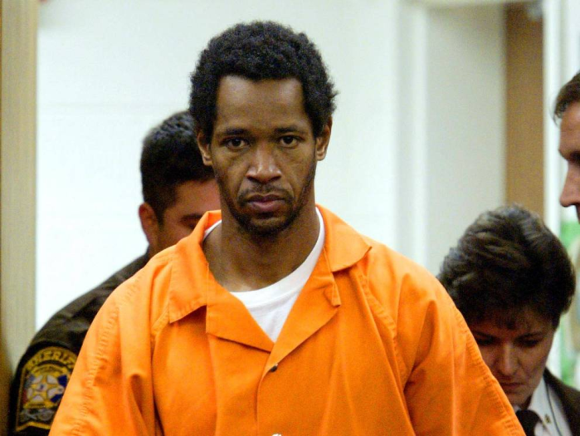
Lee Malvo
Lee Malvo was only 17 when he committed the murders. Initially he said he pulled the trigger for all the killings in an attempt to protect Muhammad by taking the blame as a minor. Eventually he confessed that Muhammad had manipulated him by becoming a father figure. There were more attacks in the works and Muhammad had even devised a plan to recruit more boys into a militia.

Representing Himself
John Allen Muhammad handles a rifle scope during cross examination of Sgt. Maj. Mark Spicer during his trial. He made the choice to fire his defense team and represent himself instead. It wasn't a good choice, he was sentenced to death.

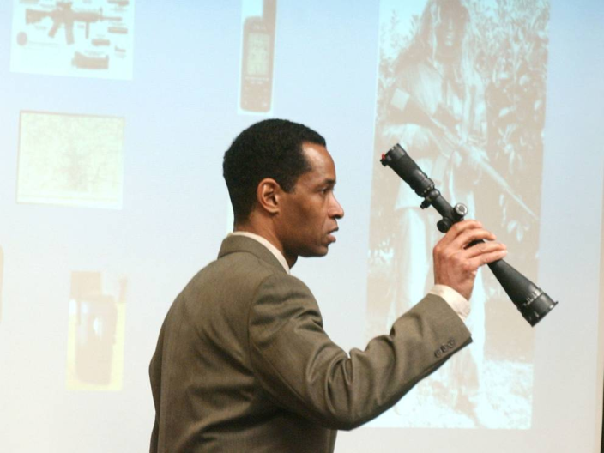
Drawings Made By Malvo
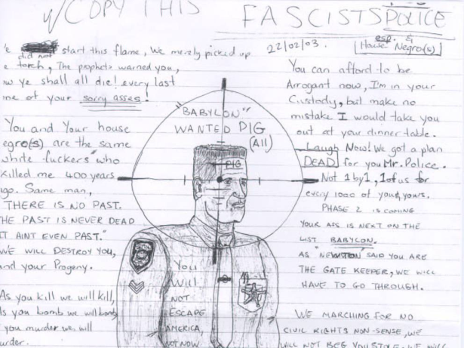
Malvo made strange cryptic drawings while he was in custody. This one targeted a police officer and called police fascists. The drawings were entered into evidence during his trial.

John Allen Muhammad Executed
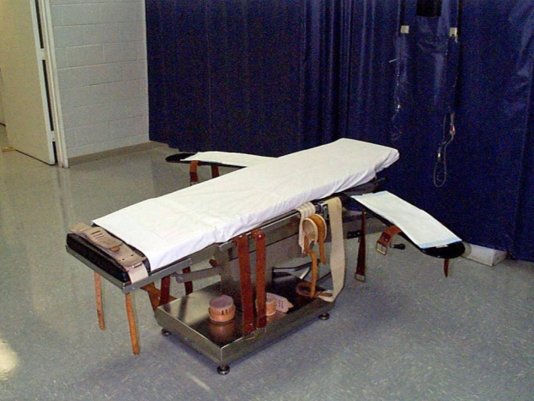
This is the gurney where convicted sniper John Allen Muhammad was put to death at the Greensville Correctional Center in Jarratt, Virginia. Muhammad was put to death by lethal injection on November 10, 2009. He was 48. Lee Boyd Malvo is serving 6 consecutive life sentences. He has expressed regret over the murders he participated in and even sent apologetic letters to victims who had survived the attacks.

Timeline - D.C. Area Shooting Spree:
October 2, 2002 - A shot is fired through a window at a Michael's crafts store in Aspen Hill, Maryland, but no one is hit.
- Not linked by ballistic evidence.
October 2, 2002 - The first killing takes place when 55-year-old James D. Martin, a program analyst for the National Oceanic and Atmospheric Administration, is shot in the parking lot of Shoppers Food Warehouse in Wheaton, Maryland.
- Not linked by ballistic evidence.
October 3, 2002 - Police are called to a crime scene and find James L. Buchanan, a 39-year-old landscaper who has been fatally shot while mowing a lawn at a commercial establishment near Rockville, Maryland.
October 3, 2002 - 54-year-old Premkumar Walekar, a part-time cab driver, is killed while pumping gas into his taxi at a station in the Aspen Hill area of Montgomery County, Maryland.
October 3, 2002 - Sarah Ramos, 34, of Silver Spring, Maryland, is killed at a post office near Leisure World Shopping center. A witness reports seeing a white van or truck speed from the post office parking lot immediately after the shooting.
October 3, 2002 - Lori Ann Lewis-Rivera, 25, of Silver Spring is shot dead at a Shell gas station in Kensington where she was vacuuming her van.
October 3, 2002 - In the only killing in Washington and the first one to occur at night, Pascal Charlot, 72, is shot in the chest as he walks along Georgia Avenue. He is taken to a hospital, where he dies less than an hour later.
October 4, 2002 - In a Michael's parking lot in Fredericksburg, Virginia, Caroline Seawell, 43, is shot as she puts her bags inside her Toyota minivan. She is released from a Fairfax hospital on Monday, October 14.
October 7, 2002 - Iran Brown, 13, is shot and critically wounded outside Benjamin Tasker Middle School in Maryland's Prince George's County.
October 9, 2002 - A tarot card is found near the scene of the shooting at the school. CNN sources say it is the "Death Card" with the message "Call me God" for police.
October 9, 2002 - Dean Harold Meyers, 53, of Gaithersburg, Maryland, is killed while pumping gas at a station in Manassas, Virginia. A white minivan seen in the area was first thought to have some connection with the shooting but was cleared by police.
October 11, 2002 - Kenneth Bridges, 53, a Philadelphia businessman, is killed at an Exxon station just off I-95 near Fredericksburg, Virginia. Police enforce a huge roadblock, trying to find a white van-like vehicle (similar to a Chevy Astro) with a ladder rack on top.
October 14, 2002 - Linda Franklin, 47, of Arlington, Virginia, is killed by a single gunshot in a Home Depot parking lot in Falls Church, Virginia.
October 19, 2002 - Jeffrey Hopper, 37, is shot in a parking lot at a Ponderosa Steakhouse near I-95 in Ashland, Virginia, 83 miles south of Washington. Doctors remove the bullet from the victim during surgery on October 21 and connect him to the others by ballistics.
October 21, 2002 - Police surround a white van at a pay phone at an Exxon gas station in Richmond, Virginia. They arrest one man in the vehicle and a second man "in the vicinity" but later say that they can not be connected to the sniper shootings.
October 22, 2002 - Bus driver Conrad Johnson, 35, of Oxon Hill, Maryland, is shot as he stands on the top step inside his commuter bus in Aspen Hill, Maryland. He later dies at a hospital in Bethesda. Investigators confirm on October 23 that his death is connected to the sniper.
October 24, 2002 - John Allen Muhammad and Lee Boyd Malvo are arrested. They are later tried and convicted - Muhammad receives a death sentence and is executed on November 10, 2009. Malvo receives life in prison without parole.

