Aftermath of Hurricane Katrina
Hurricane Katrina was one of the strongest on record, and tore a path of destruction and heartache through Gulf Coast communities.

The Katrina Storm Surge-The 175 mph winds generated by Hurricane Katrina caused their fair share of damage but the biggest devastation was wrought by the 20-foot-high storm surge that battered the coasts from the Florida Panhandle to the Texas Gulf Coast. This video shows the destructive storm surge in Mississippi.

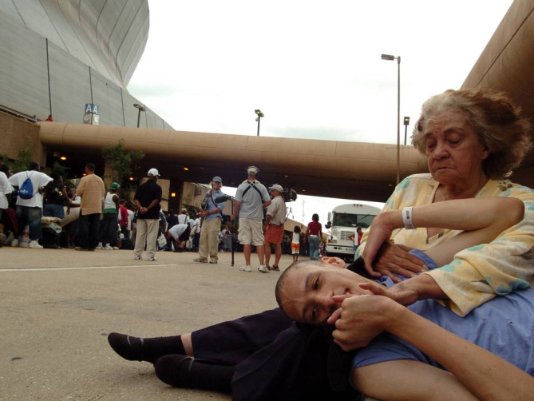
Outside The Super Dome- Marion Camp of New Orleans, Louisiana holds her autistic grandson William Camp while his mother waits in line to enter the New Orleans Super Dome on August 28, 2005. They were trying to get into the Dome, which was converted to a shelter for people with special needs and people who hadn't yet been evacuated, before the storm hit the next day.

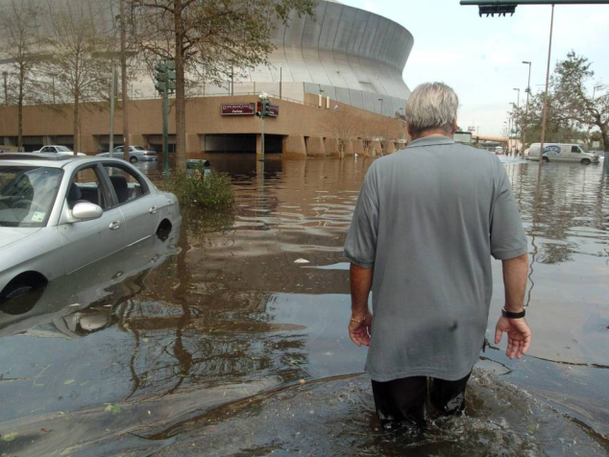
The Super Dome After The Storm-An unidentified man makes his was through flooded Poydras Street towards the Super Dome on August 30, the day after hurricane Katrina swept through New Orleans.

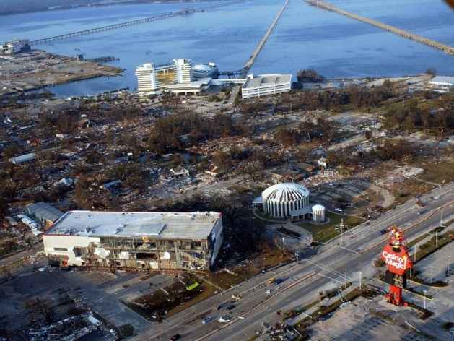
A Devestated Biloxi-Hurricane Katrina destroyed the Point Cadet section of Biloxi, Mississippi, as shown in this August 30, 2005 photo. Estimates are 238 Mississippi people were killed during the storm.

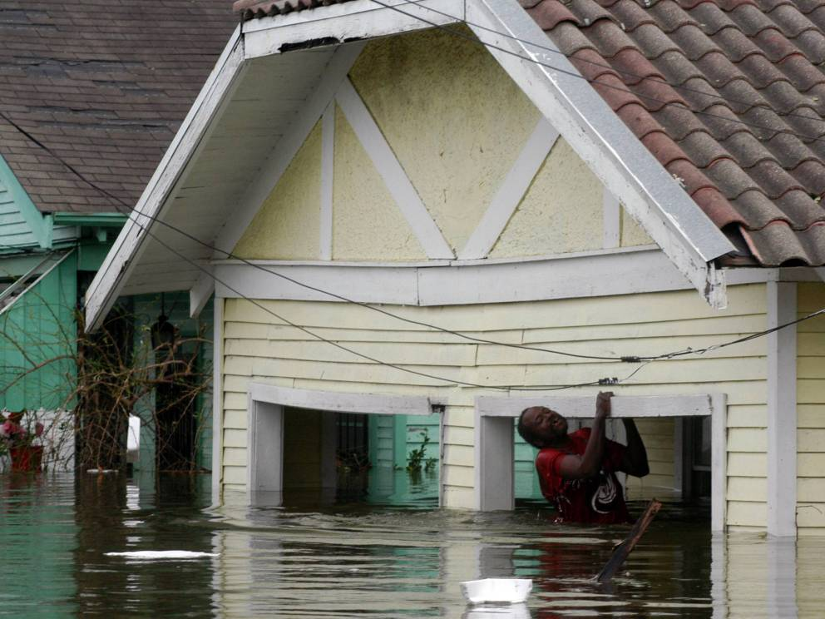
When The Levee Breaks-A man holds himself on his porch in Lower Ninth Ward in New Orleans, Louisiana on August 29, 2005. The largely working class Lower Ninth Ward was one of the most heavily hit sections of New Orleans. Estimates are nearly 80 percent of the city was underwater.

Hurricane Katrina- Louisiana on August 30, the day after Hurricane Katrina slammed Louisiana. Without enough security officials, the city plunged into chaos and anarchy after the hurricane hit Louisiana.

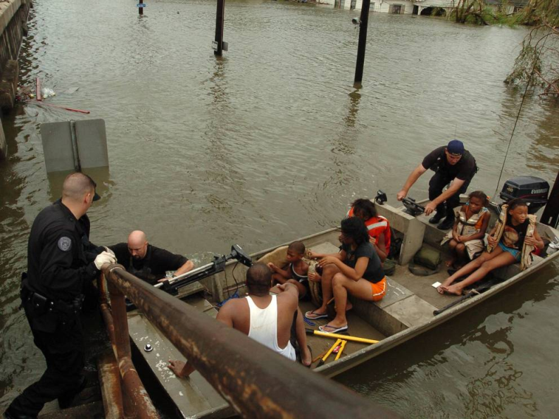
Few Rescue Boats-New Orleans police bring people ashore from rescue boats from the flooded Lower Ninth Ward in New Orleans. The city's federally constructed levee system was designed to withstand a category 3 storm, but Katrina peaked at category 5 before slamming Louisiana as a category 4 storm. Much of New Orleans was flooded after levies broke and water rushed into the city.

Clinging To Life-Survivors rescued from the flooded Lower Ninth Ward recuperate on the St. Cloud Bridge. Many people sought refuge on raised bridges and roads as they were some of the only structures above the waterline.

Military Rescues-Flood survivors are helped onto a military truck after being rescued from their flooded homes in the Lower Ninth Ward in New Orleans on August 30, 2005. Louisiana suffered 1,577 people killed in the storm- more than half them were seniors.

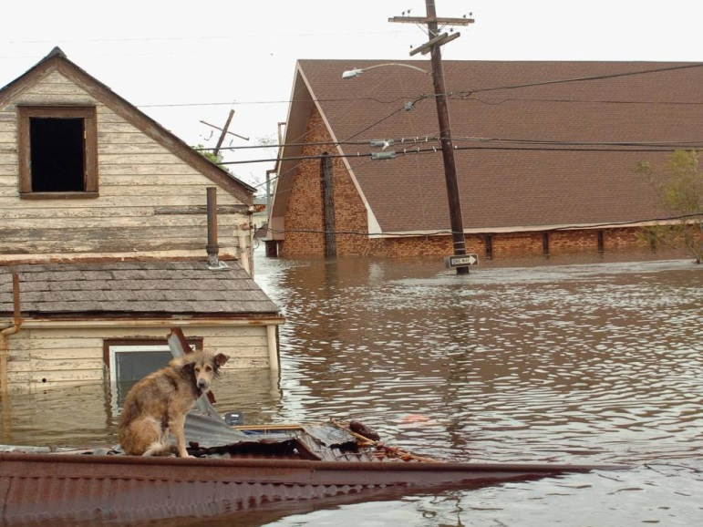
Little Help For Pets-A dog sits stranded on a rooftop in the flooded Lower Ninth Ward in New Orleans on August 29, 2005. Animal rights groups estimate more than half a million pets were killed or left without homes after the disastrous hurricane.

Not Enough Emergency Crews-Reed Duane has a smoke at Washington Artillery Park while plumes of smoke from a fire in a chemical factory rise on September 3, 2005. Emergency crews had their hands full aiding people and could do nothing about the fire.
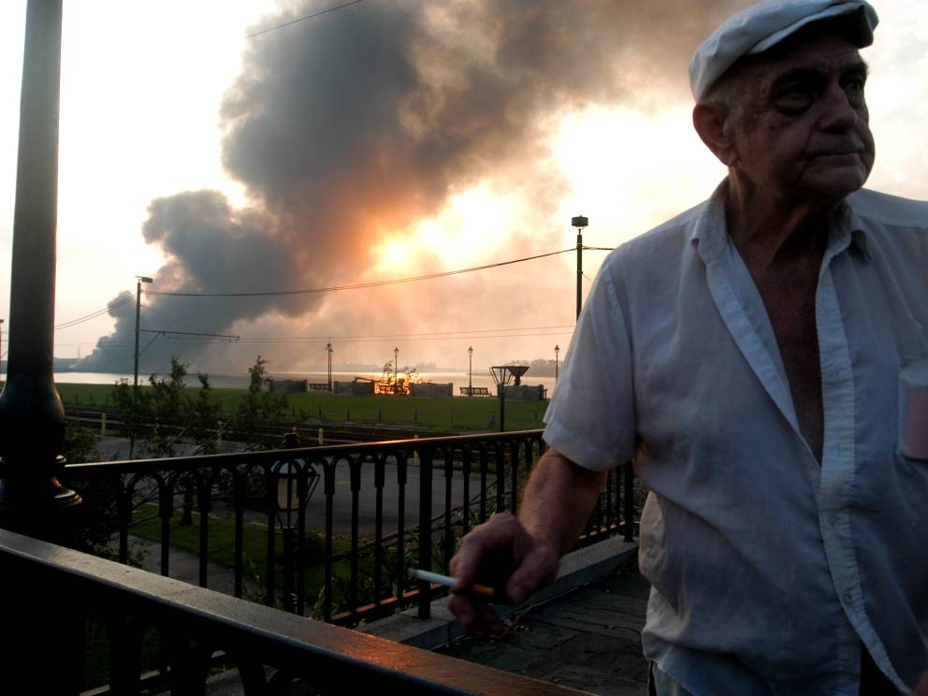

From Surviving To Rebuilding-A displaced flood survivor looks for his shoe size on Canal Street on September 3, 2005 in New Orleans. People were left without homes, proper sanitation and basic supplies.

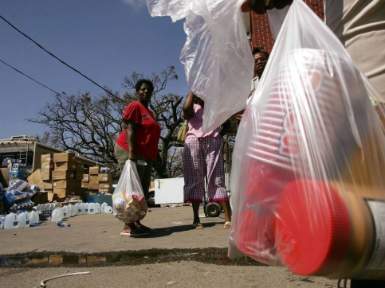
Aftermath Of Hurricane Katrina-Ali Jaber looks over his children's room which had been flooded and drained during Hurricane Katrina. A week after Hurricane Katrina hit, residents were allowed back to their houses in Metairie to collect possessions, but authorities told them they couldn't stay.

In Need Of The Basics-Residents hold bags of food received from a church for victims of Hurricane Katrina September 8, 2005 in Biloxi, Mississippi. Thousands of people on Gulf Coast were without electricity or access to basic amenities.

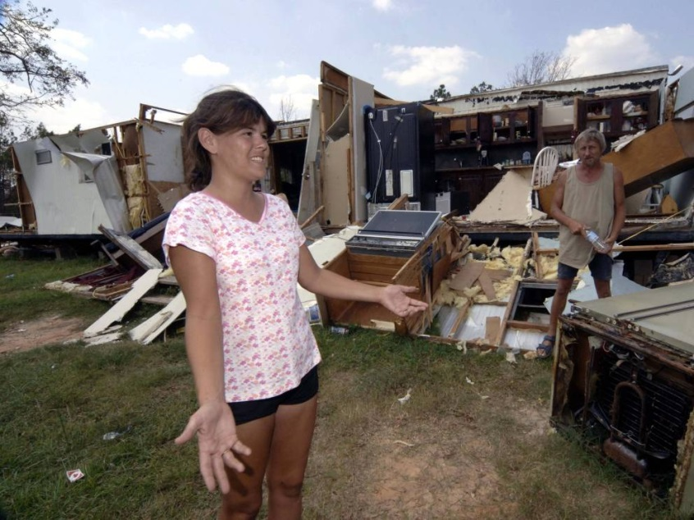
Solace In Neighbors-A group of neighbors in Biloxi in what was left of their front yards on September 1, 2005. The Red Cross estimates 275,000 homes were destroyed in Louisiana, with 65,000 more between Mississippi and Alabama.

Wondering Where To Turn- Krystal and Glen Rester wonder where they will live after Hurricane Katrina left them homeless in Pass Christian, Mississippi. The Resters and their eight children were living in a tent behind their destroyed home.

Endless Debris-Debris from Hurricane Katrina lines the streets in Waveland, Mississippi. Scenes like this were common in Gulf Coast communities after the hurricane.

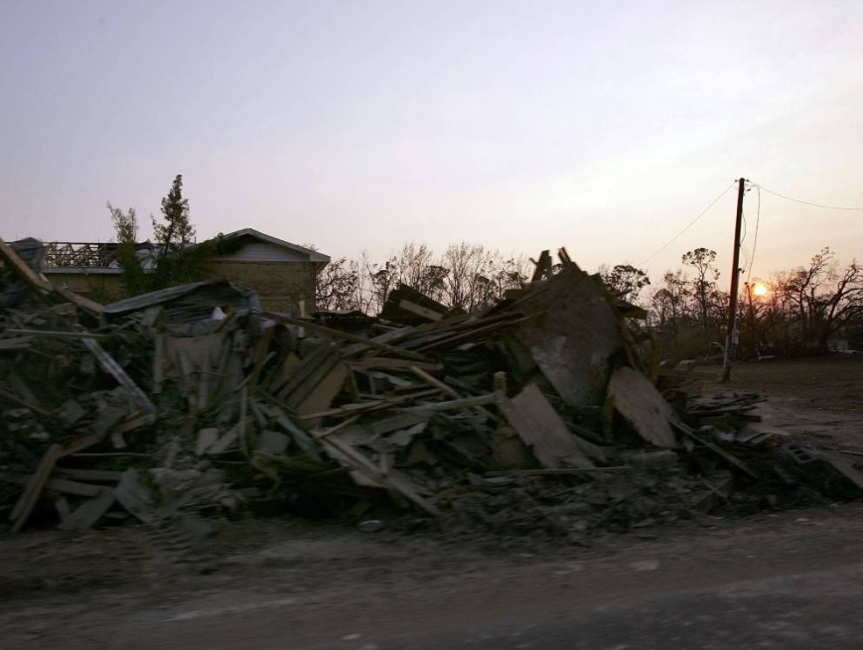
Military To The Rescue- A military Humvee rolls past debris piled up by high water from Hurricane Katrina in New Orleans. The Coast Guard estimates their personnel evacuated or rescued about 33,500 people by helicopter and boats, even though half of their people lost their homes in the flooding as well.
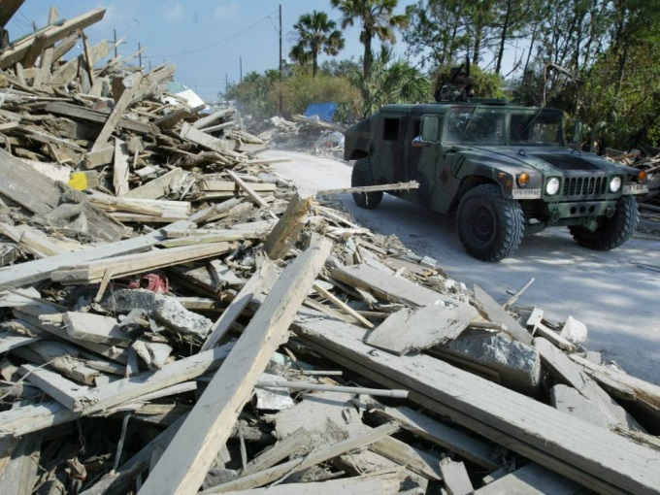

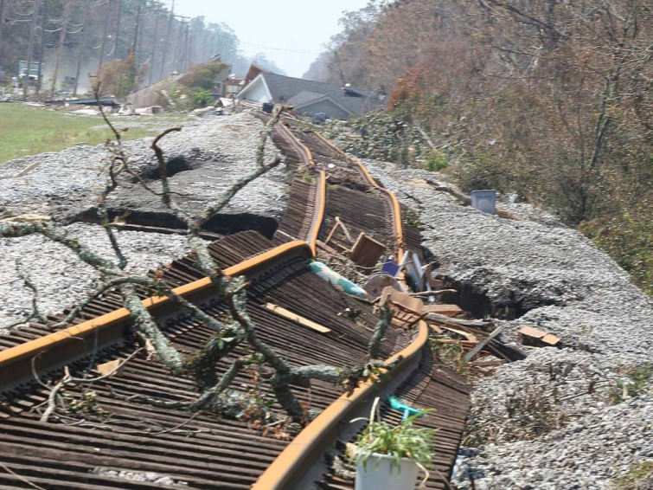
A Crippled Infrastructure-Twisted railroad tracks lie damaged by Hurricane Katrina in Waveland, Mississippi. The transport, sanitary, electric and water infrastructures of the effected areas were essentially crippled.

Hurricane Katrina Aftermath - Day 16-A boat sits more than 200 yards across a road from New Orleans' West End Harbor after the storm. The hurricane is estimated to have caused $81 billion in property damages.

A Blow To Gulf Coast Industry-A large container ship rests partially on land after being pushed up off the dock by the storm surge. The economic damage to the area is estimated at $150 billion. It ruined industries and left thousands of people both homeless and jobless.

The Destroyed Port- Shipping containers that were knocked over by high winds from Hurricane Katrina are seen at the Port of New Orleans. Hurricane Katrina brought the United States' fourth largest port to its knees, causing extensive damage and limiting abilities to ship and receive from the port.

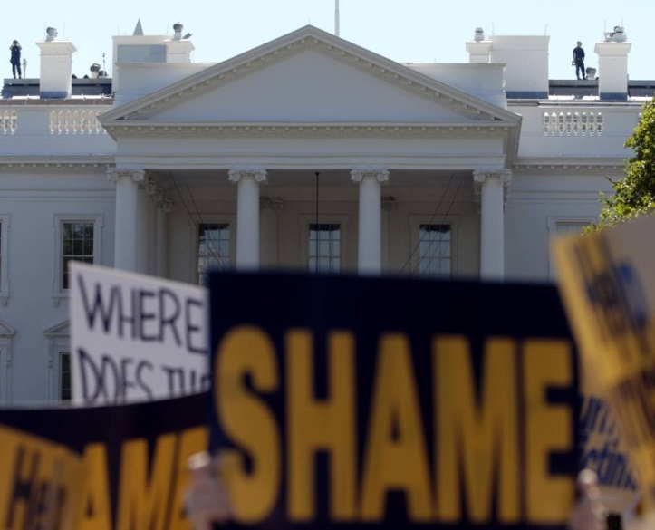
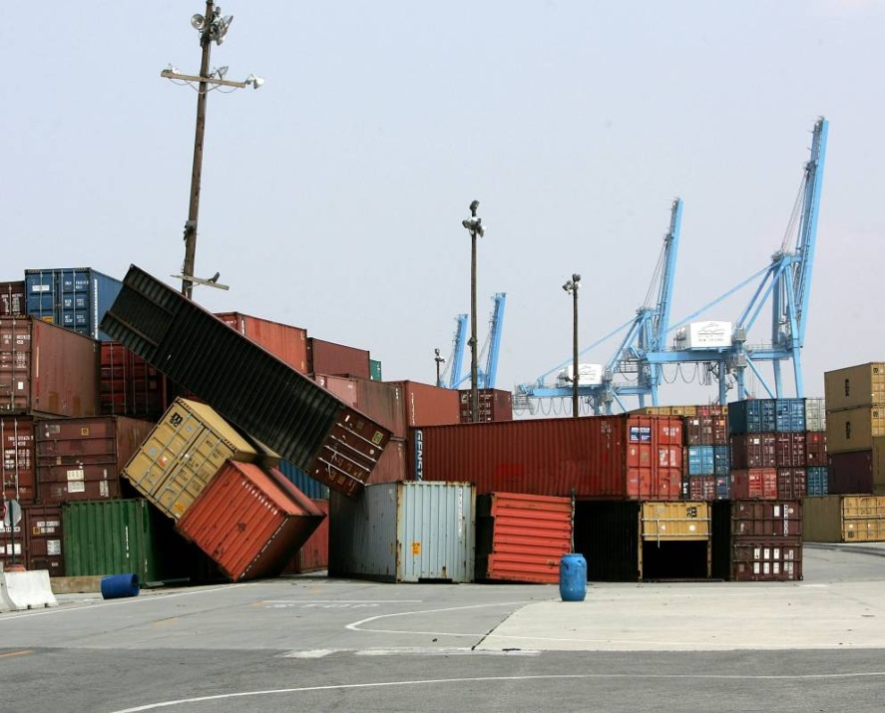
Hurricane Katrina-Many people criticized the local and federal governments role in the disaster. Citizens were angry about what they saw as a lack of proper preparation, especially with poorly maintained levies that broke during the storm. They also said the government rescue response was slow and wildly mismanaged. MoveOn.org organized a protest against President Bush in front of the White House to protest his 'lack of action and leadership' during Hurricane Katrina.

