Name:____________________ Date:_______________
New Deal Programs Gallery Walk- Graphic Organizer
Using the New Deal Gallery Walk Readings complete the following organizer. Be sure to understand the Law Created, its purpose, whether it was Relief, Recovery or Reform and how it affected Society Then and in the 1990’s.
Goals of the Program | Law/ New Deal Organization Name | What did the Program attempt to do? | Impact Made During the Depression | Impact made in the 1990s
Aid to the Elderly 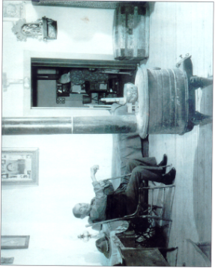

Circle One-
Relief
Recovery Reform
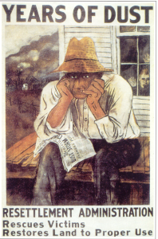
Aid to Farmers

Circle One-
Relief
Recovery Reform

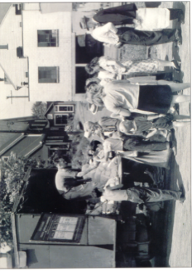
Direct Relief

Circle One-
Relief
Recovery Reform
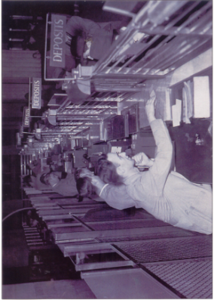
Insured Bank Deposits

Circle One-
Relief
Recovery Reform

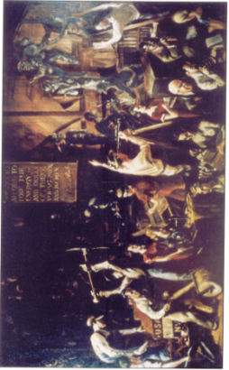
Investment in Youth

Circle One-
Relief
Recovery Reform

Job Programs
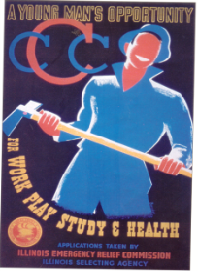

Circle One-
Relief
Recovery Reform

Workers Rights
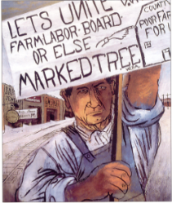

Circle One-
Relief
Recovery Reform
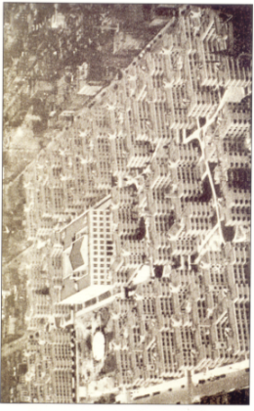
Public Housing

Circle One-
Relief
Recovery Reform

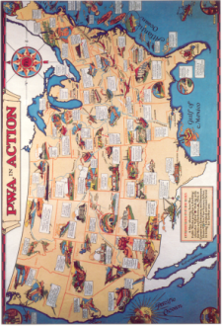
Public Works

Circle One-
Relief
Recovery Reform

Regulated Stock Market
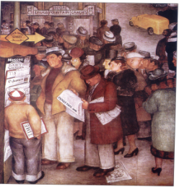

Circle One-
Relief
Recovery Reform
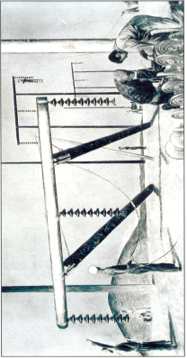
Rural Electricifcation

Circle One-
Relief
Recovery Reform

