Section 7 - The 2000s: Confronting New Challenges
The beginning of a new millennium was a momentous event for baby boomers and their families, promising a new era of American prosperity. However, the September 11 attacks, the war on terrorism, and a financial collapse introduced Americans to a decade that would be defined by new conflicts and challenges.
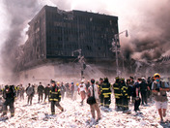
September 11, 2001 On September 11, 2001, terrorists hijacked four commercial American airplanes. They smashed two planes into the Twin Towers of New York’s World Trade Center, causing both towers to collapse. The third hit the Pentagon, the Department of Defense’s headquarters just outside of Washington, D.C. The fourth airplane crashed in a Pennsylvania field after passengers fought with the hijackers. This last plane had been heading for either the White House or the Capitol building. Altogether, about 3,000 people died in the terrorist acts of 9/11.
In the days that followed, Americans learned that a terrorist group called al Qaeda had carried out the 9/11 attacks. The organization’s leader was Osama bin Laden, a wealthy Saudi Arabian and Muslim extremist who wanted to rid Muslim countries of Western influence.
The attacks shattered Americans’ sense of safety. Most sensed that life had suddenly changed. As an editorial in the New York Times later stated, “It was one of those moments in which history splits, and we define the world as ‘before’ and ‘after.’”
The War on Terrorism President George W. Bush reacted to al Qaeda’s attacks on 9/11 by declaring a war on terrorism. In a speech to Congress, he declared, “Our war on terror begins with al Qaeda, but it does not end there. It will not end until every terrorist group of global reach has been found, stopped, and defeated.” This war would be waged not only against the terrorists themselves, but against any governments that sponsored them.
The war on terrorism began in Afghanistan, al Qaeda’s main base of operations. A radical Muslim group called the Taliban ruled the nation, approving of al Qaeda’s terrorist training camps. In October 2001, U.S. and British forces began bombing al Qaeda camps and Taliban military sites. Anti-Taliban Afghan militias also joined the fighting. Soon Afghanistan’s capital, Kabul, and other major cities fell. In November, U.S. Marines landed in the country to fight off the remaining Taliban forces.
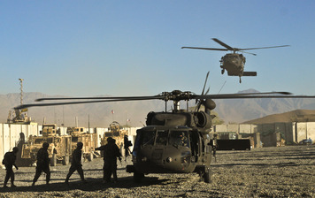
After replacing the Taliban government, President Bush turned his attention to another Middle Eastern country—Iraq. Bush feared that Iraq’s dictator, Saddam Hussein, would provide terrorists with weapons of mass destruction (WMD), such as chemical, biological, or nuclear weapons. In March 2003, an international group of forces led by the United States launched an invasion into Iraq. Within a month, the forces captured Iraq’s capital, Baghdad, and toppled the government. U.S. inspection teams began the search for banned weapons, but later found that Iraq had no WMD.

The United Stated hoped to bring democracy to Afghanistan and Iraq, but the price was high. Continuing violence forced U.S. soldiers to remain in the countries for far longer than expected. As of June 2012, about 6,500 American troops had died in the two military campaigns. Critics questioned whether the attempt to build democracy was worth the cost in money and lives. The last U.S. troops left Iraq in December 2011. However, American soldiers are expected to remain deployed in Afghanistan into 2014.
Compassionate Conservatism Though he took a hard stance on fighting terrorism, President George W. Bush promised to lead a more caring Republican Party through his message of “compassionate conservatism.” For six of his eight years in office, Bush was backed by a Republican majority in Congress. With this support, he was able to enact much of his domestic agenda.
Bush succeeded in the passage of an education reform bill known as the No Child Left Behind Act (NCLB). NCLB increased the federal government’s role in education, requiring schools to meet achievement standards in basic subjects. To enforce these standards, the law required federally funded schools to test student progress in reading and math and to share the results with the government.
The Great Recession Following the September 11 attacks, President Bush oversaw several years of economic growth. However, the economy took a sudden and unexpected turn for the worse in 2006. After years of rapidly rising house prices, the housing market collapsed. Meanwhile, many big banks and financial institutions had poured money into risky investments called mortgage-backed securities, which were tied to the housing market. When the housing market fell apart, so did their investments. Suddenly, a number of the nation’s largest and richest firms were facing bankruptcy. By 2008, the entire financial system was on the brink of collapse.
The federal government decided to act. President Bush and Congress put together legislation to bail out the failing banks and other huge investment firms. Bush also approved funds to help the American auto industry. The rescue program was called the Troubled Asset Relief pro¬gram, or TARP. Congress approved $700 billion for the program.
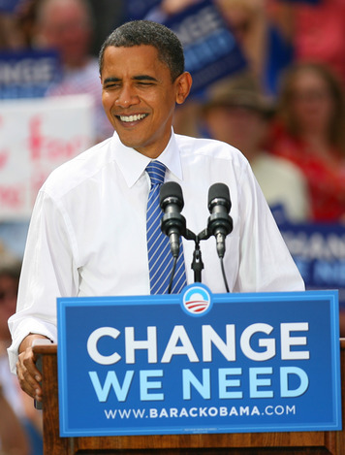
In early 2009, Congress pushed through a second recovery bill, which provided $787 billion in spending and tax cuts. The recession officially ended in June 2009. The economy began to grow again, but very slowly. However, economists continued to worry about the possibility of a second downturn in the following years.

A Vision for Change The 2008 election pitted a young Democratic senator from Illinois, Barack Obama, against a more experienced senator from Arizona, John McCain. Obama called for change. He criticized President Bush’s tax-cut policies and his pursuit of the war in Iraq. He also supported a larger central government that would help those in need.
Obama won the presidency with 365 electoral votes to McCain’s 173, becoming the nation’s first African American president. This landslide victory allowed Obama to pursue his plan for moving the country in a new direction. Once in office, however, Obama experienced great challenges in pushing forward his ideas.
Renewed Debate Early in his presidency, President Obama worked to enact some of the reforms he had promised during his campaign. With a Democratic majority in both houses of Congress, Obama was able to pass the Patient Protection and Affordable Care Act in 2009. This health care reform bill, Obama said, would lower health costs, improve care for those with health insurance, and expand coverage to the millions who had none. He also appointed two liberal justices to the Supreme Court: Sonia Sotomayor and Elena Kagan.
Many Republicans opposed Obama’s plans, especially his health care initiative. The Tea Party, a conservative activist group, formed to protest against a large federal government. In the 2010 midterm elections, with Tea Party help, the Republicans took a majority in the House. President Obama would now find it harder to meet his policy goals.
With conflict in the legislature and a poor economy, Obama and Congress were forced to reexamine the role of government in American society. American leaders will continue to face various challenges in the future, some similar to the ones you have studied in this course, others very different. It will be up to each generation to guide the United States toward a brighter future.

