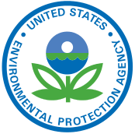
1970’s Environmentalism
The Environmental Movement Blossoms Pg 732
EPA-

What did the Clean Air Act do in 1970?

Clean War Act (1972)-

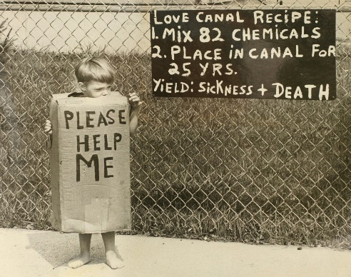
Endangered Species Act (1973)-

Love Canal Pg 732-733
Where was Love Canal Located?

Describe some of the health problems residents of Love Canal began to notice

How did the State finally respond and attempt to help the people in 1978?

What did Jimmy Carter do to help in 1980?

The Love Canal Disaster: Toxic Waste in the Neighborhood | Retro Report | The New York Times
1. How did the Toxic chemicals get into the homes of the residents at Love Canal?

2. What did the residents at Love Canal do that finally got the Federal Governments attention and got everyone relocated?

3. Did research ever find a link between serious diseases and the contamination at Love Canal? What about birth defects?
Concerns About Nuclear Energy Pg 733
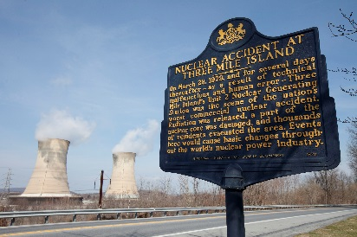
What were citizens scared of in the 1970s?

What were the pros and cons of nuclear energy?

Where was Three Mile Island Located?

What happened in the early hours of March 28th?

How did Officials fix the problem?

What was the impact of Three Mile Island Scare? (Be Specific)

Three Mile Island Documentary: Nuclear Power's Promise and Peril | Retro Report | The New York Times

1. What impact did the Three Mile Island Melt Down have on Nuclear Energy in the United States?

2. What did Scientists call the “China syndrome? “

3. What becomes the ultimate fear of Americans nearby?

4. What impact did the potential Three Mile Island disaster have on the anti-nuclear movement?

5. How do many people in the United States feel about nuclear power now?

